42: Multi-Axis Cobot For Factory Automation

Adrian Guzman, Emily Hamsa, Ethan Woods, Jaishil Shah

**Subsystem Reports**

REVISION – 0

5 December 2024

Subsystem Report

for

42: Multi-Axis Cobot For Factory Automation

Prepared by:

_____________________________

Author Date

Approved by:

_____________________________

Project Leader Date

_____________________________

John Lusher II, P.E. Date

_____________________________

T/A Date

**Change Record**

| **Rev.** | **Date** | **Originator** | **Approvals** | **Description** |
| --- | --- | --- | --- | --- |
| **0** | 12/5/2024 | All Members | All Members | Draft Release - Revision 0 |

**Table of Contents**

**Table of Contents III**

**List of Tables IV**

**List of Figures IV**

**1. Overview** **1**

**2. Motor/Motor Driver Subsystem** **1**

2.1. Subsystem Introduction 1

2.2. Subsystem Details 1

2.2.1. Torque Calculations and Motor Selection 2

2.2.2. Motor Movement 5

2.2.2.1. DRV8161 Motor Driver 5

2.2.2.2. PCB Design and Creation 7

2.2.2.3. Testing and Results15

2.3. Subsystem Validation 21

2.4. Subsystem Conclusion 22

**3****. MCU/Processing Subsystem** **24**

3.1. Subsystem Introduction 24

3.2. Subsystem Details 24

3.2.1. Subsystem Block Diagram 24

3.2.2. PCB Schematic Design 25

3.2.2.1. General-Purpose Input/Output (GPIO) 25

3.2.2.2. Power 27

3.2.2.3. Programming (JTAG) 28

3.2.2.4. Miscellaneous 28

3.2.3. C2000 Launchpad Development 29

3.2.4. PCB Testing and Results 31

3.2.4.1. Power 32

3.2.4.2. JTAG Flashing & Programming 32

3.2.4.3. PWM Waveform Generation 35

3.2.4.4. Communication with ESP-32 37

3.3. Subsystem Validation 38

3.4. Subsystem Conclusion 39

**4****. Power & Battery Management Subsystem** **41**

4.1. Subsystem Introduction 41

4.2. Subsystem Details 41

4.2.1. Planning and Selection 41

4.2.2. Schematic and PCB Design 42

4.2.2.1. Schematic Design 42

4.2.2.2. PCB Design and Fabrication 44

4.3. Subsystem Validation 45

4.3.1. Output Voltage Verification 45

4.3.2. Input and Output Voltage Noise Verification 47

4.4. Subsystem Conclusion 49

**5. User Interface & Wireless Connectivity Subsystem** 505.1. Subsystem Introduction 50

5.2. Subsystem Details 50

5.2.1. Subsystem Block Diagram 50

5.2.2.1. Mobile Application (Flutterflow) 51

5.2.2.2. Mobile Application (App Store / Mobile Application Deployment) 53

5.2.3 PCB Layout Breakdown 54  
 5.2.3.1. ESP-32 Chip 54

5.2.3.2. GPIO Headers 54  
 5.2.3.3. Power Selection & Voltage Regulation 55

5.2.3.4. Boot/User & Reset Buttons 55  
 5.2.3.5. USB Connectors 56

5.2.3.6. Miscellaneous Components 56  
 5.2.4. GPIO Pin Layout 57  
 5.2.5. Arduino IDE 58

5.2.6. Communicating via high/low GPIO Pins & Physical Board Validation59

5.3. Subsystem Validation 61

5.4. Subsystem Conclusion 61

**List of Tables**

Table 1: Differences and Similarities between Torque Categories 3

Table 2: Motor Torque for Each Category 4

Table 3: Selected Motors for 5-DoF Collaborative Robot 5

Table 4: Pinout for the Molex Mini-Fit Jr. Pinout (Motor Pinout) 7

Table 5: Motor Driver Subsystem Validation Plan Goals 22

Table 6: C2000 Pinout (Signals sent to 3x Motor Drivers) 26

Table 7: C2000 Pinout for ESP-32 Connectivity 27

Table 8: MCU/Processing Validated Deliverables 39

Table 9: Cobot Load List 41

Table 10: Validated Deliverables: Power Supply PCB 48

Table 11: Bluetooth Functions & their Functionality 52

Table 12: Subsystem Validation - Jaishil Shah 61

**List of Figures**

Figure 1: Conceptual Design and Free-Body Diagram 2

Figure 2: DRV8161 Simplified Schematic and Pinout 6

Figure 3: DRV8161 Evaluation Module’s Necessary Circuits and Signals 8

Figure 4: Motor Driver Schematics (Chip and Power Stage (Phase)) 10

Figure 5: MCU Launchpad Connector Schematic 10

Figure 6: Reference DRV8161 EVM PCB Layout 11

Figure 7: Front and Back Implementation of the ‘Main Board’, Board A 12

Figure 8: Front and Back Implementation of Board B 13

Figure 9: Front and Back Implementation of Board C 14

Figure 10: Texas Instruments DRV8161 Evaluation Module GUI 14

Figure 11: DRV8161 EVM Connected to Power Supply and Launchpad 15

Figure 12: GUI Interface Showing Connection to 48V PVDD with Output Disabled 16

Figure 13: Measuring the Phase Output Terminal on the DRV8161 EVM 17

Figure 14: Phase Voltage Outputs on Terminals A, B, and C (Respectively) 17

Figure 15: Created PCBs All Wired Together Without Motor and Phases Connected 18

Figure 16: Successful Connection to the GUI Showing 48V PVDD 19

Figure 17: Output of Each Voltage Step-Down Circuit (3.3V, 5V, and 12V Respectively) 19

Figure 18: Measuring the Phase Output Terminal on Phase A Board (Same for B and C) 20

Figure 19: Phase Voltage Output on Each Board (A, B, C) Respectively 20

Figure 20: MCU/Processing Block Diagram 24

Figure 21: GPIO PCB Schematic 25

Figure 22: Power PCB Schematic 27

Figure 23: JTAG Programming PCB Schematic 28

Figure 24: Miscellaneous PCB Schematic 28

Figure 25: LED Blinky 29

Figure 26: MicroServo 9g SG90 30

Figure 27: Stepper Motor w/ ULN2003 Motor Driver 30

Figure 28: PWM Signal Modulation 31

Figure 29: Front & Back of PCB 31

Figure 30: 3.3V Input to Terminal Block 32

Figure 31: Successful JTAG Programming Method 32

Figure 32: Flashing through Launchpad 33

Figure 33: Successful Connection 33

Figure 34: C2000 Software for Demo 34

Figure 35: ESP-32 Arduino Software (High/Low Toggle) 34

Figure 36: Demo Setup 36

Figure 37: Probing PWM Output Pins 36

Figure 38: PWM Generation EPWM7A & EPWM7B (GPIO12 & GPIO13) 36

Figure 39: PWM High/Low Generation 37

Figure 40: ESP32/C2000 Setup 38

Figure 41: ESP-32 to C2000 Communication (LED Toggle) 38

Figure 42: 3.3V, 0.5A Step-down Circuit Schematic 42

Figure 43: 5V, 1A Step-down Circuit Schematic 42

Figure 44: 6V, 2.5A Step-down Circuit Schematic 43

Figure 45: 12V, 1A Step-down Circuit Schematic 43

Figure 46: 24V, 1A Step-down Circuit Schematic 43

Figure 47: Connection from Vin Directly to Output Schematic 44

Figure 48: Power Supply PCB 44

Figure 49: 3.3V Output When Tested with 25V Input 45

Figure 50: 6V Output When Tested with 30V Input 45

Figure 51: 12V Output When Tested with 30V Input 45

Figure 52: 24V Output When Tested with 30V Input 46

Figure 53: 3.3V Noise Output When Tested with 25V Input 47

Figure 54: 6V Noise Output When Tested with 25V Input 47

Figure 55: 24V Noise Output When Tested with 30V Input 47

Figure 56: 12V Noise Output When Tested with 30V Input 48

Figure 57: UI & Wireless Connectivity Subsystem Block Diagram 50

Figure 58: Application Page List 51  
Figure 59: Intro Page 51  
Figure 60: Home Page 51  
Figure 61: Device Page 51  
Figure 62: Bluetooth Function UI 52  
Figure 63: Block Diageam of Function Overlap 52  
Figure 64: Mobile Application Deployment via TestFlight 53  
Figure 65: Mobile Application Deployment to iPad and iPhone 53   
Figure 66: Mobile Application on iPhone 53   
Figure 67: ESP-32-S3-MINI Module Schematic 54   
Figure 68: GPIO PIN Headers Schematic 54   
Figure 69: Power Selection & Voltage Regulation Schematic 55  
Figure 70: Boot/User & Reset Button Schematics 55   
Figure 71: USB Connector Schematics 56   
Figure 72: Miscellaneous Schematics 56 Figure 73: GPIO Pin-Out Sheet 57 Figure 74: Arduino IDE interface 58   
Figure 75: Mobile Input → ESP-32 → OLED screen 58  
Figure 76: Full Subsystem Functionality Test 59  
Figure 77: 3D render of ESP-32 PCB 60  
Figure 78: ESP-32 PCB used in four-part system 60  
Figure 79: Arduino Serial Monitor displaying Signals Received 60

# Overview

The multi-axis cobot for factory automation will be able to lift and move objects wirelessly to improve productivity, minimize worker injury, and work in dangerous environments. The cobot will take user input through a mobile app and then move according to the input. The system is broken down into four subsystems, motor/motor driving, MCU/processing, power/battery management, and user interface/wireless connectivity. Each team member has researched, developed, and tested their individual subsystem. The validation and execution plans have been followed closely to ensure an easy path to integration in the following semester.

# Motor/Motor Driver Subsystem - Ethan Woods

## 2.1. Subsystem Introduction

The Motor/Motor Driver Subsystem is responsible for controlling the movement of the Collaborative Robot (Cobot) through the selection and control of the motors. This subsystem focuses on identifying the motors capable of handling the calculated torque requirements for the different joints in the Cobot. These motors are driven using Texas Instruments’ DRV8161 Motor Drivers, which controls the 3-Phase Brushless DC (BLDC) motors using generated PWM signals.

To achieve motor movement, custom PCBs were designed and fabricated with the primary goal of spinning a 3-phase BLDC motor. These boards integrate key functionalities, including voltage step-down circuits, Motor Driver circuits, and connections for phase signal generation, inspired by the Texas Instruments’ DRV8161 Evaluation Module. The PCB system consists of a main board and two supporting boards, collectively enabling control and high-performance operation of the motor. The design has compatibility with the LAUNCHXL-F280049C, a Texas Instruments’ C2000 Launchpad Development Kit, and supports the high torque, voltage, and current requirements of the motors needed.

***2.2. Subsystem Details***

During this semester, the subsystem had two main goals: **Motor Selection** and **Motor Movement**. The first goal was to calculate the necessary torque needed for each motor in the Cobot to accommodate its maximum payload, desired dimensions, and material weight. Based on these calculations, five motors were selected—one for each joint: Base, Arm 1, Arm 2, Neck, and Head. All motors except for the Head are 3-phase BLDC motors, chosen for their precision and compatibility with the DRV8161 Motor Drivers.

The second goal was to move and spin one of the selected motors. To achieve this, the DRV8161 Motor Drivers were used to generate the three phases required for the operation of a 3-phase BLDC motor. This involved designing and creating a system of PCBs that worked together to generate and route the necessary signals for motor control. The motor was connected to a main board, which ensured it received all the signals needed for movement and allowed control through an external device.

***2.2.1. Torque Calculations and Motor Selection***

At the start of the semester, the team met to conceptualize the operation and movement of the Cobot and establish its primary constraints. As a Collaborative Robot, the design emphasized smooth and unrestricted movement within its range of motion. This discussion led to the decision to implement a 5-Degree of Freedom (DoF) design, requiring five motors—one for each joint. At this stage, the focus was solely on the degrees of freedom and the maximum payload the Cobot should handle, without addressing details about its material composition or dimensions.

With this conceptual framework in place, the next step involved analyzing the conditions under which the motors would operate. Using free-body diagrams and calculations, the assumptions and constraints necessary to determine the torque range required for motor selection were defined. Below is the process followed to determine the torque range required for each motor. Calculations are not provided here but are available in the document linked below.

*These calculations and results are presented in the document:* [*Motor Calculations*](https://drive.google.com/file/d/1-wp_XzNhOnYnFOjFMtRx3apCVsc_YNEo/view?usp=sharing)

*If the link does not work, send concerns to* [*ewoods738@tamu.edu*](mailto:ewoods738@tamu.edu) *or (210)774-0465*

To calculate the required torques for each of the five motors in the conceptual Cobot, the design was translated into a 5-jointed robotic arm representation. This step enabled visualization of the system and the creation of the free-body diagram (FBD) shown below, which depicts the robotic arm in its worst-case scenario. By analyzing this worst-case configuration, the torque calculations are intentionally overestimated, ensuring a safety margin in the design rather than risking underestimations. Below is the conceptual 5-DoF design and the corresponding free-body diagram used as the basis for the torque calculations.

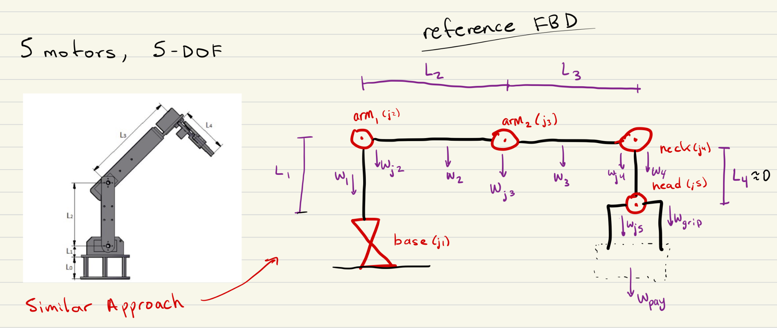

*Figure 1: Conceptual Design and Free-Body Diagram*

With the creation of the free-body diagram (FBD), the forces acting on each joint were determined, enabling the calculation of the gravitational or angular torque required for each motor. Motors responsible for lifting (Arm 1 and Arm 2) require gravitational torque calculations, while those responsible for rotation (Base and Neck) require angular torque calculations. To account for variability in the Cobot's design, the torque requirements were classified into three ranges: **Low Torque**, **Medium Torque**, and **High Torque**.

* **Low Torque** represents a smaller and lighter-than-expected design.
* **Medium Torque** reflects the expected design based on our initial assumptions.
* **High Torque** assumes a heavier, overestimated design to ensure safety margins in the motor selection.

**Torque Categories: Differences and Similarities**

The differences between the torque ranges are based on varying constraints such as arm length, material density, and acceleration. However, certain assumptions, such as the payload and the gripper motor's specifications, remained consistent across all categories. The table below summarizes these differences and similarities:

| **Category** | **Base and Neck Acceleration** | **Weight of**  **Arms (Material Density,Cross-**  **Section)** | **Length of Arms** | **Payload Weight** | **Gripper Motor Weight/**  **Length** | **Joint Motor Weight** |
| --- | --- | --- | --- | --- | --- | --- |
| **Low Torque** | Reduced | Lower density,  smaller cross-  section | Shorter | Fixed (2  lb / 0.91 kg) | Fixed* (Amazon Servo Motor) | Fixed/  Estimated** |
| **Medium Torque** | Average/  Expected | Average density and cross-section | Average/  Expected | Fixed | Fixed* | Fixed/  Estimated** |
| **High Torque** | Increased | Higher density, and larger cross-section | Longer | Fixed | Fixed* | Fixed/  Estimated** |

*Table 1: Differences and Similarities between Torque Categories*

* The motor and claw specifications are on Amazon. These were used during calculations.

** Weights were estimated based on the average weights of different motors that could be used during the project. Ended up being 1.4 kg for Joint 2, 0.8 kg for Joint 3, and 0.25 kg for Joint 4.

With the completion of the torque calculations, the estimated torque requirements for each motor in the Cobot have been determined across three categories: Low Torque, Medium Torque, and High Torque. These calculations provide a clear range of torque values for each joint—Base, Arm 1, Arm 2, Neck, and Head—ensuring the selected motors can handle both expected and extreme conditions. The table below summarizes the calculated torque values for each motor in all three categories, serving as the foundation for motor selection.

| **Motor** | **Low Range Torque** | **Mid Range Torque** | **High Range Torque** |
| --- | --- | --- | --- |
| **Base Motor** | .1428 N/m** | .5339 N/m | 1.993 N/m |
| **Arm 1 Motor** | 563 oz-in*** | 1197 oz-in | 2763 oz-in |
| **Arm 2 Motor** | 181.72 oz-in | 354 oz-in | 745 oz-in |
| **Neck Motor** | .00649 N/m | .00973 N/m | .0129 N/m |
| **Gripper Motor\*** | 11 kg/cm | 11 kg/cm | 11 kg/cm |

*Table 2: Motor Torque for Each Category*

* Gripper Motor is bought off Amazon. Cannot change the value of the torque produced or required for the Gripper Motor as 11 kg/cm should be more than enough for 2 lbs.

** N/m is the measurement for angular torque, as it is the amount of torque needed to produce the acceleration necessary for the Base and Neck motors

*** oz-in is a measurement of torque in relation to gravity. It shows the lifting power needed for that motor to lift a payload of 2 lbs when considering the entire design of the Cobot.

**Motor Selection Based off Estimated Torque Range**

With the established torque ranges for each joint, we could now select motors that meet the performance requirements while aligning with the constraints of the Cobot's design. The motors chosen are high-power, 3-phase BLDC motors, capable of handling the calculated torque for their respective joints. The table below highlights the selected motors, along with their key specifications such as voltage, current, torque output, and cost, ensuring they are well-suited for their designated roles in the Cobot.

| **Motor** | **Name** | **Link** | **Torque** | **Rated Voltage** | **Rated Current** | **Encoder Type** | **Weight** | **Price** |
| --- | --- | --- | --- | --- | --- | --- | --- | --- |
| **Base** | 57BSA | [link](https://www.omc-stepperonline.com/48v-3000rpm-0-6nm-188w-5-40a-57x57x100mm-brushless-dc-motor-57bsa100-48-01) | 0.6 N/m | 48 V | 5.4 A | Hall | 1.35 kg | $59 |
| **Arm 1** | NEMA 34 Hudson | [link](https://teknic.com/hudson-model/M-3432S-LN-02D/?model_voltage=48) | 1223 oz-in | 48 V | ~10 A  max:  20 A | Differential/Hall | 2.8 kg | ~$360 |
| **Arm 2** | NEMA 23 Hudson | [link](https://teknic.com/hudson-model/M-2311P-QN-08D/?model_voltage=48) | 223 oz-in | 48 V | ~ 10 A  max:  30 A | Differential/Hall | 0.6 kg | ~$210 |
| **Neck** | 42BYA | [link](https://www.omc-stepperonline.com/24v-3000rpm-0-04nm-13w-1-00a-42x43mm-brushless-dc-motor-42bya43-24-01) | 0.04 N/m | 24 V | 1 A | Hall | 0.3 kg | $20 |
| **Head** | MG996R | [link](https://www.amazon.com/Professional-Mechanical-Educational-Raspberry-Platform/dp/B08WPZ9FGW/ref=sr_1_52?crid=27YZU0INICY5H&dib=eyJ2IjoiMSJ9.WCDSC5rzLEaM66dcxYARhpFdNj62xm0yeHtVYDBMxX1ZOXbzKWLye8swIAanG2pnp1dHjuPK2g4l2AcqQyuO8daYV-Q63bgGczpb6SgeX19-1c_hQ-FU0PSbZCNCrRKBNydat9FnVBKs7Wv2IVduUaBsoWC6UM2CH2L-YKS36ghfO9ToORUdCrr1OWvDNxHAB_uHCKFbxRCrzGTs04bxD_CyJr54uECMBbgCT_M9yHr-HHPjZBxoudh3OStVYXc9WQC_N-EYm_8LyNwo_a9SSlzJfU3fIUPinHSm75AlQDA.cV853680l-eolYdCzcXIyM_HxmuylG833f66PXE0lwo&dib_tag=se&keywords=robotic%2Barm%2Bgrabber&qid=1728328167&refinements=p_36%3A1500-&s=toys-and-games&sprefix=robotic%2Barm%2Bgrabber%2Ctoys-and-games%2C104&sr=1-52&th=1) | 11 kg/cm | 5 V | 0.17 A | N/A | 0.095 kg | $27 |

*Table 3: Selected Motors for 5-DoF Collaborative Robot*

With the torque calculations complete and motors selected, my focus for the remainder of the semester shifted to achieving motor movement. The NEMA 23 Hudson motor, paired with a 48V 25A power supply, was chosen as the test motor for this phase. Using custom-designed PCBs, the goal is to successfully drive and spin the chosen motor. The process of how this was accomplished is outlined in Section 2.2.2 below.

***2.2.2. Motor Movement***

To enable movement in the selected 3-Phase BLDC motor, the focus shifts to the second critical component of this subsystem: Texas Instruments’ DRV8161 Motor Driver. This motor driver serves as the foundation for controlling all motor operations in this project by generating the phase signals required for motion. Given that our above motor operates with three phases, three DRV8161 Motor Drivers are necessary to facilitate its movement. The following sections will outline the design and implementation of a system of PCBs used to produce the necessary control signals, leading to the successful operation of the 3-Phase BLDC motor.

***2.2.2.1. DRV8161 Motor Driver***

The **DRV8161** is a high-performance, 100V half-bridge smart gate driver designed to enable precise and reliable control of high-voltage, high-current motor systems. As part of Texas Instruments’ latest DRV816x family, released in early 2024, this driver integrates advanced features such as a low-offset current sense amplifier, robust protection mechanisms, and versatile PWM control options. The DRV8161 supports a wide range of features that make it ideal for high-performance applications, such as an industrial Collaborative Robot. It includes built-in protection systems to guard against undervoltage, overcurrent, and overheating, ensuring safe operation under various conditions. With a Pulse-Width Modulation (PWM) signal input, the chip produces phase signals needed to control motor movement accurately.

Figure 2 illustrates a simplified schematic of how three DRV8161 Motor Drivers are used to generate the three-phase signals required to control a BLDC motor. The figure also includes the 20-pin pinout of the DRV8161, highlighting the essential connections and signals needed for operation.

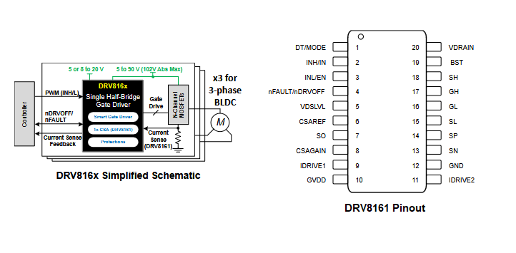

*Figure 2: DRV8161 Simplified Schematic and Pinout*

To understand how the DRV8161 operates, the functionality can be separated into two parts: **Phase Output** and **Hardware Selection and Fault Detection.**

**Phase Output**

The first key aspect of the DRV8161 is the actual generation of the Phase Signal through the various internal and external circuits of our motor driver. The DRV8161 motor driver operates by receiving a 12V supply voltage (GVDD) to power the chip. A PWM input signal is provided, where the high and low signals (INH/INL) control the gate driver. The input PWM signal interacts with the Dead Time/Mode (DT/MODE) configuration, determining the specific mode of operation for the driver. Based on this, the chip generates the necessary output signals: Bootstrap (BST), High-Side Gate (GH), High-Side Source (SH), Low-Side Gate (GL), and Low-Side Source (SL). These signals are then fed into the N-Channel MOSFET circuits, which are responsible for switching and ultimately creating the motor's phase signals.

Additionally, the DRV8161 includes an integrated current sense amplifier to monitor the current flow through the MOSFETs. This feature provides an added layer of protection, helping to prevent overcurrent situations that could damage the MOSFETs or other components in the system. Through this sequence, the DRV8161 efficiently drives the motor while ensuring safe operation under varying load conditions.

**Hardware Selection and Fault Detection**

The second key aspect of the DRV8161’s operation is its integrated protection and hardware selection features. The chip allows users to configure various hardware settings through external resistors connected to specific pins. These pins include IDRIVE1, IDRIVE2, VDSLVL, and DT/MODE, each offering different levels of control for fault detection and functionality. The desired settings are selected by adjusting the resistors in the circuit around the DRV8161.

In addition to these hardware selection options, the DRV8161 is equipped with several internal fault detection mechanisms, which are communicated through the nFAULT pin. This pin is pulled low during a fault condition, indicating issues such as GVDD undervoltage, VDS overcurrent, or thermal shutdown. With the help of a microcontroller monitoring these fault signals, the system can protect itself under these conditions. When a fault is detected, the chip disables the gate driver outputs, turning the external MOSFETs off to prevent further damage. Normal operation resumes only once the fault condition is cleared.

To better understand how the DRV8161 integrates into a system, let's now explore the PCB design process required to drive a 3-phase BLDC motor and enable its operation.

***2.2.2.2. PCB Design and Creation***

**Understanding the Signals and Circuits Needed for Movement**

To design the necessary PCBs for driving the motor, it is crucial to first understand the signals required for operating the 3-phase BLDC motor. The initial step involves identifying the motor’s pinout, which defines the signals needed for proper motor control. In this case, the focus is on the NEMA 23 Hudston Servo Motor and its corresponding Molex Mini-Fit Jr. connector. This pinout provides key signal connections, such as phase signals and communication pins, that are essential for motor movement.

| **Pin #** | **AWG** | **Signal Name** | **Pin #** | **AWG** | **Signal Name** |
| --- | --- | --- | --- | --- | --- |
| 1 | 16 | P DRAIN | 2 | - | NO CONNECT |
| 3 | 26 | COMM S-T | 4 | 26 | COMM R-S |
| 5 | 26 | COMM T-R | 6 | 26 | E DRAIN |
| 7 | 26 | GND | 8 | 26 | ENC A~ |
| **9** | **16** | PHASE R | **10** | **16** | PHASE S |
| **11** | **16** | PHASE T | 12 | 26 | +5VDC IN |
| 13 | 26 | ENC I | 14 | 26 | ENC B |
| 15 | 26 | ENC A | 16 | 26 | ENC B~ |

*Table 4:Pinout for the Molex Mini-Fit Jr. Pinout (Motor Pinout)*

Once the motor's pinout is understood, the next step is to examine the motor driver's role in generating the required control signals. This process involves utilizing the DRV8161 Evaluation Module (EVM) paired with the LAUNCHXL-F280049C development kit. This hardware combination, along with an external GUI on a laptop, facilitates the generation of PWM signals to drive the motor while also providing fault detection and diagnostics via built-in LEDs. Figure 3 below highlights the key areas involved in the operation of the EVM alongside the GUI.

*Figure 3: DRV8161 Evaluation Module’s Necessary Circuits and Signals*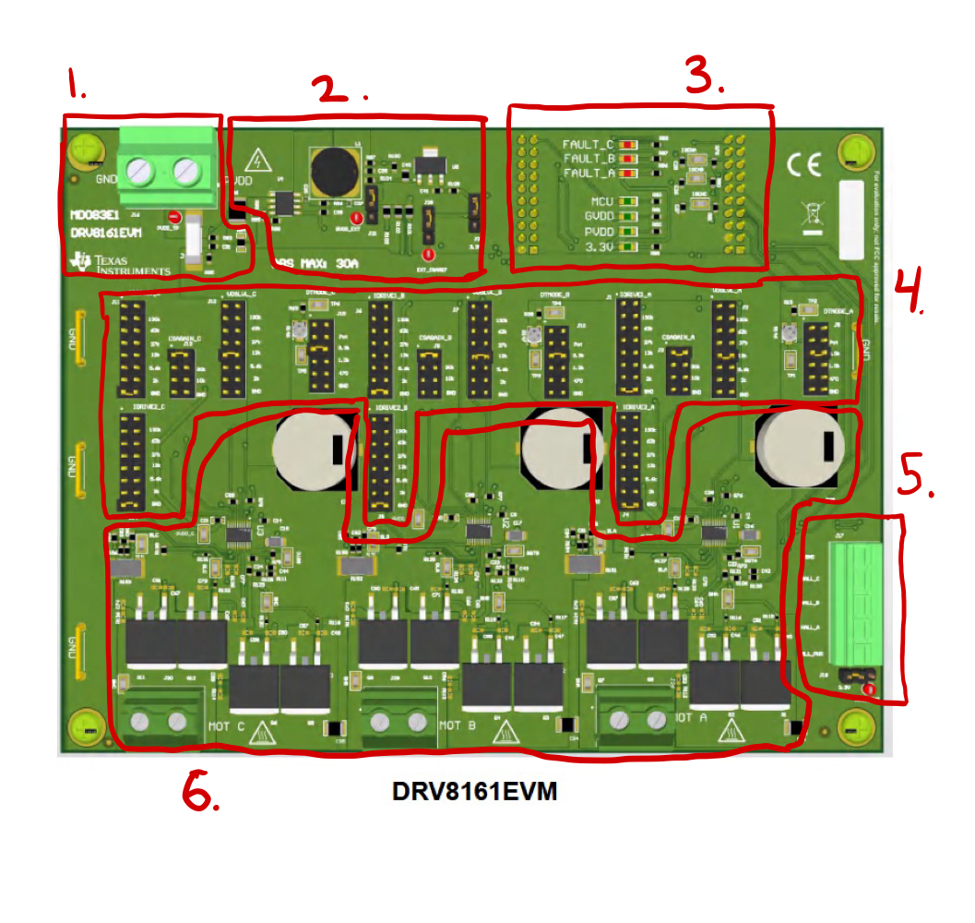

1. **PVDD/GND Input**: The power supply input and ground for the entire board, with an input voltage range of 4.5V to 48V and a maximum current rating of 30A.
2. **12V and 3.3V Step-Down Circuits**: These circuits step down the input voltage to provide 12V GVDD for the motor driver and 3.3V for the CSAREF and MCU voltage requirements.
3. **Launchpad Integration and Fault/Status LEDs**: The LAUNCHXL-F280049C is mounted beneath the EVM and connected to a laptop via MicroUSB. The laptop interfaces with the GUI, which controls the MCU/EVM code and provides real-time fault and status monitoring via built-in LEDs.
4. **Hardware Configuration Jumpers**: Resistor jumpers allow for customization of the IDRIVE, CSA gain, VDSLVL, and dead time mode settings for each of the three DRV8161 motor drivers.
5. **Hall Sensor Inputs**: This feature takes input from an external Hall sensor in the motor, adjusting the phase outputs accordingly. These adjustments are made through the GUI for precise control.
6. **Motor Driver Circuits**: The EVM contains three identical motor driver circuits, each driving the phase signals generated by the DRV8161. Large terminals are provided at the bottom for routing the phase signal outputs.

Finally, we can categorize the critical and non-critical signals and circuits involved in driving the NEMA 23 motor using the DRV8161. **Critical signals and circuits** are essential for generating the phase outputs required by the motor drivers, such as the input voltages and Launchpad connections. **Non-critical signals and circuits**, on the other hand, are not strictly necessary for phase signal generation and can be configured to a fixed value, allowing for greater flexibility in PCB design. For example, the hardware selection signals can be set to a single, fixed value and do not need to be dynamically adjustable.

**Critical Signals and Circuits:**

* **PVDD/GND Input:** Supply power and GND to board. Used by almost everything on the board.
* **Launchpad Connection:** Launchpad connection jumpers to route signals generated by the GUI and the Launchpad to/from the Motor Drivers.
* **Hall Sensor Inputs:** Critical feedback mechanisms from the motor, allowing for accurate phase output adjustments.
* **Motor Phase Outputs:** The control phase signals generated by the DRV8161 Motor Driver, which control the rotation of the motor.
* **Step-Down Circuits:** 12V, 5V, and 3.3V step-down circuits are needed because of different components on the board.
* **Encoder Inputs:** Another critical feedback mechanism from the motor, allowing for precise control of movement from the motor.

**Non-Critical Signals and Circuits:**

* **Hardware Selection Jumpers (IDRIVE, CSA Gain, VDSLVL, DT Mode):** These signals are configurable through resistor combinations, but can be set to a fixed mode, eliminating the need for a dynamic adjustment jumper circuit.
* **Fault and Status LEDs:** Although non-critical, it is always helpful to have Fault and Status LEDs to help diagnose problems. Provides visual feedback from the MCU/Motor Driver to see faults.

With a clear understanding of the critical and non-critical signals required to drive the NEMA 23 motor using the DRV8161, we can now transition to the implementation of the system of three PCBs that were made to generate motor movement.

**Integrated PCB Design for Motor Operation**

The design and development of the PCBs were heavily inspired by the DRV8161 Evaluation Module, which provided a strong foundation for implementing the motor driver circuits. Many schematics, layout designs, and component footprint libraries required for the motor driver were readily available through Texas Instruments, streamlining the design process. Additionally, the voltage step-down circuits, an essential part of the PCBs, were adapted from schematics provided by Emily Hamsa, who is responsible for the Power Subsystem. Key elements such as the MOSFET layout and driver circuit designs drew direct inspiration from the DRV8161 EVM, ensuring both functionality and reliability. Below are some examples of the referenced schematics and layouts that influenced the PCB design.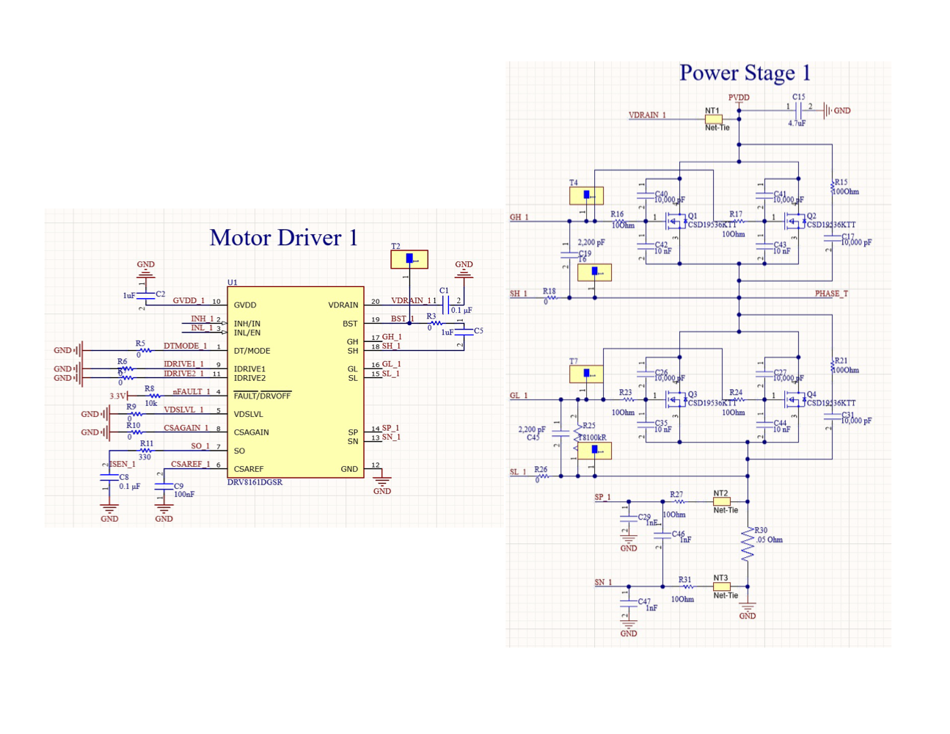

*Figure 4: Motor Driver Schematics (Chip and Power Stage (Phase))*

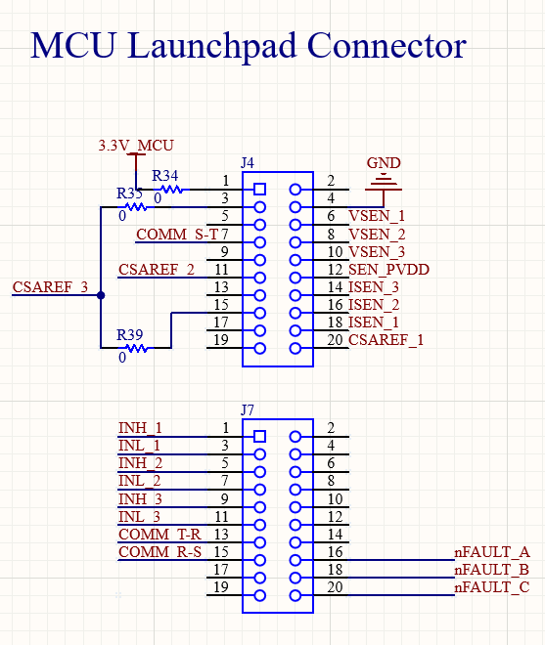

*Figure 5: MCU Launchpad Connector Schematic*

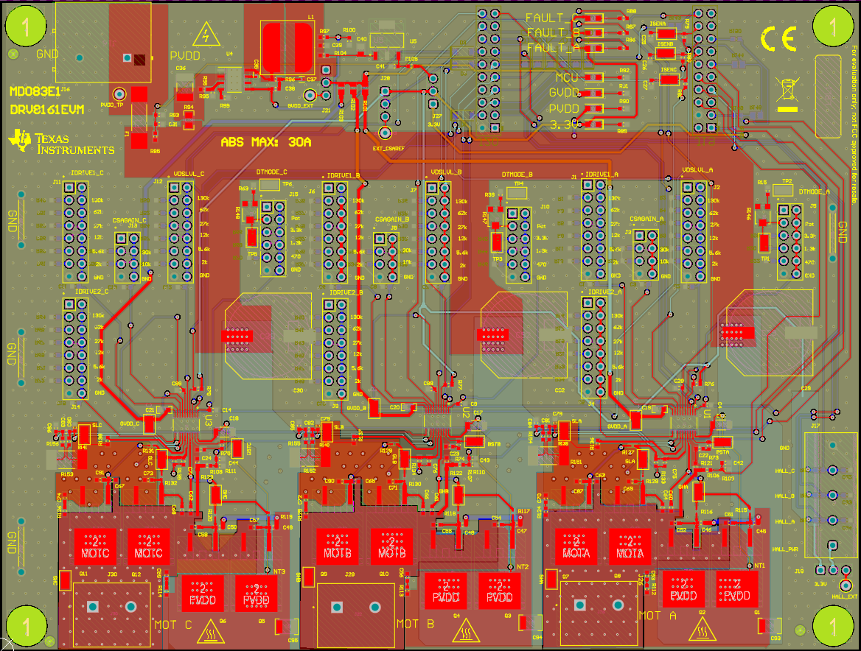

*Figure 6: Reference DRV8161 EVM PCB Layout*

Above in Figure 3 and Figure 6, you can see the Hardware Selection jumpers for the different logic levels in the DRV8161 Motor Driver. Since this is a non-critical circuit in the creation of the phase signal, our boards were able to be simplified by setting each selection to its ‘Level 0’ logic level by having a 0Ω resistor for each selection. By setting the selection levels for each signal to its base value, we ensured that there would be no unexpected complications during operation and could omit the large circuitry needed for the resistance jumper selection system.

To finally generate motor movement using three DRV8161 Motor Drivers, a system of three PCB boards was developed: **Board A, Board B, and Board C**. Each board corresponds to one of the three phase signals required by the motor and produced by the motor drivers. Among these, Board A serves as the ‘Main Board,’ as it houses additional circuits necessary for the motor's operation. The other two boards, Board B and Board C, focus primarily on driving their respective phases. Below is a breakdown of each board, highlighting its key functionalities and the circuits it contains.

**Board A**

Board A serves as the ‘Main Board’ since it will be the main powerhouse of the three PCBs. It will serve as the board that the Launchpad and the motor will plug into and run off of. It will have output terminals for each of the step-down voltage circuits on the board, terminals for motor feedback functions, and terminals to input Motor Driver phase outputs from Boards B and C. Below are the key functions that are on the board:

Key Functions: **(Numbered in Figure 7 Below)**

* Take PVDD/GND Input (48V, 30A Input) **(1)**
* Motor Driver Circuit (Phase Generation) **(2)**
* Voltage Step-Down Circuits (Schematics from Emily Hamsa)
  + 48V PVDD -> 12V GVDD **(3a)**
  + 48V PVDD -> 5V Hall/Encoder **(3b)**
  + 48V PVDD -> 3.3V MCU **(3c)**
* Input Terminals for Phase B & C **(4)**
* LAUNCHXL-F280049C Jumper Connector **(5)**
* Input/Output Terminals for Encoder/Hall Sensor **(6)**
* Output Terminals for 12V, 5V, and 3.3V **(7)**
* Motor Connector Mating Terminal **(8)**

Board A was designed with the goal of isolating the ability to produce a single phase signal, making it straightforward to replicate this functionality across two additional boards—Board B and Board C. This modular approach simplifies the design process and ensures consistency between phases. Below is the completed build of Board A, labeled with its corresponding key functions as outlined above.

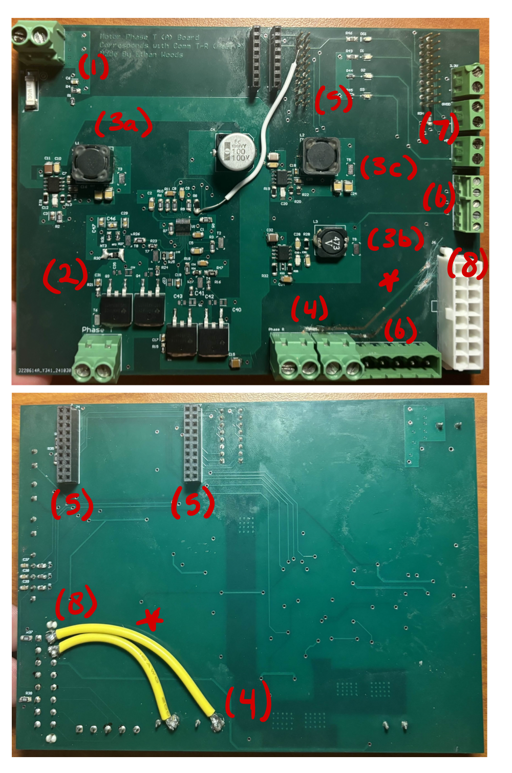

*Figure 7: Front and Back Implementation of the ‘Main Board’, Board A*

**Boards B & C**

Boards B and C complete the system by generating the final phase signals required to drive motor movement. These boards were intentionally designed for simplicity, relying solely on the signals provided by Board A to produce their respective phase outputs. Connections between Board A and Boards B and C are made via jumper wires, ensuring seamless communication. Once all necessary inputs are received, Boards B and C generate their corresponding phase signals, which are then routed back to Board A. Below are the key functions that are on the boards:

Key Functions: **(Numbered in Figure 8 and 9 Below)**

* PVDD/GND Input (48V, 30A Input) **(1)**
* Input Terminals for 12V and 3.3V **(2)**
* Jumper Terminals for Signals from Board A **(3)**
* Motor Driver Circuit (Phase Generation) **(4)**
* Phase Output Terminal **(5)**

Boards B and C are dedicated to generating their respective phase signals, which are then routed back to Board A for integration. This modular design allows each phase signal to be created independently, simplifying the overall system and ensuring flexibility in the design. Below are the finalized builds of Board B and Board C, with their key functions labeled as outlined above.

*Figure 8: Front and Back Implementation of Board B*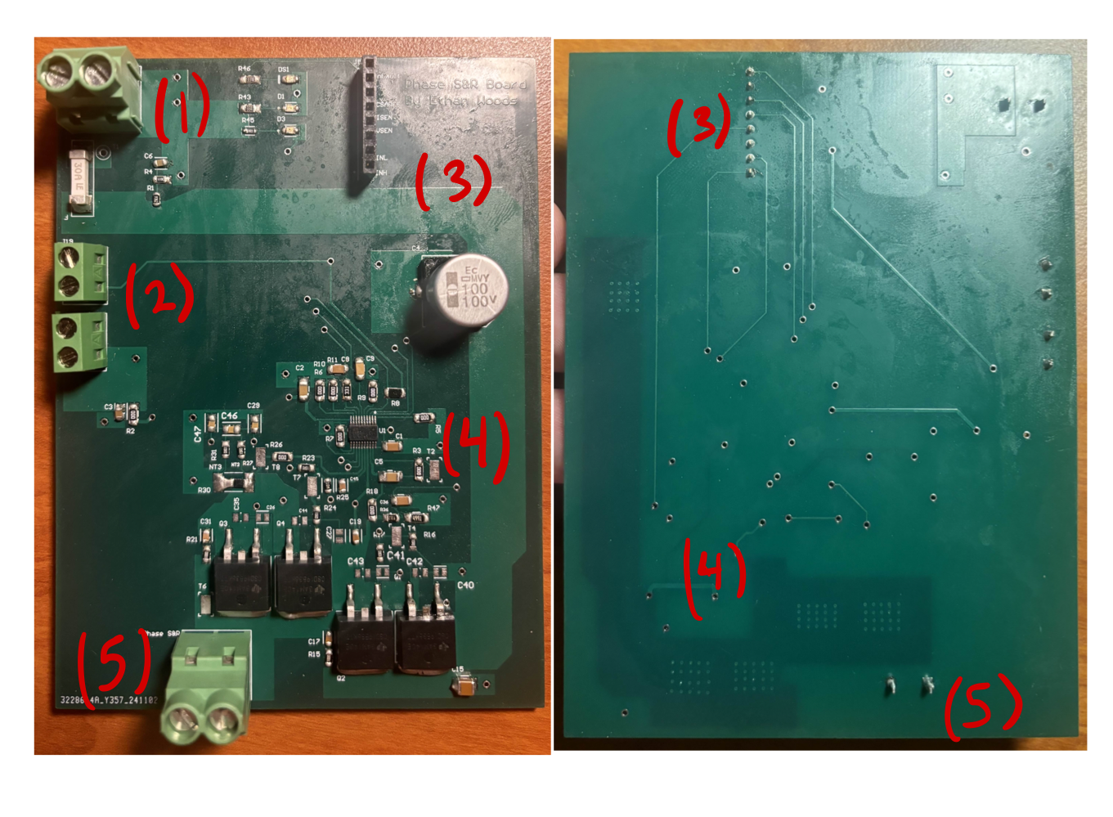

*Figure 9: Front and Back Implementation of Board C*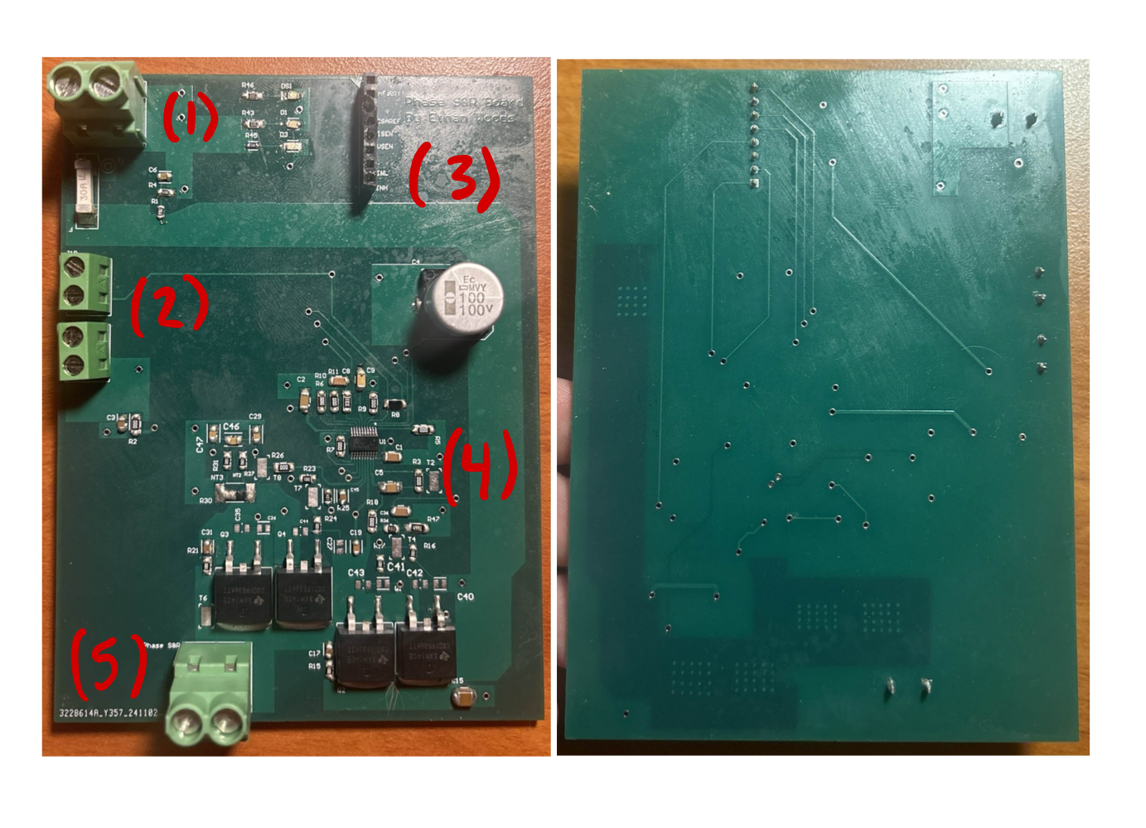

With all three boards assembled and interconnected, the system is now ready to drive the motor. By connecting the Launchpad to the designated connector on Board A and linking it to a laptop, we can utilize the GUI software provided by Texas Instruments to control the setup. This GUI mirrors the functionality of the DRV8161 EVM, enabling the user to adjust parameters such as duty cycle and acceleration delay with ease. Through the GUI, the output of our PCB system can be enabled, allowing the generation of the phase signals required to drive the motor. Figure 10 shows the GUI and its configuration.

With the hardware and control system in place, we now move into **Testing and Results**, where we evaluate the performance and functionality of the PCBs in driving the motor.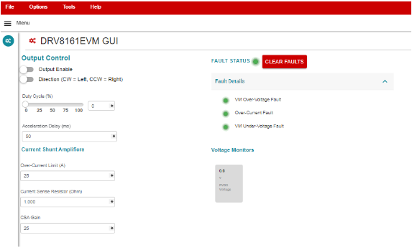

*Figure 10: Texas Instruments DRV8161 Evaluation Module GUI*

***2.2.2.3. Testing and Results***

To begin testing each board, they were powered using a 48V 25A power supply. On power-up, the corresponding LEDs on Board A illuminated as expected, confirming proper functionality. However, on Boards B and C, some LEDs were found to be installed backward, preventing them from lighting even when power was applied. Despite this, terminal testing with a multimeter confirmed that all PVDD and GND connections were functioning correctly, ensuring the boards were receiving power.

With power delivery confirmed, the next step was to validate the functionality of the DRV8161 EVM as a baseline for comparison. The EVM was powered using the same 48V 25A power supply and connected to the GUI through the LAUNCHXL-F280049C Launchpad. This setup allowed us to simulate identical circuit conditions to those in our PCB system and measure the phase output voltages generated by the EVM.

To verify the performance of our boards, the phase output voltages from the DRV8161 EVM were measured and used as reference values. By comparing these outputs with the corresponding phase signals from our boards, we could validate whether the PCB system was producing accurate signals needed for motor operation.

Below is the process for connecting and measuring the outputs from the DRV8161 EVM, followed by images of the measured phase signals for comparison.

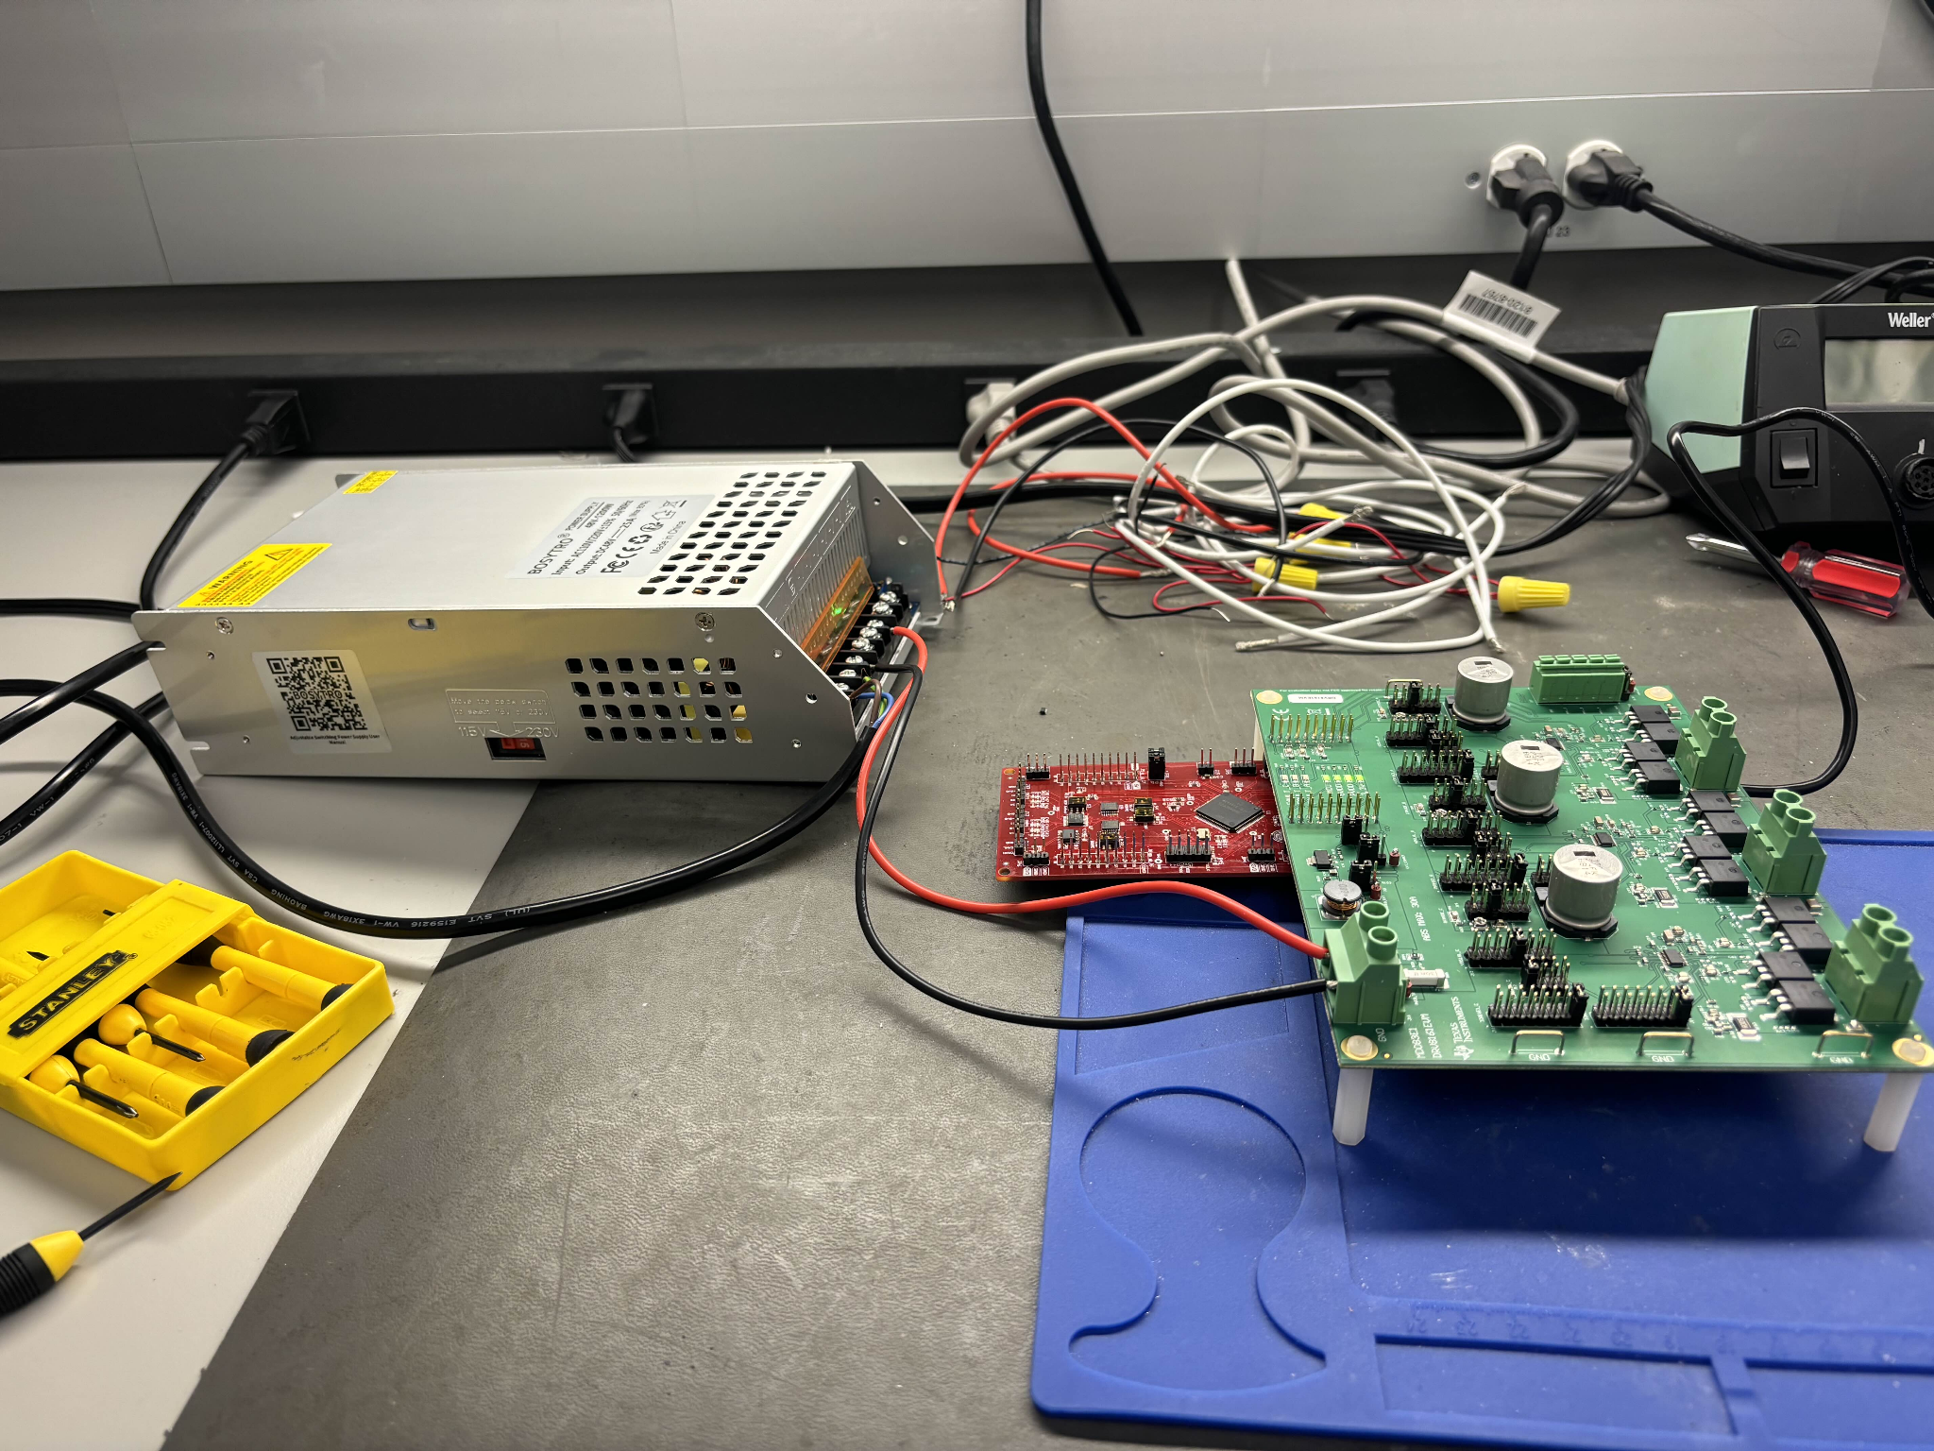

*Figure 11: DRV8161 EVM Connected to Power Supply and Launchpad*

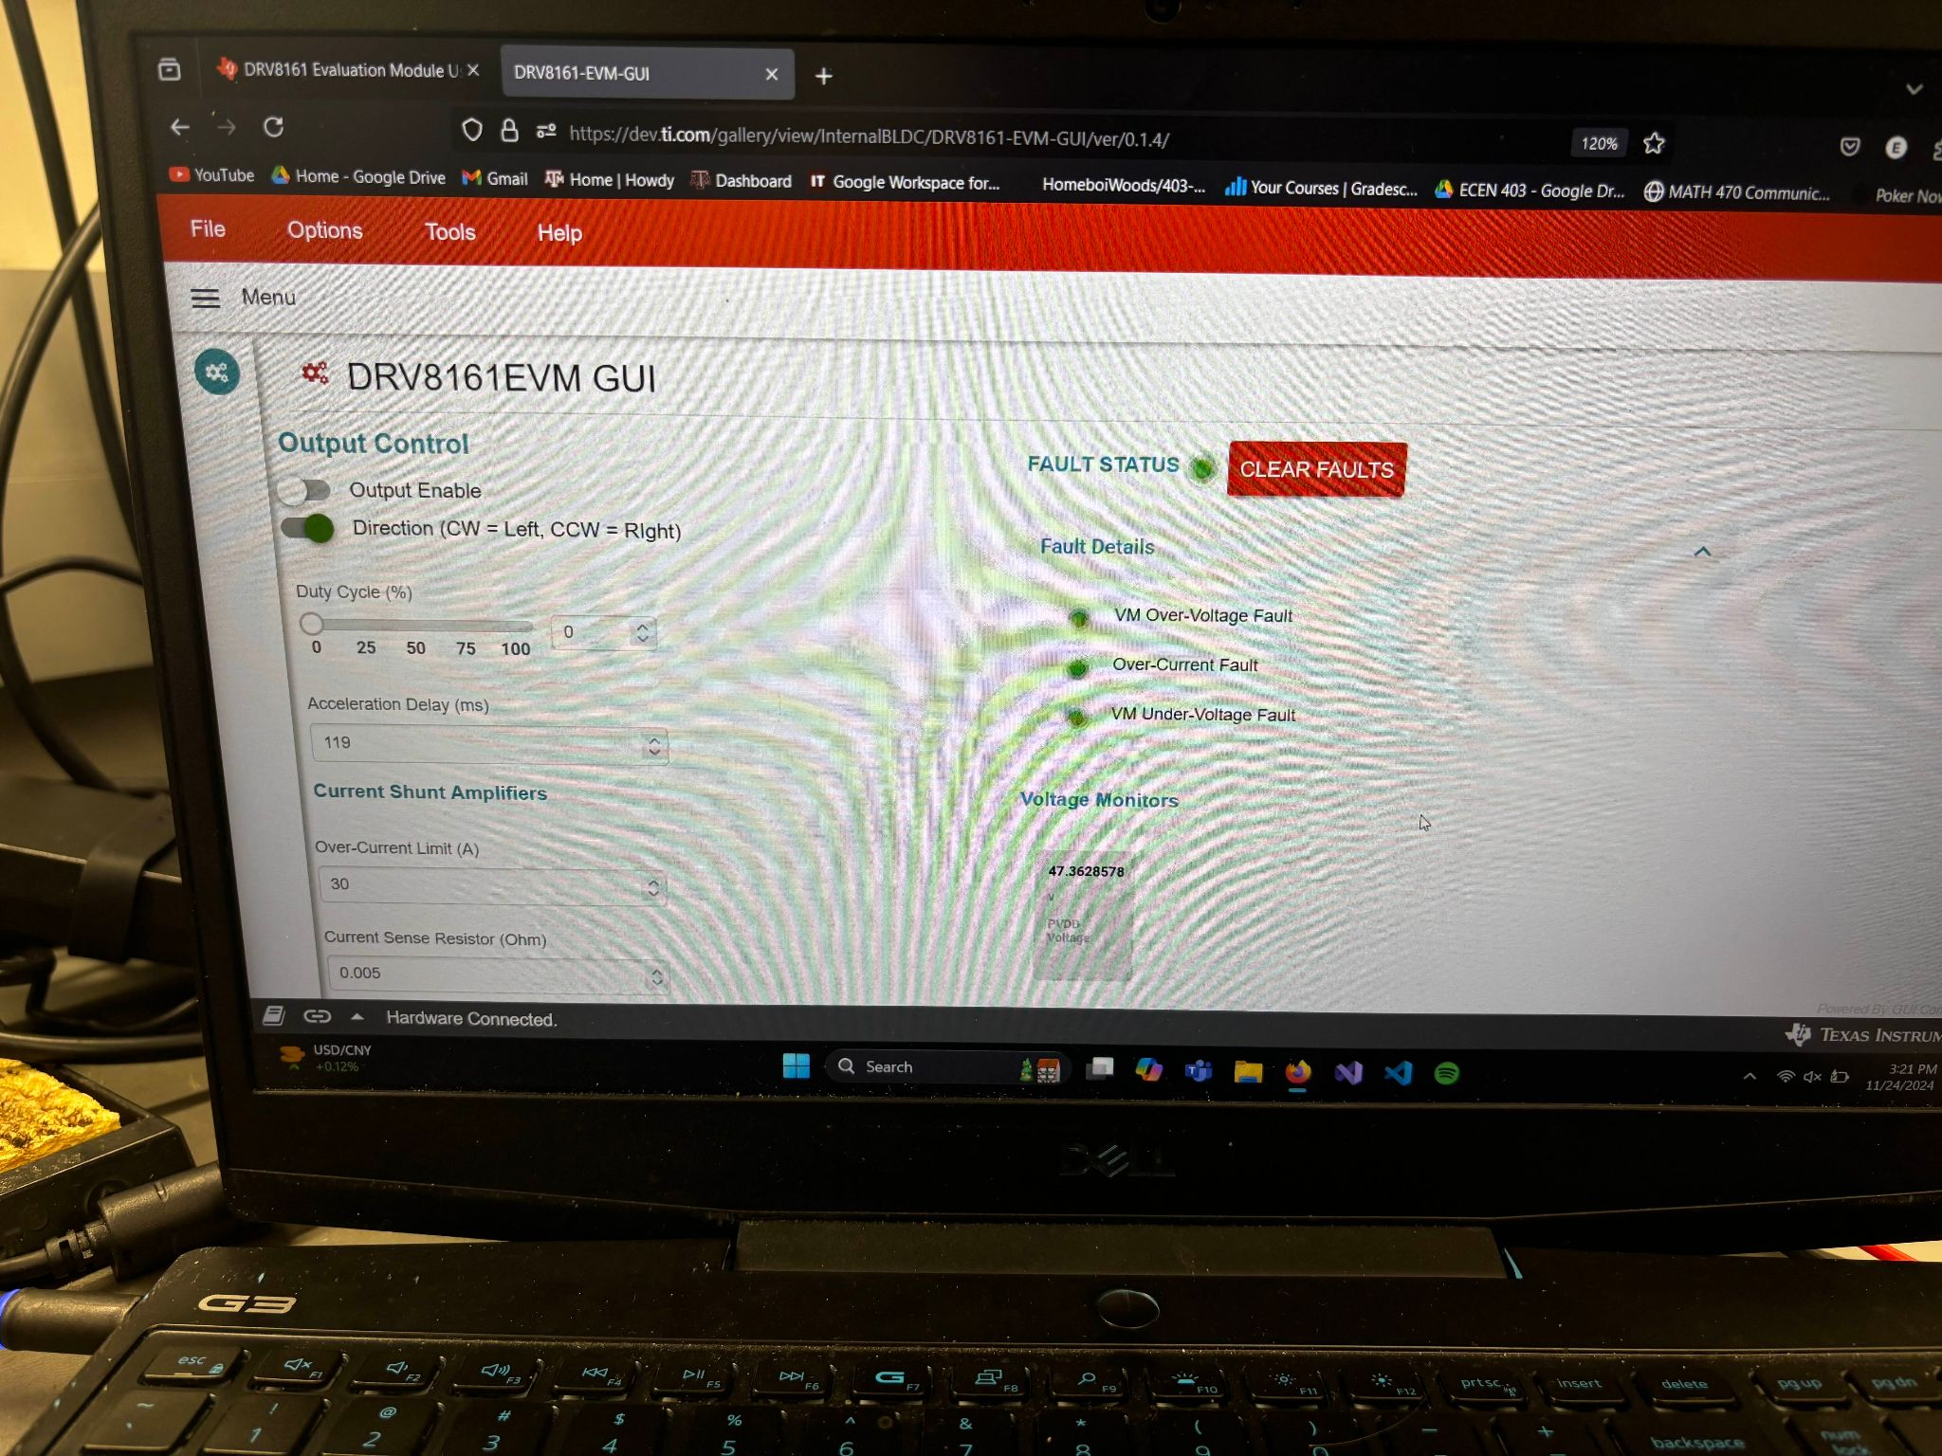

*Figure 12: GUI Interface Showing Connection to 48V PVDD with Output Disabled*

Once connected, the DRV8161 EVM is successfully linked to the Launchpad and ready to enable its output to produce the three-phase signals required for motor operation. However, while the EVM can generate these signals, we are unable to use it to spin a motor directly due to the design of Board A.

Although Board A includes terminals capable of routing all three-phase signals to the motor connector, this setup is incompatible with the motor driver already present on Board A. Since the motor driver circuit is powered through the board's power supply, it interferes with the output at one of the terminals used to route a phase signal. As a result, the motor cannot be properly connected or controlled via Board A when paired with the EVM.

Instead, validation is performed by comparing the phase output voltages at the EVM's phase terminals with those generated by our PCBs. By measuring and analyzing these outputs, we can confirm the functionality of our design. Below are the results of measuring the phase output terminals for each respective phase.

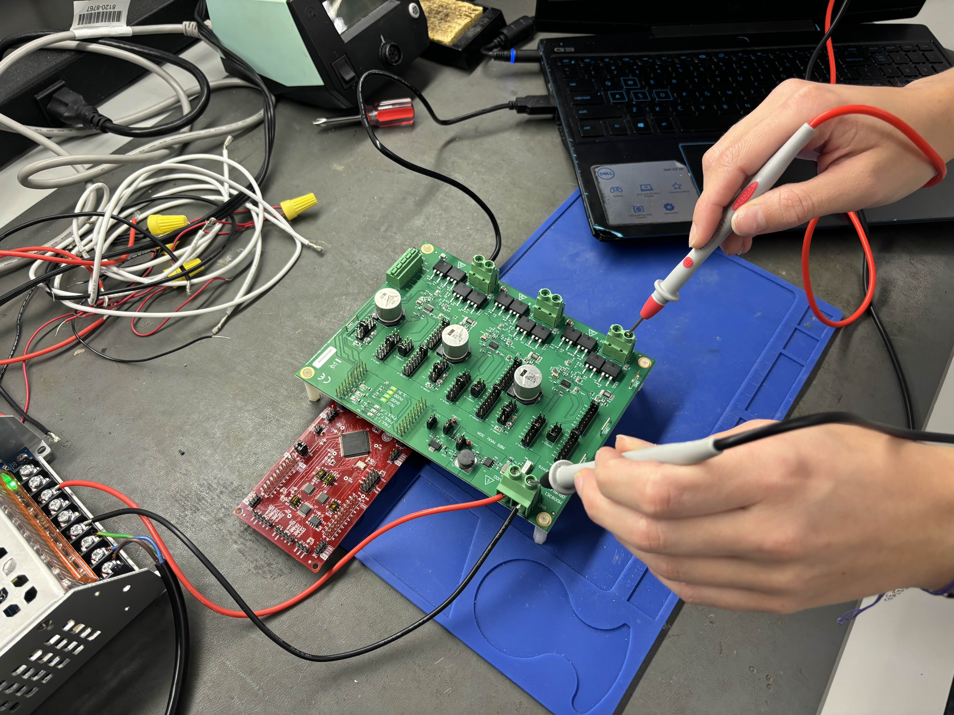

*Figure 13: Measuring the Phase Output Terminal on the DRV8161 EVM*

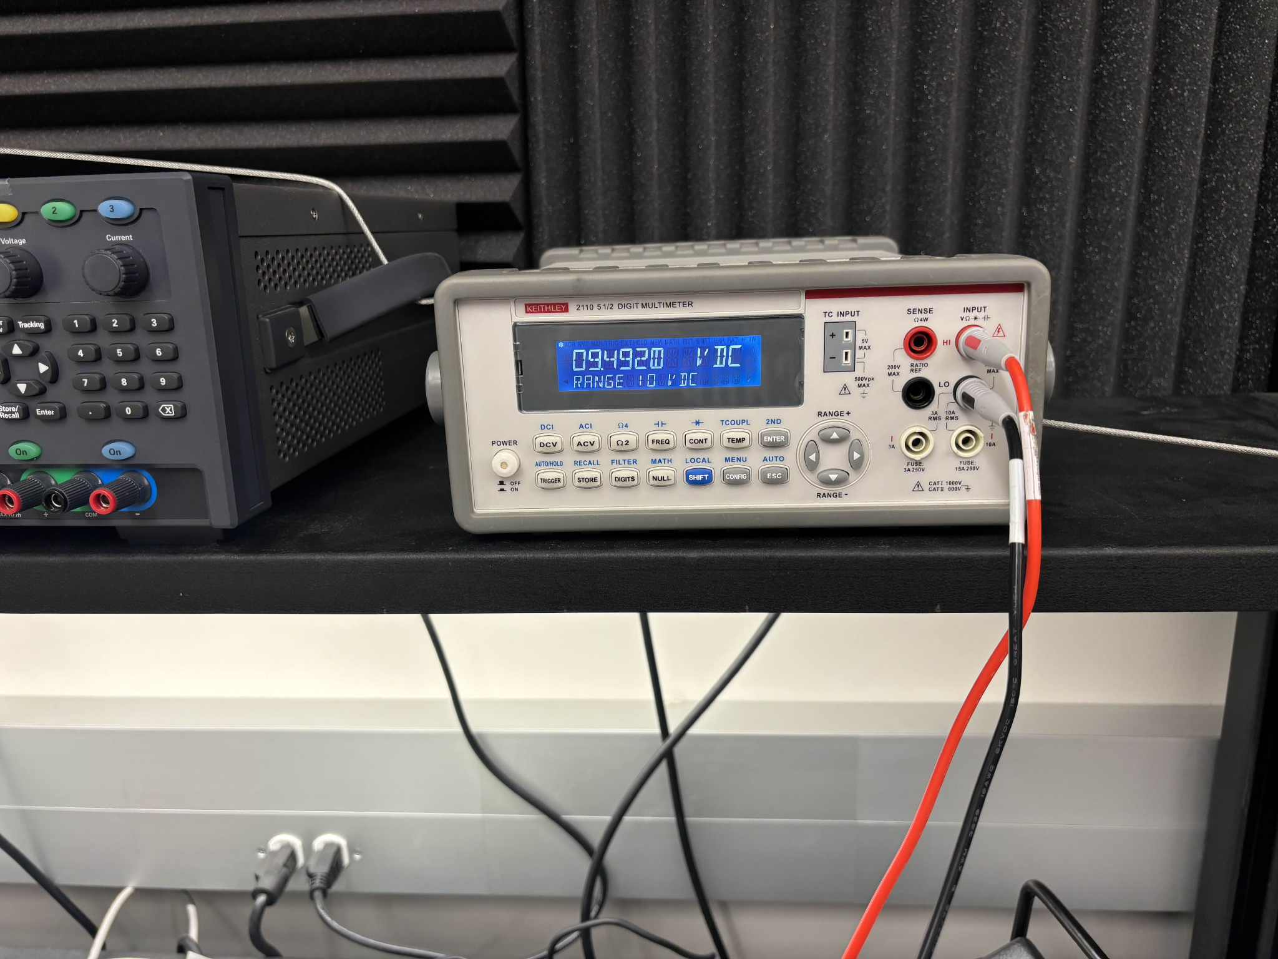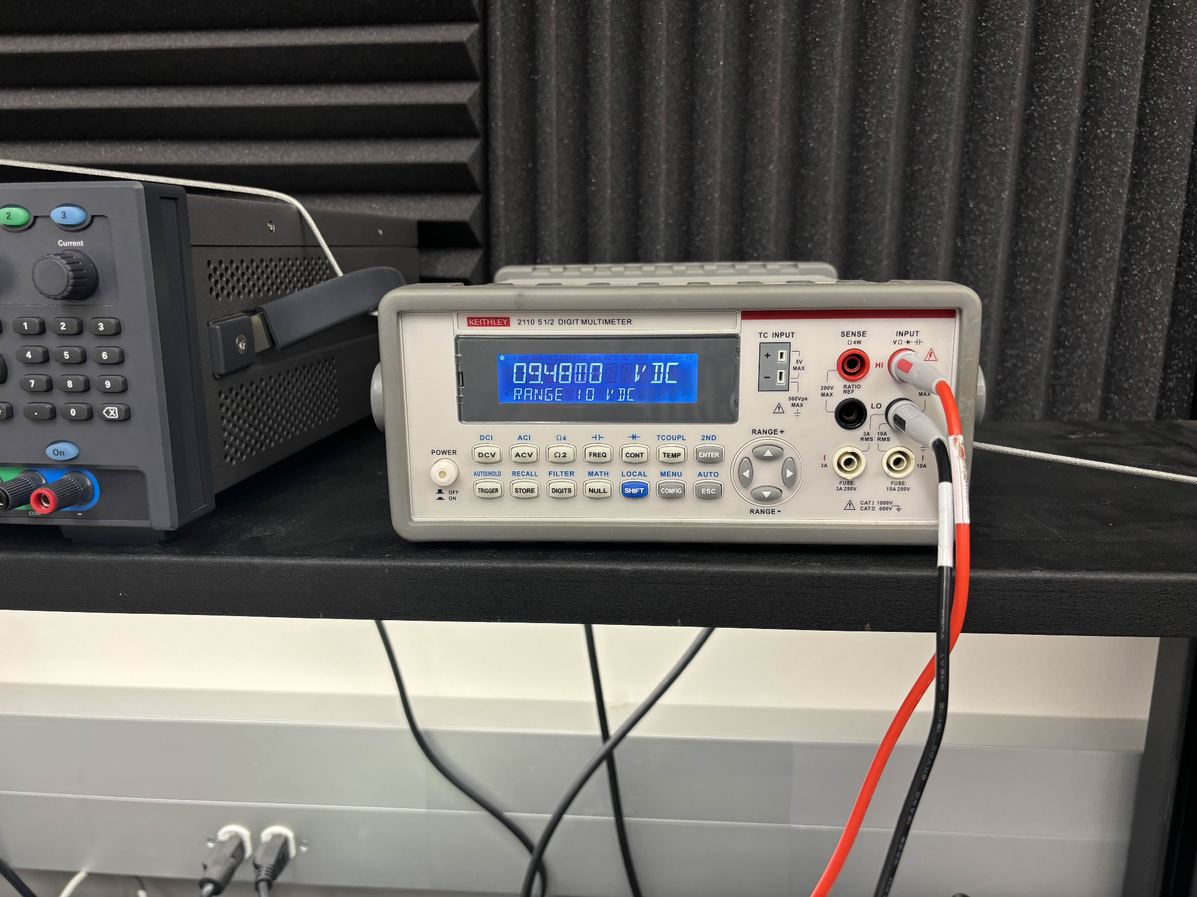

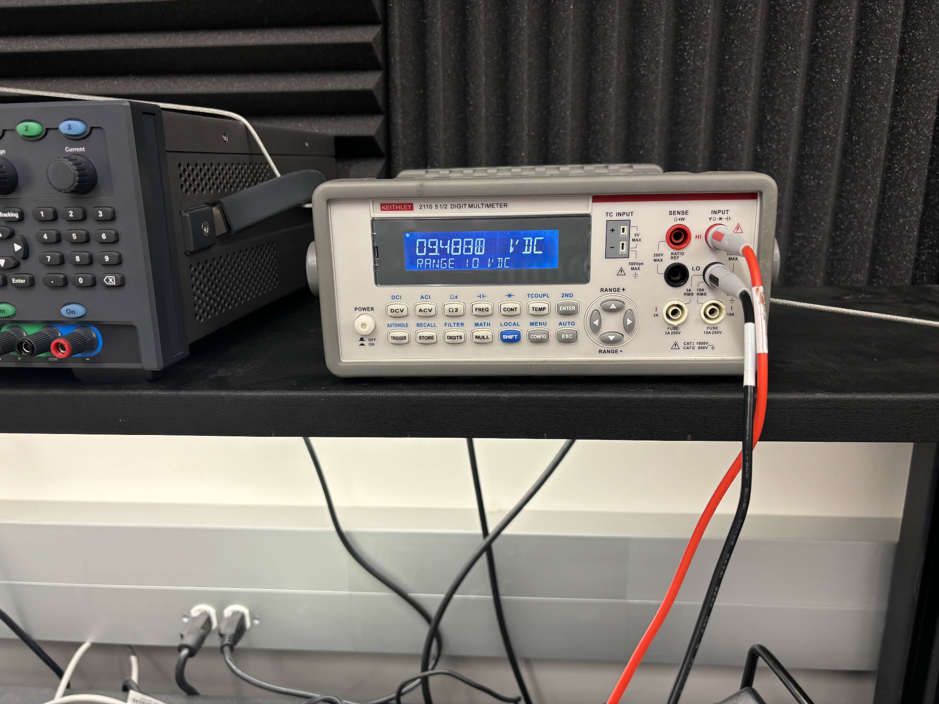

*Figure 14: Phase Voltage Outputs on Terminals A, B, and C (Respectively)*

As seen in Figure 14, the three-phase output terminals of the DRV8161 EVM measure approximately 9.48 Volts. This voltage serves as the benchmark for validating the outputs of our PCB system. To begin testing the three PCBs, the boards are connected as shown in Figure 15 below.

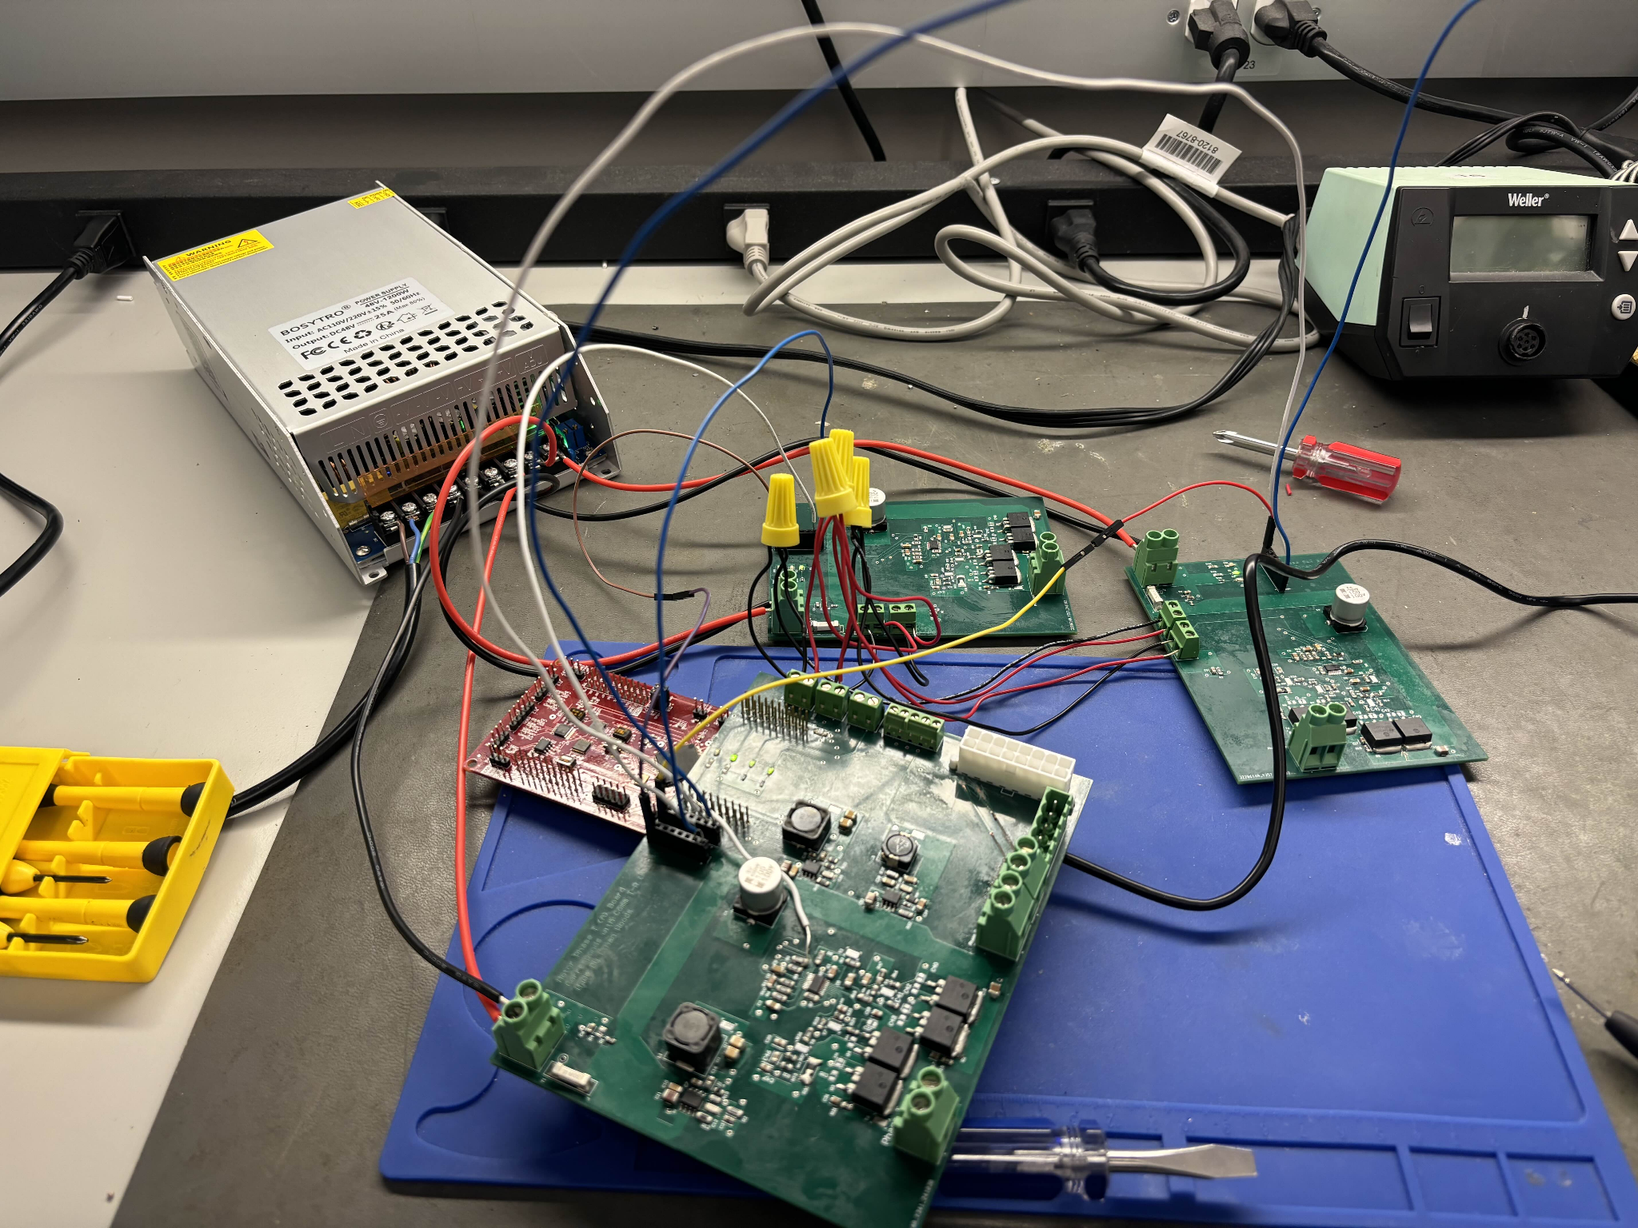

*Figure 15: Created PCBs All Wired Together Without Motor and Phases Connected*

In this setup, all the boards are powered by the 48V power supply, and the necessary input signals for generating the phases are routed accordingly. However, as depicted in Figure 15, the motor and phase signal connections to Board A are not included in this particular configuration.

Earlier in the day, during an initial test with the motor and phase wires connected, enabling the output via the GUI resulted in a trace on Board A burning out instantly. Despite debugging and reattempting, the same issue occurred a second time. The damaged trace was subsequently repaired with a replacement wire, as shown in the previously referenced Figure 7 (denoted by the star).

Given this outcome, testing now focuses on measuring the voltage outputs at the phase terminals and verifying the functionality of the voltage step-down circuits. The results of these measurements are detailed in the following figures:

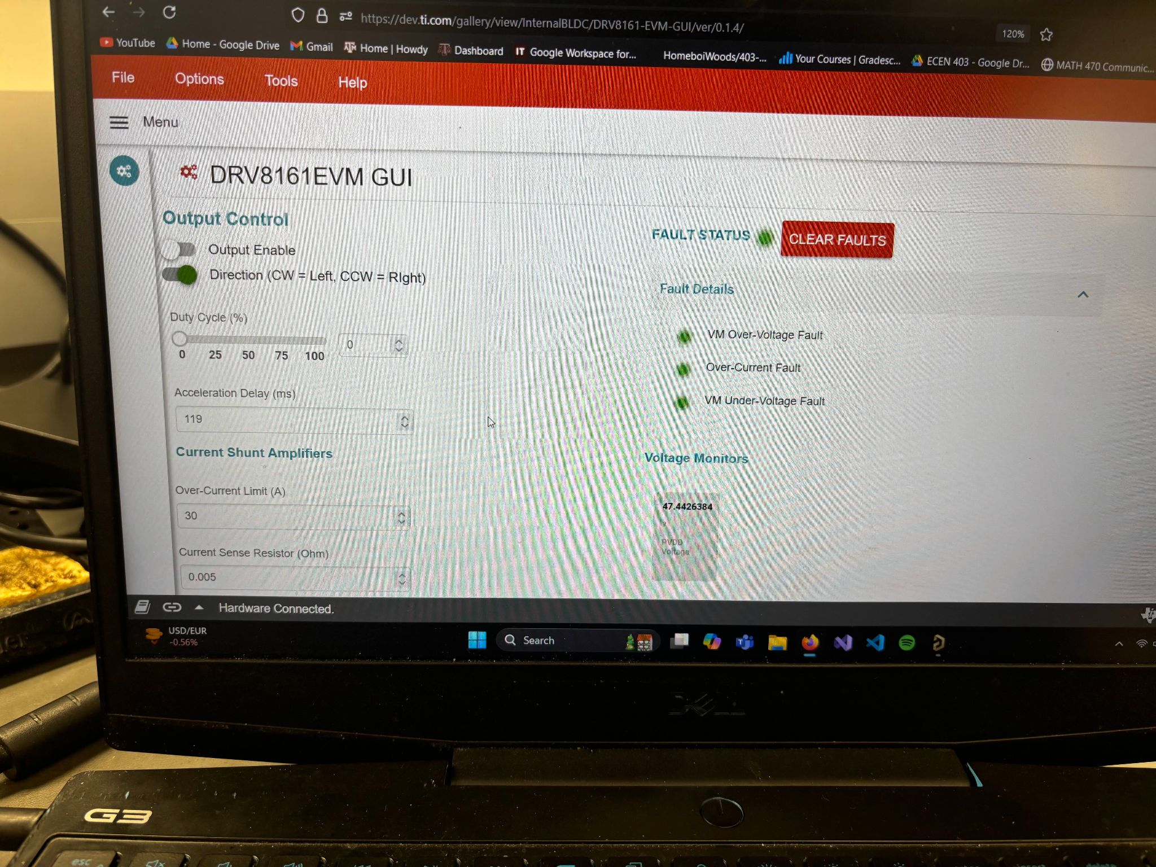

*Figure 16: Successful Connection to the GUI Showing 48V PVDD*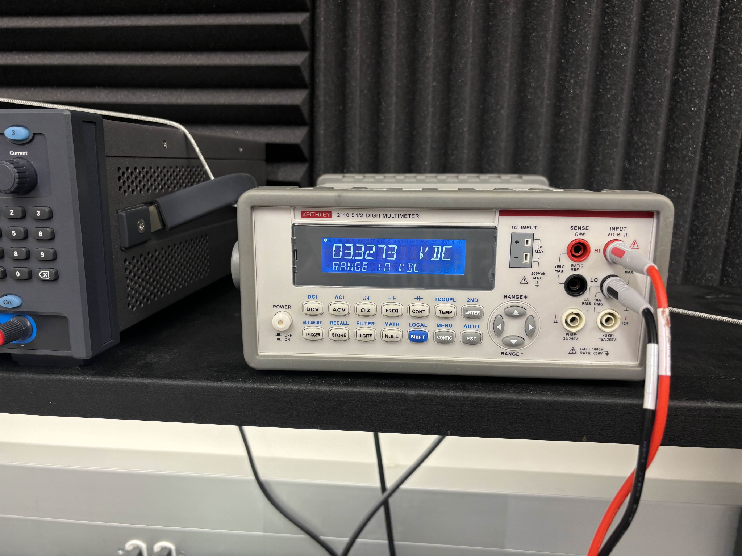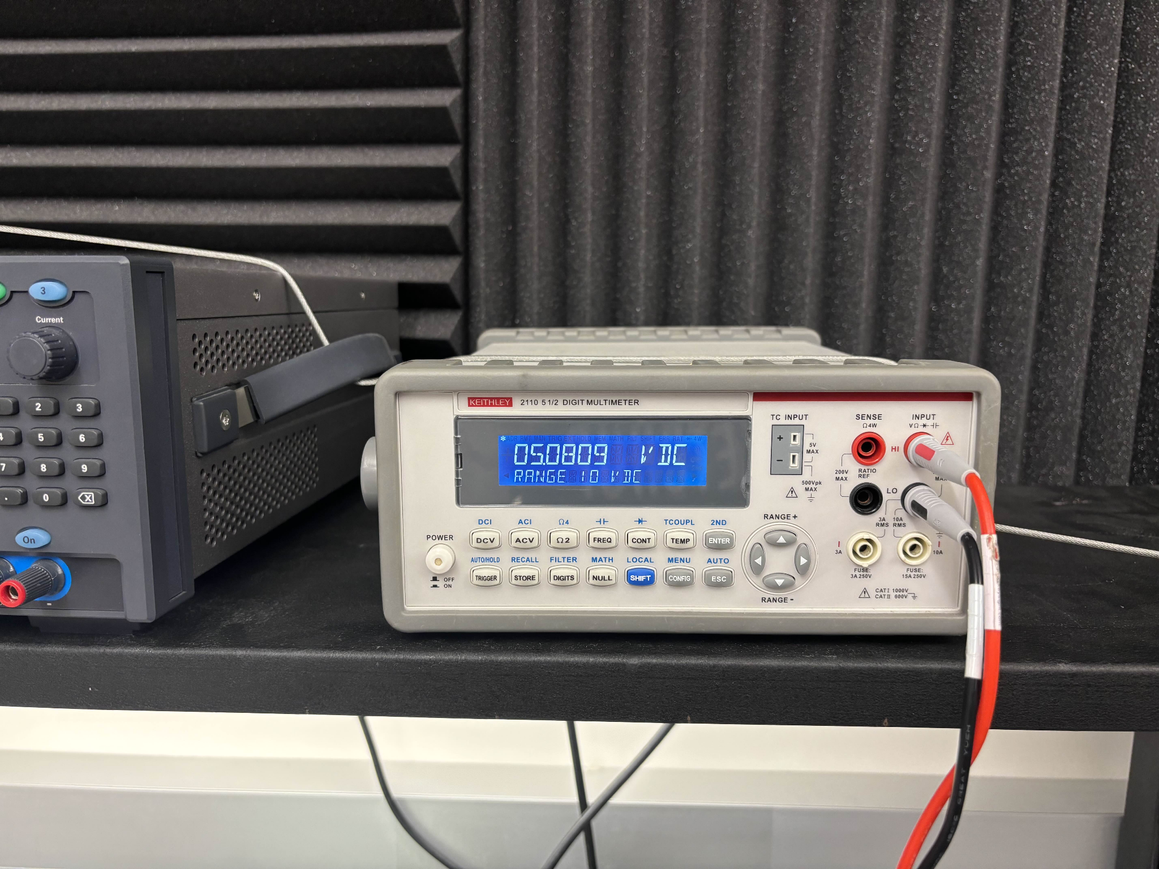

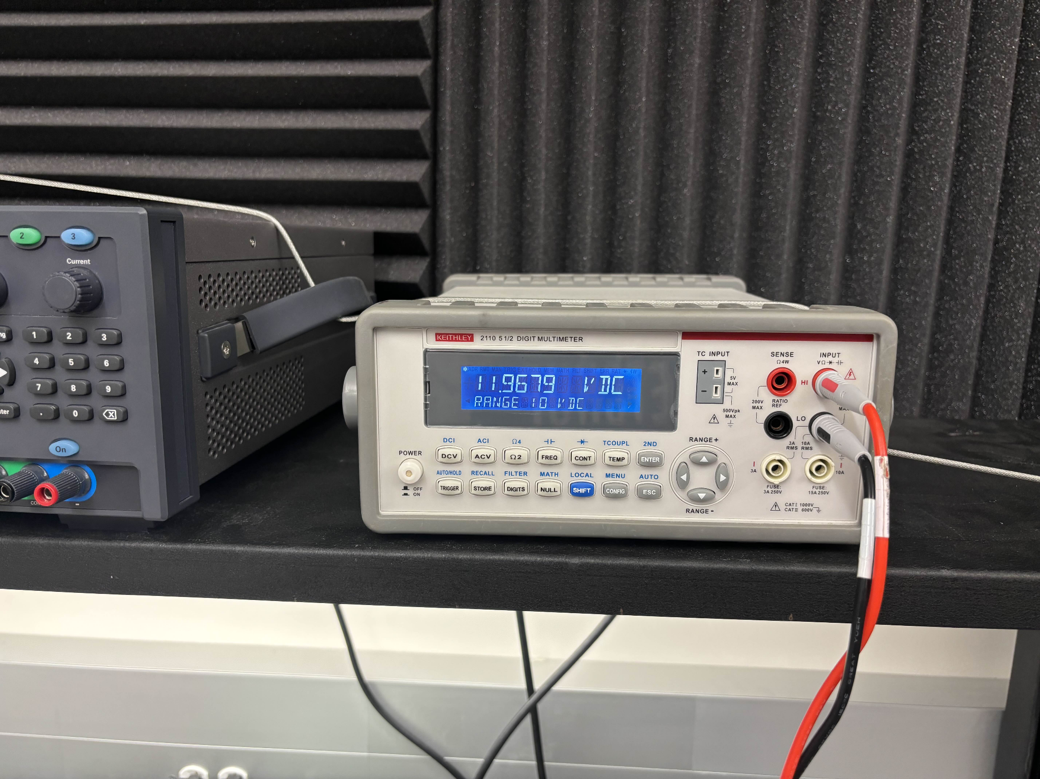

*Figure 17: Output of Each Voltage Step-Down Circuit (3.3V, 5V, and 12V Respectively)*

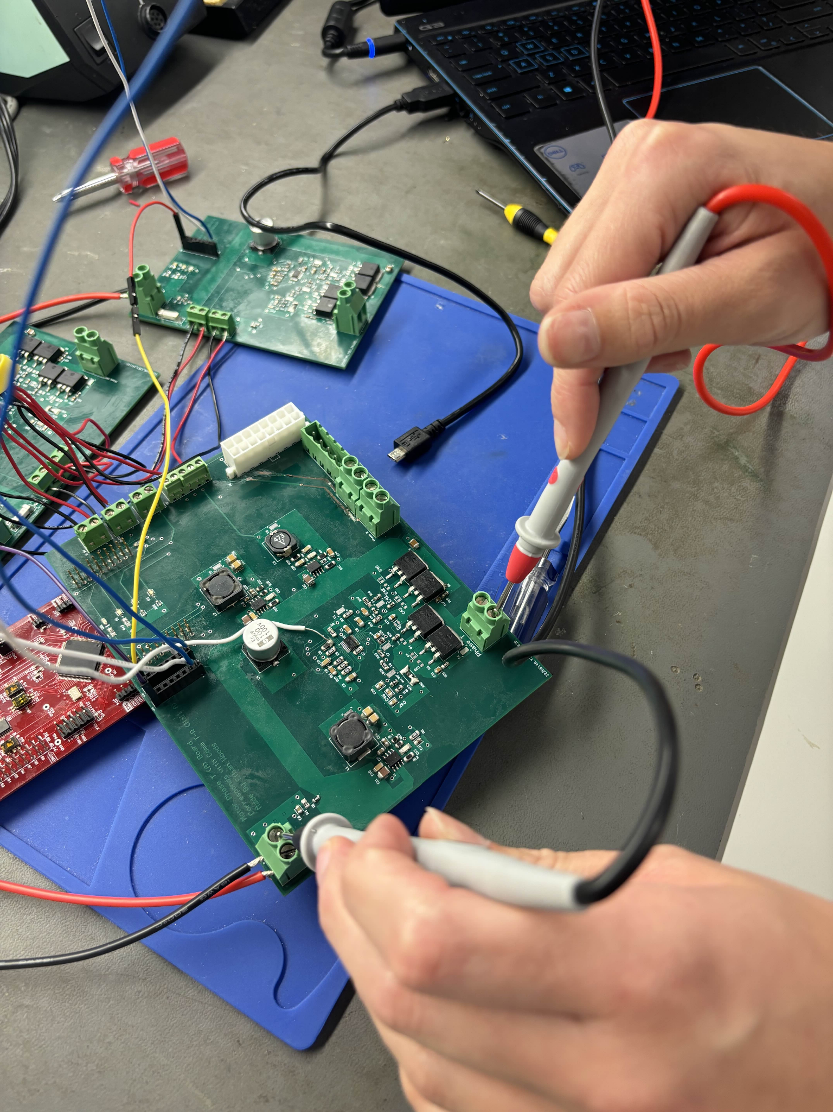

*Figure 18: Measuring the Phase Output Terminal on Phase A Board (Same for B and C)*

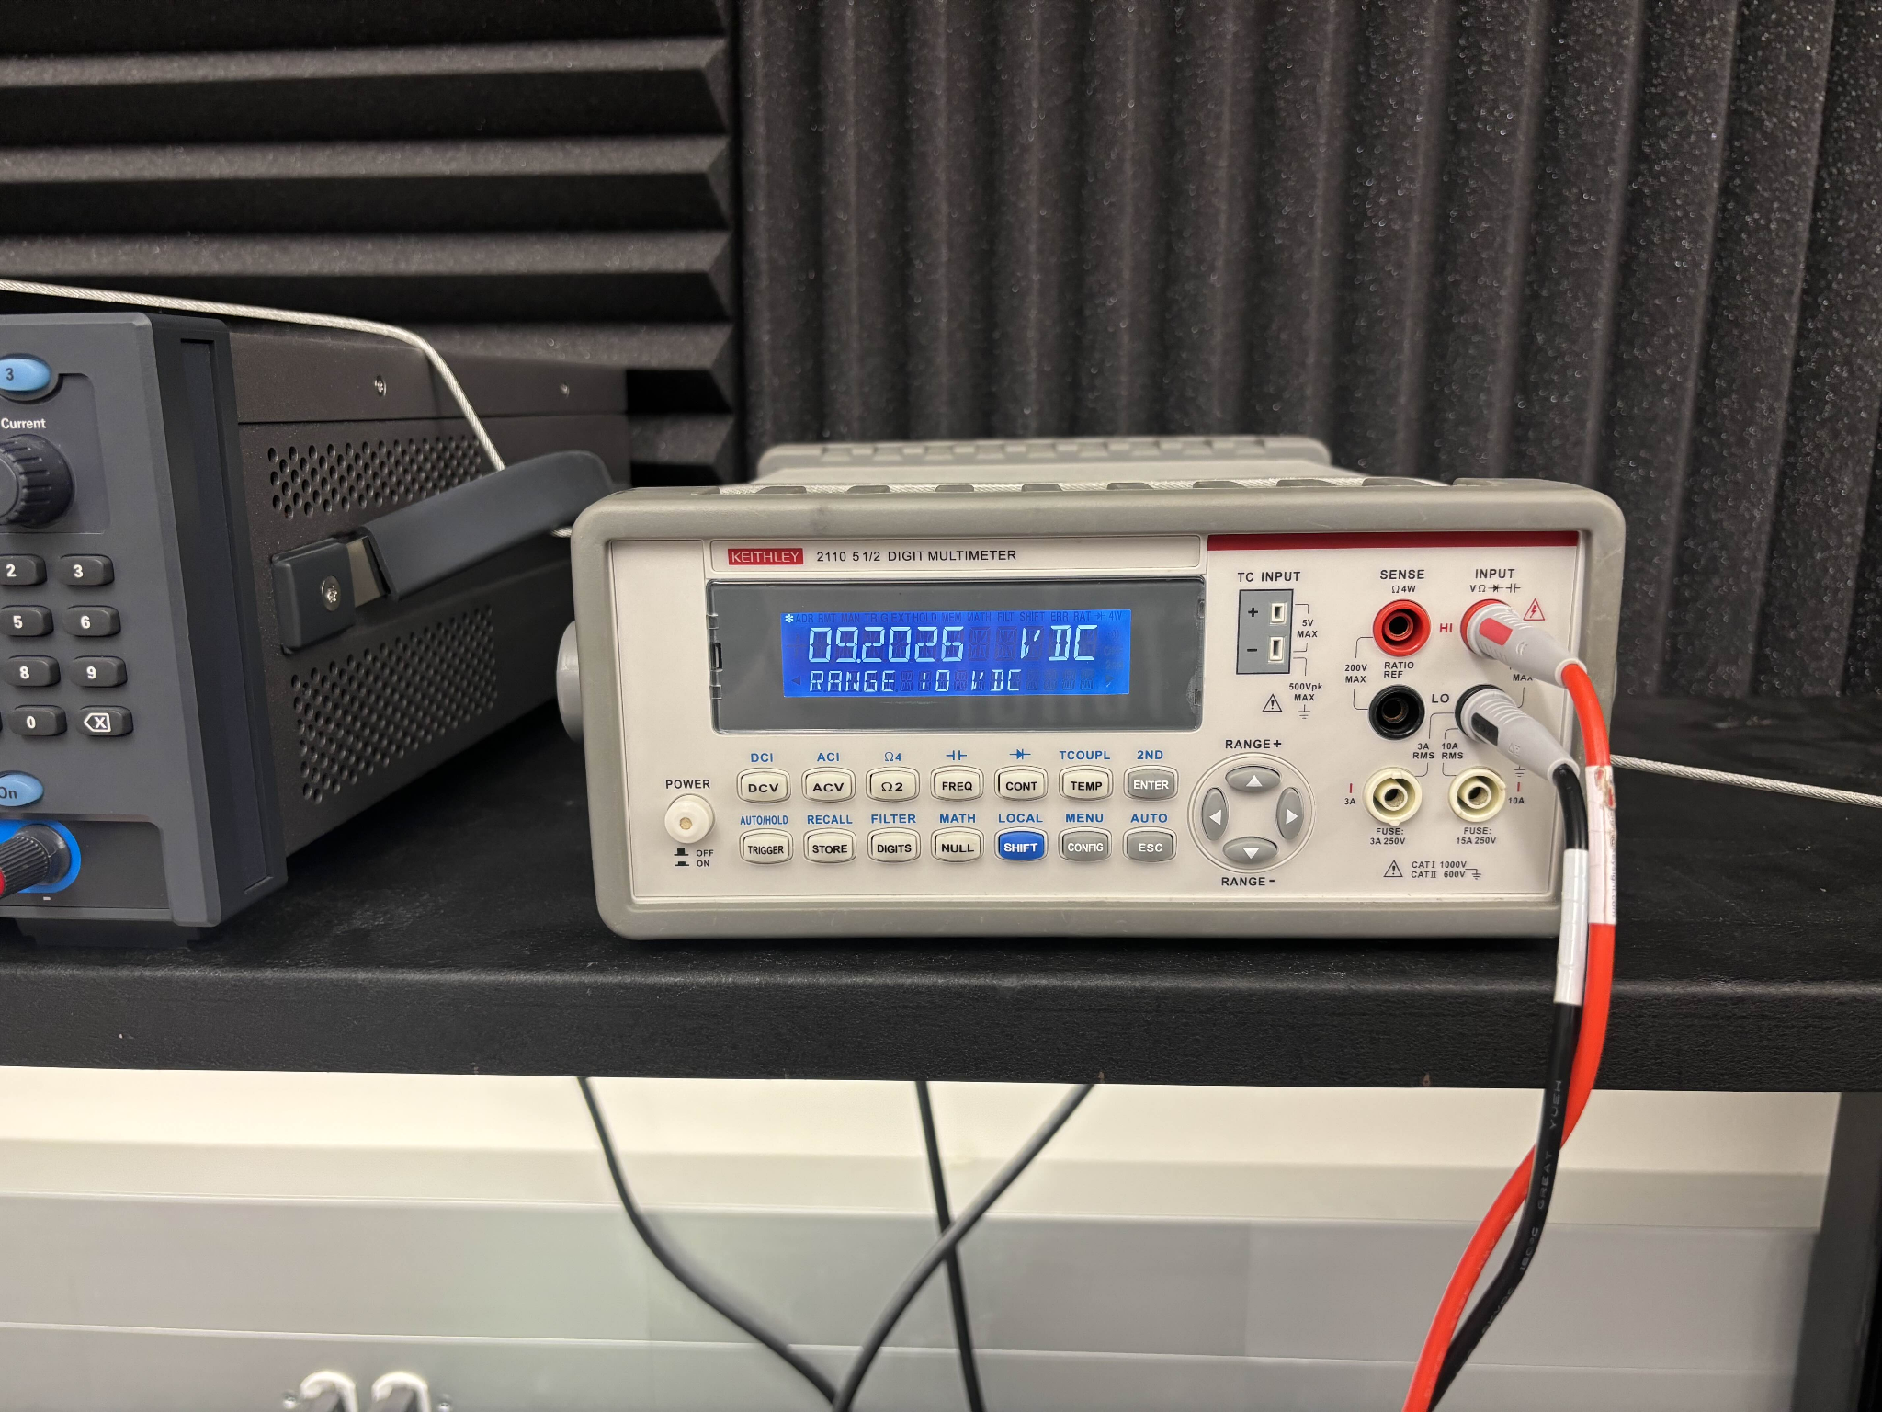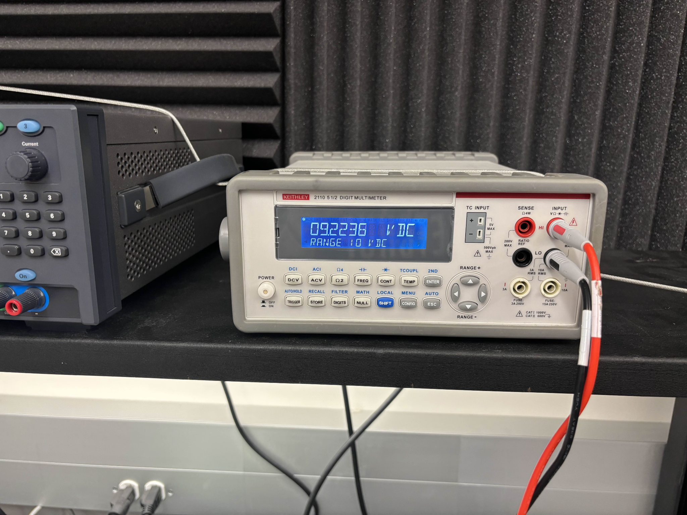

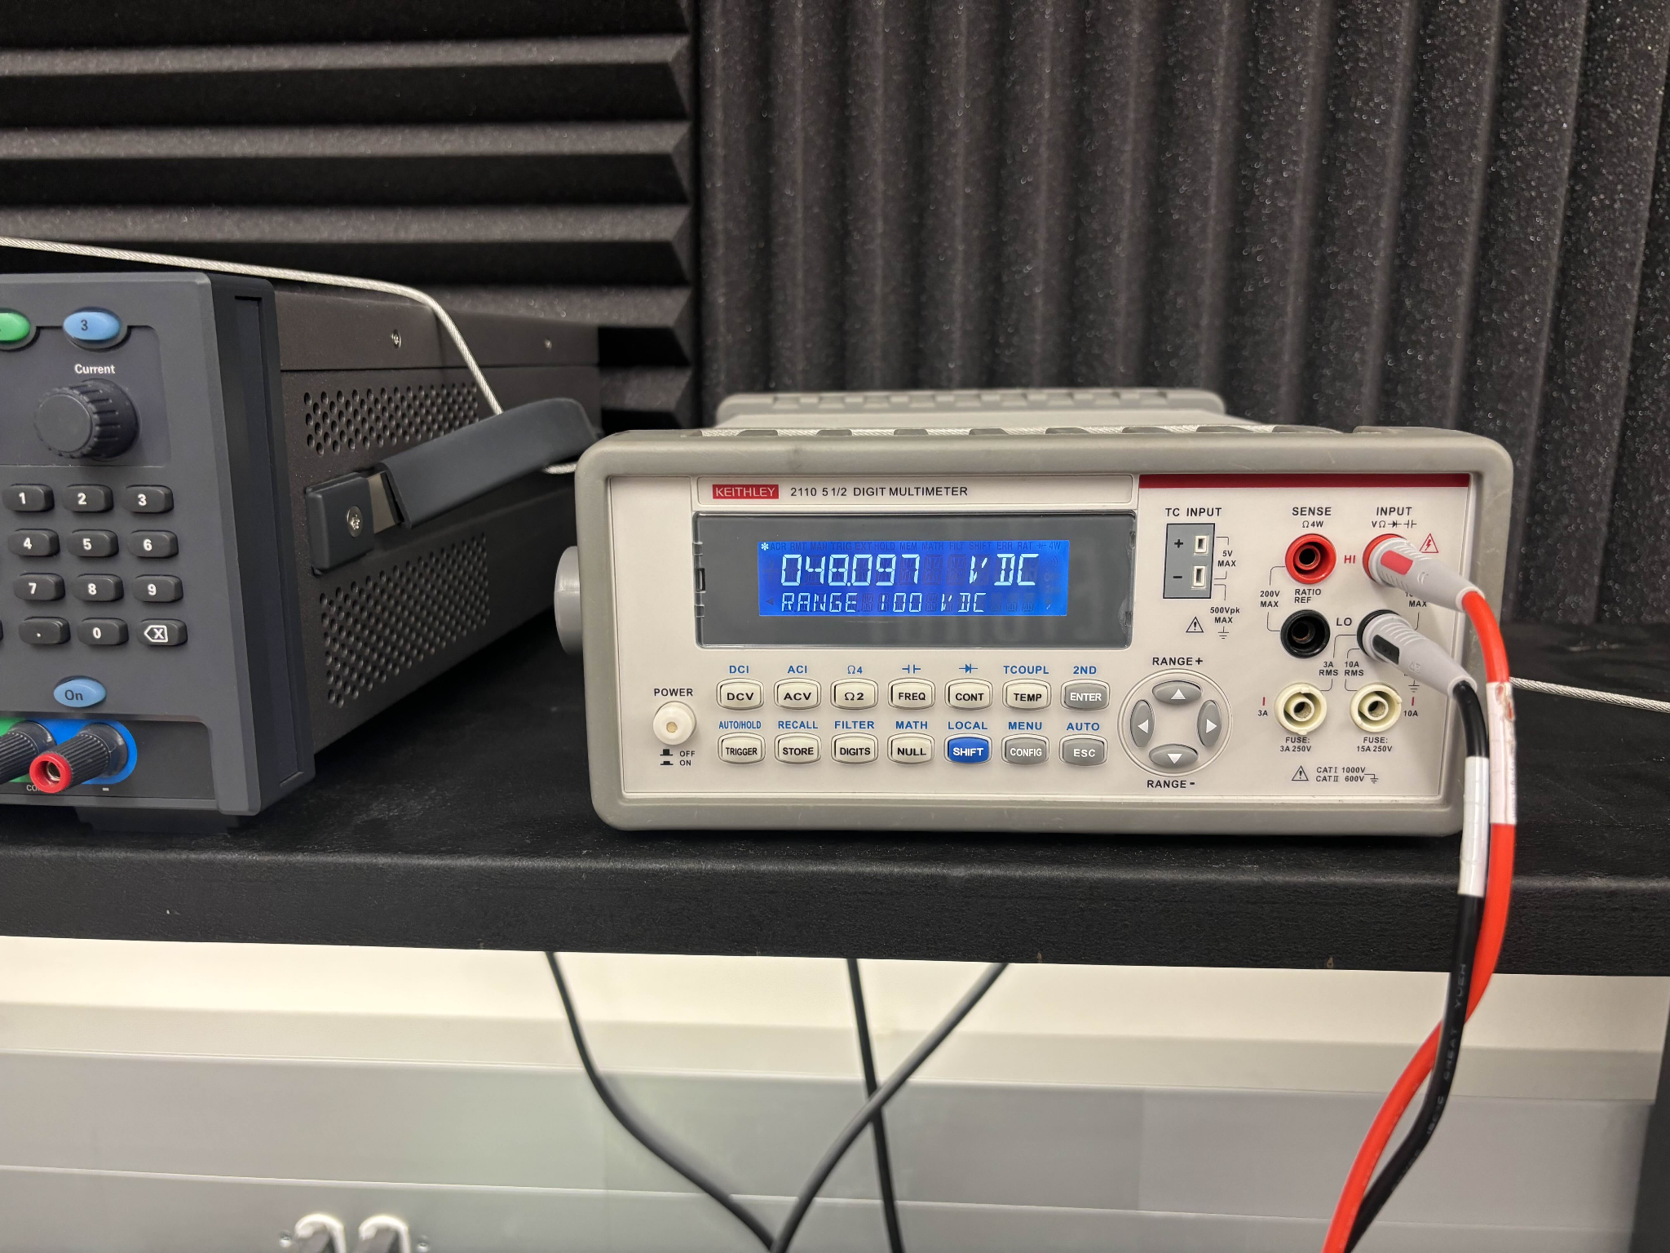

*Figure 19: Phase Voltage Output on Each Board (A, B, C) Respectively*

In conclusion, while the testing of the PCB system did not achieve the desired outcome of motor movement, significant progress was made in understanding and isolating the issues. The measurement results confirmed that two of the phase terminals (A and B) were functioning as expected, producing voltages near 9.48V. However, the issue with Board C, where one of the terminals was producing an unexpected 48V, highlighted a short to the input voltage. This has been traced back to a potential fault with the DRV8161 chip, which will be further investigated.

Given the importance of having all three motor driver circuits fully functional, Board C's failure prevents the successful operation of the 3-phase BLDC motor. However, with plans for continued work over the winter break, efforts will focus on reworking Board C and potentially creating an additional board to ensure proper motor operation. Though this semester’s testing did not achieve the final goal, it laid the critical groundwork needed for future progress.

Looking ahead, further testing and refinement will be necessary to achieve full motor movement and integration with other subsystems in ECEN 404. The experience gained this semester will prove invaluable as we continue to improve the design, and the validation of the system’s objectives will be a crucial next step in confirming the success of the overall project.

***2.3. Subsystem Validation***

The ultimate goal of validating this subsystem was to achieve movement in a 3-Phase BLDC Motor using a system of custom PCBs connected to the C2000 Launchpad. While motor movement was not achieved this semester due to a short on one of the boards, the validation focuses on proving that generating one correct phase signal demonstrates the feasibility of producing the other two in the same manner. This reasoning underscores the importance of achieving even partial functionality, as it lays the groundwork for future success.

Given the complexity of this subsystem, involving over 200 components (primarily 0805-sized) across multiple PCBs, there were many opportunities for small errors to propagate and affect overall performance. Each board required meticulous attention to detail, from schematic design to fabrication and testing, to ensure proper operation. Therefore, the validation approach breaks down the subsystem into measurable, incremental goals to assess the progress made and identify areas for improvement.

Below is the validation plan, highlighting the specific criteria used to evaluate each aspect of the subsystem and how it aligns with the project’s objectives:

| **Test Deliverable** | **Achieved Goal?** | **Why/How?** | **Supporting Figure(s)** |
| --- | --- | --- | --- |
| **Schematic and PCB Design** | Yes | Created system of 3 PCBs to work to spin a motor | Figures 7, 8, 9 |
| **PWM Phase Output from Motor Drivers** | Yes | Achieved an output voltage similar to our benchmark voltage on the EVM | Figure 19 |
| **Motor Movement** | No | Short on Board C prevented complete integration and motor movement | N/A |
| **Precise Motor Control** | No | With no motor movement, no control could be done | N/A |
| **All Motor Movement** | No | No motor movement generated | N/A |

*Table 5: Motor Driver Subsystem Validation Plan Goals*

***2.4. Subsystem Conclusion***

While motor movement remains unachieved this semester, significant groundwork has been laid to make it an attainable goal in the near future. This is a critical step for the Collaborative Robot, as motor-driven movement is central to its functionality. Despite this gap, the process and implementation described show that motor movement is within reach. The priority for the winter break will be to repair or produce a new board to replace the malfunctioning Board C. With a functioning Board C—or an alternative board designed to fulfill its role—motor movement should be straightforward, requiring only connection to the GUI and Launchpad.

Beyond this immediate task, the Motor/Motor Movement subsystem is well-positioned to transition into the next phase of integration. The current approach, using three motor drivers to spin a 3-Phase BLDC motor, will remain the foundation moving forward. However, next semester’s design will consolidate the motor driver circuits onto a single main board, which will simplify wiring and reduce the overall complexity of the system. This main board will interface with a dedicated voltage step-down board from the Power Subsystem, streamlining power distribution. Custom connectors for each motor will also ensure proper compatibility and ease of use.

This brings us to a key consideration: complexity. Creating and testing these initial boards, which only include the minimum functionality to generate phase signals, required designing over 200 components. Scaling this approach to accommodate four additional motors would demand an immense amount of time and effort, which is further compounded by the limited resources and lack of mechanical engineering expertise within the team. As a result, there is growing support for simplifying the collaborative robot into a crane-like design. This shift would reduce the motor count from four to two (plus a claw), cutting the number of required boards in half and allowing the team to focus on optimizing the system’s core functions.

Despite these challenges, the subsystem’s achievements this semester provide a solid foundation for future work. With phase signals successfully generated and the boards communicating effectively with the MCU subsystem, integration is already underway. Next semester, the focus will include refining the PWM signals needed to drive the motor driver circuits, collaborating with the Power Subsystem to route external voltage levels directly onto the main board, and enhancing interaction with the Wireless Connectivity Subsystem for mobile application control. This forward-looking plan ensures that, with continued effort, the Motor/Motor Movement subsystem will achieve full functionality and play a pivotal role in the Collaborative Robot’s success.

# MCU/Processing Subsystem - Adrian Guzman

## 3.1. Subsystem Introduction

The MCU/Processing subsystem is designed to receive input signals from the mobile application subsystem and generate PWM waveforms that will be used by the motor driver subsystem to control a motor. This subsystem plays a major role in supporting the goal of achieving a fully functional Collaborative Robot (cobot). The subsystem utilizes the TMS320F280049C microcontroller from Texas Instruments’ C2000 family of real-time control MCUs. The power subsystem supplies the necessary power to the MCU to facilitate the completion of tasks. The MCU subsystem has been designed to incorporate compatibility and integration to other subsystems. The required deliverables of this subsystem have been accomplished by adhering to the execution and validation plan. Furthermore, the subsystem was thoroughly tested in the lab to ensure the necessary signals can be received and generated to achieve the end project goal. The following documentation provides a detailed breakdown as to what has been accomplished.

## 3.2. Subsystem Details

### 3.2.1 Subsystem Block Diagram

The following figure presents a high level block diagram for the MCU/Processing Subsystem, which is capable of receiving signals from the ESP-32 and generating PWM signals for motor control.

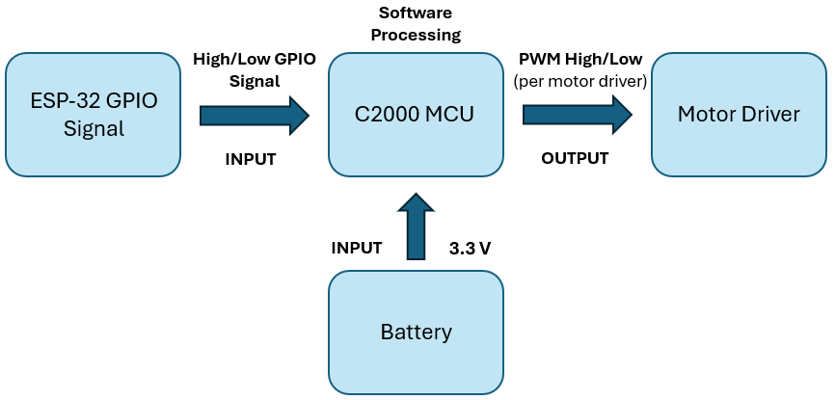

*Figure 20: MCU/Processing Block Diagram*

The MCU/Processing subsystem utilizes the TMS320F280049C MCU, which features a variety of peripherals such as pulse-width modulation (PWM) for motor control and a large quantity of General-Purpose Input/Output (GPIO) pins. The GPIO pins will support the communication between the C2000 and the ESP-32 within the mobile application subsystem.

The mobile application subsystem includes a mobile app with a game style like controller. When a button is pressed, a GPIO pin on the ESP-32 shall change from low to high. The C2000 will detect this input and generate the necessary PWM signals. These PWM signals will be sent to the DRV816x motor drivers to rotate a Brushless DC motor (BLDC).

### 3.2.2. PCB Schematic Design

The primary objective for the MCU/Processing subsystem was to design a PCB that enables functionality of the MCU, including power to the MCU, programming via JTAG, generating PWM signals, establishing communication with external devices like the ESP-32, and verifying GPIO functionality. Key features of the MCU include its 3.3V operating voltage, 16 ePWM channels, and 40 GPIO pins.

The PCB was built with reference from the C2000 Launchpad development board, an evaluation board that TI created to incorporate the TMS320F280049C MCU for developmental purposes. The following sections of the document detail the design of the PCB which focuses on GPIO allocation, Power, Programming, and Miscellaneous parts.

#### 3.2.2.1. General-Purpose Input/Output (GPIO)

The figure below details the GPIO allocation within the PCB schematic.

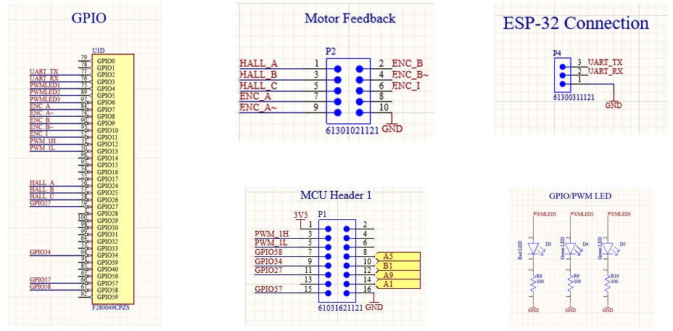

*Figure 21: GPIO PCB Schematic*

The GPIO pins contain specific features, pins with the ability to generate PWM signals and additional GPIO functionality were considered when deciding what pins to implement to headers. In the next PCB revision, all the GPIO pins from the MCU will be routed to 2.54mm x 2.54mm headers. The first 16x pins (GPIO0-GPIO15) include the 16x ePWM modules and will be reserved solely for PWM generation. The MCU contains 35 accessible GPIO pins, 19 of which are used in the current PCB design. These pins allow testing of the ePWM modules and generic input/output writing to GPIOs.

In the above figure, GPIO pins 2 - 13 were used to develop PWM signals for the motor driver subsystem. Additionally, these pins were used to toggle LEDs, showcasing GPIO functionality and timing, as well as rotate servo and stepper motors. The additional GPIO pins were used to connect the ESP-32 and C2000 to communicate through high/low signal generation.

One BLDC motor requires three motor drivers, one motor driver for each phase of the motor. Each motor driver will receive a high and low PWM signal, a fault check signal, and reference voltage. The below table showcases the necessary signals to be sent from the MCU to three motor drivers. The signals include PWM generation, fault check, and reference voltage.

| **Pin Number** | **Signal Name** | **Description** | **Purpose** |
| --- | --- | --- | --- |
| 79 | GPIO0 | ePWM-1 Output A | High PWM |
| 78 | GPIO1 | ePWM-1 Output B | Low PWM |
| 77 | GPIO2 | ePWM-2 Output A | High PWM |
| 76 | GPIO3 | ePWM-2 Output B | Low PWM |
| 75 | GPIO4 | ePWM-3 Output A | High PWM |
| 89 | GPIO5 | ePWM-3 Output B | Low PWM |
| 98 | GPIO30 | General I/O 30 | Fault Check |
| 99 | GPIO31 | General I/O 31 | Fault Check |
| 64 | GPIO32 | General I/O 32 | Fault Check |
| 23 | A0 | DAC-A Output | Reference Voltage |
| - | 3V3 | Reference Voltage | Reference Voltage |

*Table 6: C2000 Pinout (Signals sent to 3x Motor Drivers)*

The below table dictates the pinout between the C2000 and ESP-32. Although testing was not performed with these exact GPIO pins, other general-purpose pins were used. This table is to map out the future of what will be required. The purpose of these connections is to establish communication between the ESP-32 and C2000. The ESP-32 will toggle pins high or low based on user input to the mobile application. The C2000 will read input on the GPIO pins below to determine the desired movement from the user and generate the subsequent PWM signals.

| **Pin Number** | **Signal Name** | **Description** | **Purpose** |
| --- | --- | --- | --- |
| 56 | GPIO24 | General-Purpose Input Output 24 | UP |
| 57 | GPIO25 | General-Purpose Input Output 25 | DOWN |
| 58 | GPIO26 | General-Purpose Input Output 26 | LEFT |
| 59 | GPIO27 | General-Purpose Input Output 27 | RIGHT |
| 1 | GPIO28 | General-Purpose Input Output 28 | OPEN |
| 100 | GPIO29 | General-Purpose Input Output 29 | CLOSE |

*Table 7: C2000 Pinout for ESP-32 Connectivity*

#### 3.2.2.2. Power

This section details the power design for the MCU. The MCU operates at 3.3V, which is supplied through the terminal block and will allow integration with the power subsystem. To maintain stable voltage, decoupling capacitors on the VDD, VDDA, and VDDIO pins were placed with values of 0.1uF, 10uF, and 2.2uF. Additionally, power indicator LEDs were included to display when the system is powered.

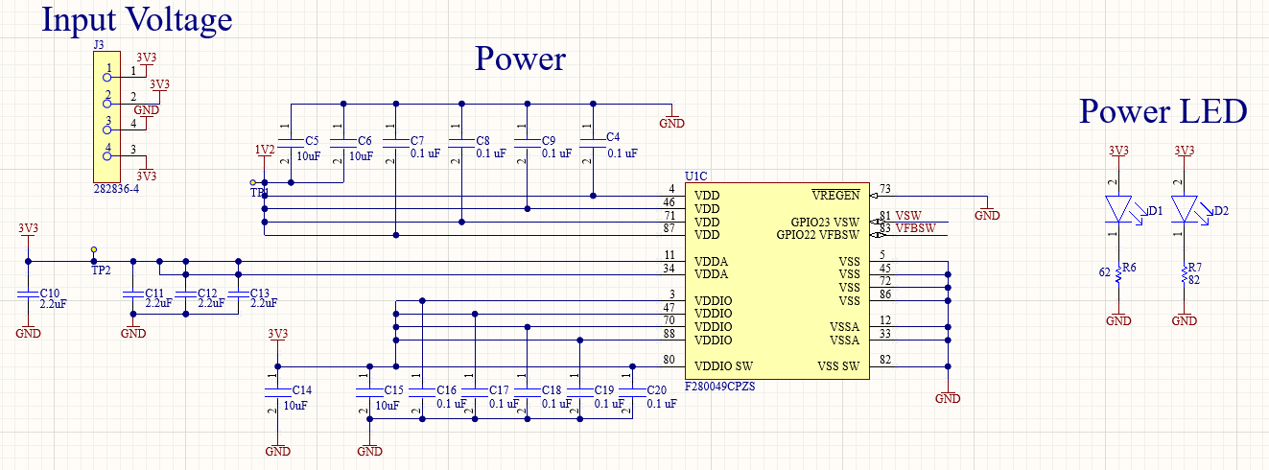

*Figure 22: Power PCB Schematic*

#### 

#### 3.2.2.3. Programming (JTAG)

This section details the schematic design for programming via JTAG. The programming process requires the TMS, TDI, TDO, and TCK signals. Due to sponsor uncertainty and concerns with connectivity to the debug probe, two headers were incorporated into the design: J2 (6 pin 2.54mm x 2.54mm) and J1 (14 pin 1.27mm x 1.27mm). However, J1 was ultimately unused due to connection issues with the XDS-110 debug probe.

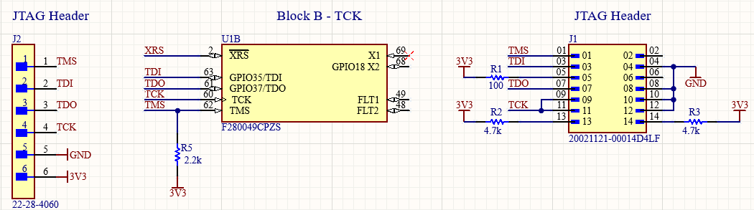

*Figure 23: JTAG Programming PCB Schematic*

**3.2.2.4. Miscellaneous**

This section outlines miscellaneous components of the PCB that were ultimately unused. The figure below highlights the ADC block, reset button, launchpad input, VSW input, and launchpad LED input. Throughout the semester, it became clear that these components were unnecessary and will be removed for the next generation design planned for next semester.

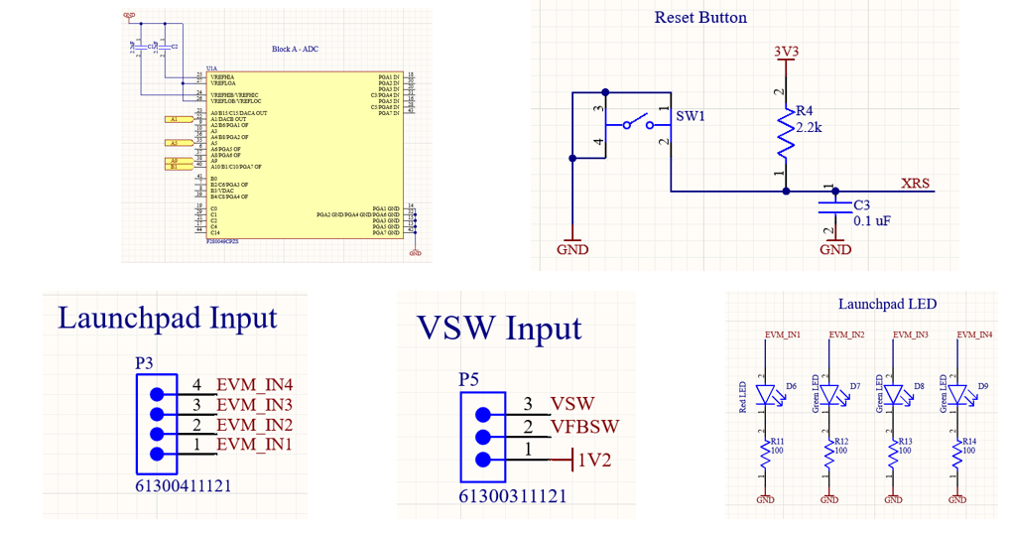

*Figure 24: Miscellaneous PCB Schematic*

### 3.2.3. C2000 Launchpad Development

To become familiar with programming and developing on the TMS320F280049C MCU, the evaluation board was ordered from Texas Instruments. This evaluation board is developed to allow testing with all features of the MCU. Additionally, TI provides a software development kit (SDK) known as C2000Ware that includes a variety of example codes to begin development on the launchpad.

To program the launchpad, TI’s choice of IDE, Code Composer Studio (CCS) was used. After installation of CCS and C2000Ware, setup of the launchpad was completed by ensuring the correct target device, debug probe, and file configuration was selected.

Using C2000Ware, examples such as “led_ex1_blinky” and “epwm_ex13_up_aq” were used to begin development. LED Blinky allowed control of a GPIO pin to toggle an LED on and off. Additionally, within this source file, additional software was developed to further understand the C2000 MCU. This included a program to spin a MicroServo 9g SG90, a program to spin a step motor 28BYJ-48 with a ULN2003 motor driver, and a program to facilitate communication between an ESP-32 and the C2000 MCU. The ePWM example generated square waveforms for viewing on an oscilloscope. This was successfully outputted for viewing and later on, development of different PWM generation code was written.

The figure below shows the LED Blinky example that was performed on the launchpad. The software writes to GPIO34, sets it high for 1000ms (ON), then sets it low for 1000ms (OFF). The script is in an infinite loop and repeats forever. This example was repeated on the created PCB and demonstrated on demo day.

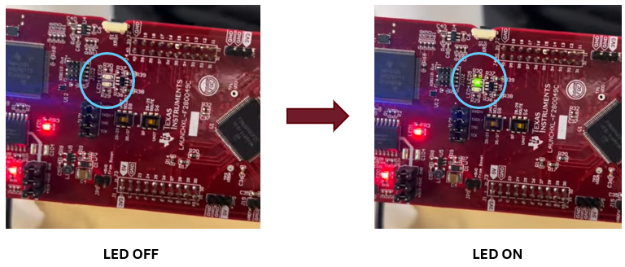

*Figure 25: LED Blinky*

The figure below details another test performed on the launchpad. A MicroServo was used to understand development with GPIO pins. The MicroServo uses 3 pins: GND, 5V, CONTROL. Using GPIO10 as the control, PWM signals were generated ranging 1000μs to 2000μs to rotate the motor from 0° to 180°.

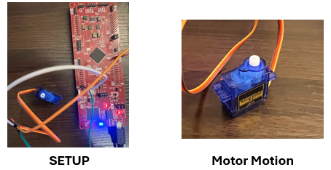

*Figure 26: MicroServo 9g SG90*

The figure below details a rotating stepper motor example performed on the launchpad. The stepper motor requires four control signals IN1, IN2, IN3, IN4, and 5V. The motor driver supplies IN1, IN2, IN3, IN4, GND, and 5V. The program rotates the stepper motor continuously in one direction through a sequence of GPIO High/Low activations. There are a total of 2038 steps in one full rotation, 90° rotation is shown in the image above. This example was performed on the created PCB and demonstrated on demo day.

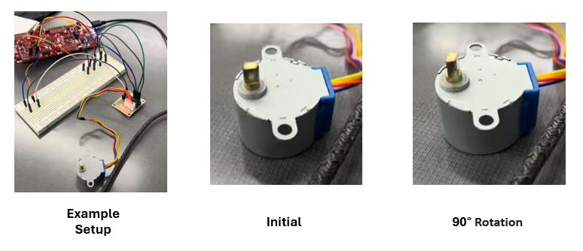

*Figure 27: Stepper Motor w/ ULN2003 Motor Driver*

The figure below demonstrates how the launchpad was able to output PWM signals using ePWM1, ePWM2, ePWM3. The oscilloscope is probing GPIO0 which corresponds to ePWM1A. The above image shows the duty cycle changing from 97% to 23%, this is a gradual change in duty cycle to show the difference between the waveforms over time. This was replicated on the PCB and demonstrated on demo day as well.

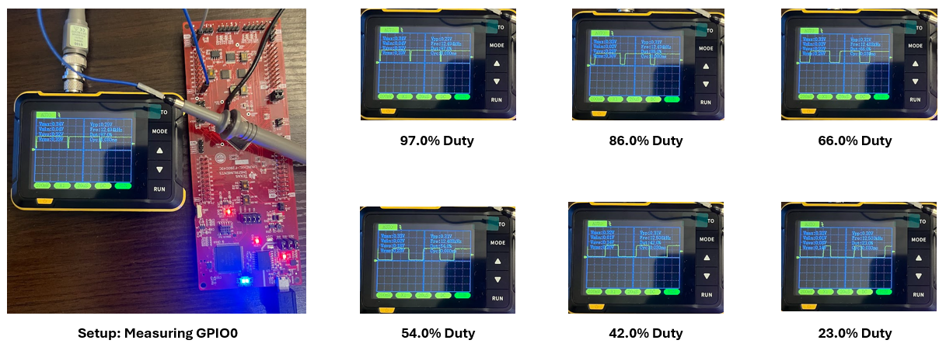

*Figure 28: PWM Signal Modulation*

Overall, the launchpad was able to provide a foundation of understanding for developing on a C2000 MCU. All the examples performed on the launchpad were replicated on the PCB board that was developed, with most of them being performed at demo.

### 3.2.4. PCB Testing and Results

The PCB board shown below was created, soldered, and assembled. Throughout the assembly process, the board was debugged to ensure traces were properly routed and correct voltages were delivered. The switch in the top right corner was removed and a trace between GND and SW1 cut as the button was shorting to ground due to an error in schematic. Before this, the device was in a constant state of reset through the XRS pin. Furthermore, the first MCU placed on the PCB had to be removed and replaced as human error led to voltage probing the wrong pin, which destroyed the initial IC.

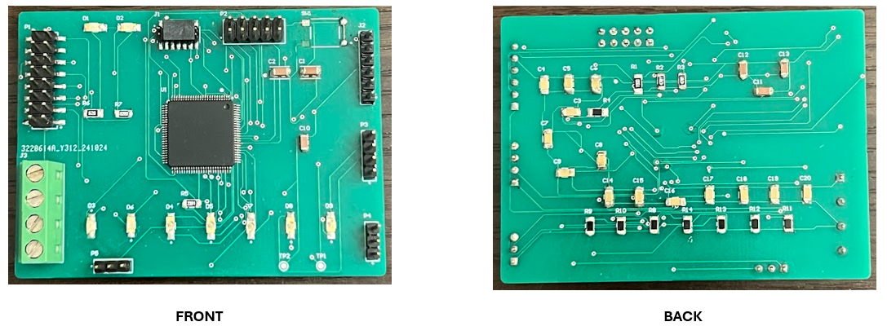

*Figure 29: Front & Back of PCB*

#### 3.2.4.1. Power

The PCB requires a 3.3V supply to provide the necessary operating voltage for the MCU. In the lab, this was tested by connecting a 3.3V input to the terminal block on the PCB. To ensure stable operation and no voltage drop off, the power supply was set to 3.3V at 100mA. The amperage was gradually increased on the power supply until no voltage drop off was observed. This ensures integration with the power subsystem, which provides a 3.3V power rail with up to 1A.

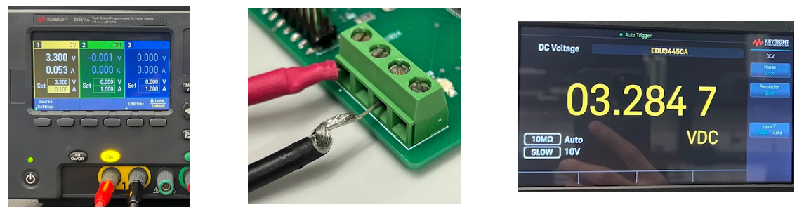

*Figure 30: 3.3V Input to Terminal Block*

#### 3.2.4.2. JTAG Flashing & Programming

The PCB was able to be programmed through the JTAG protocol. The necessary signals (TDI, TDO, TMS, and TCK) were correctly wired to a header on the PCB that connects to the JTAG header on the launchpad. The launchpad includes a built-in XDS-110 debug probe which is used to interface between the software written on CCS and then build and compile the software onto the target device (TMS320F280049C).

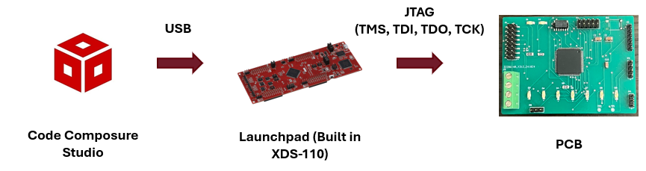

*Figure 31: Successful JTAG Programming Method*

Before the MCU was able to be programmed through the launchpad, there were a series of issues encountered, the following text explains the debugging process to obtain the solution. Originally, the sponsor recommended using an external XDS-110 debug probe. This debug probe would interface between the PC via USB and the PCB via JTAG. This method of programming did not work as the MCU could not detect the probe and a series of errors would occur.

This issue was overcome by using the onboard XDS110 that is built into the LAUNCHXL-F280049C (evaluation board). By removing the jumpers off of J101 on the evaluation board, the TDI, TDO, TMS, and TCK signals become available. By connecting the JTAG header from the PCB to the JTAG header on the launchpad, the MCU on the PCB can be programmed through the evaluation board. After doing so, programs are built, compiled, and successfully flashed onto the target MCU.

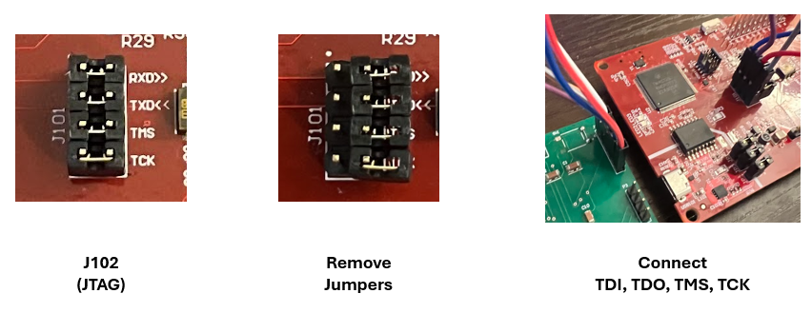

*Figure 32: Flashing through Launchpad*

The figure below demonstrates the console output after a program is successfully built, compiled, and flashed onto the MCU.

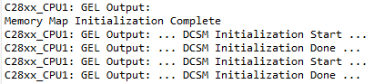

*Figure 33: Successful Connection*

The below figure shows the software for a Demo that was performed during demo day. In this demo, the PCB LEDs would toggle ON/OFF based on the high/low input received by the ESP-32. The PCB also would spin a stepper motor to show functionality of the GPIOs.

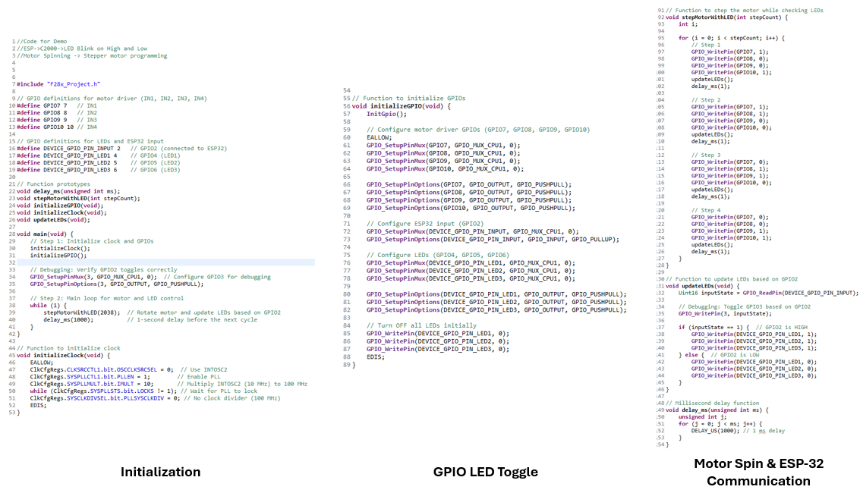

*Figure 34: C2000 Software for Demo*

The figure below shows the software written on Arduino IDE to toggle a GPIO pin on the ESP-32 to high and low every second. This signal was received by the C2000.

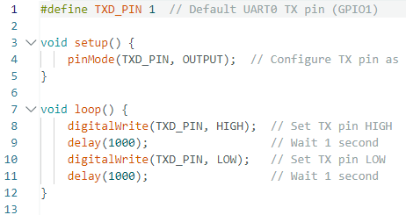

*Figure 35: ESP-32 Arduino Software (High/Low Toggle)*

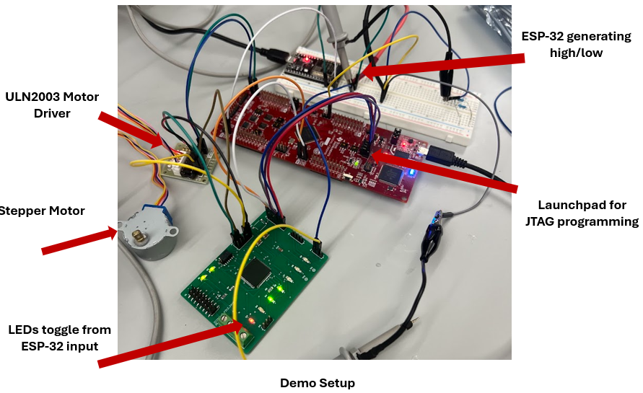

*Figure 36: Demo Setup:*

#### 3.2.4.3. PWM Waveform Generation

The PCB was successfully able to generate PWM waveforms that are to be used to drive the high and low gate driver inputs (INH/IN) (INL/EN) on the DRV816x motor driver. The motor driver subsystem will use 3x motor drivers per BLDC motor. Each motor driver will require 2x PWM signals from the MCU. Therefore, per BLDC motor, the MCU subsystem needs to provide 6x PWM signals. The MCU/Processing subsystem can successfully generate the required signals through the use of GPIO0 - GPIO15 with every two GPIOs in this range corresponding to ePWMA and ePWMB for a total of 16x possible PWM signals from one MCU.

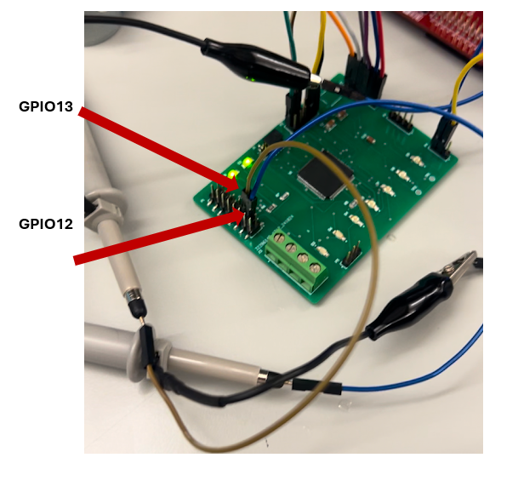

*Figure 37: Probing PWM Output Pins*

The figure below shows an oscilloscope screenshot of two PWM waveforms being formed through EPWM7A & EPWM7B at 50kHz. This was generated on the created PCB.

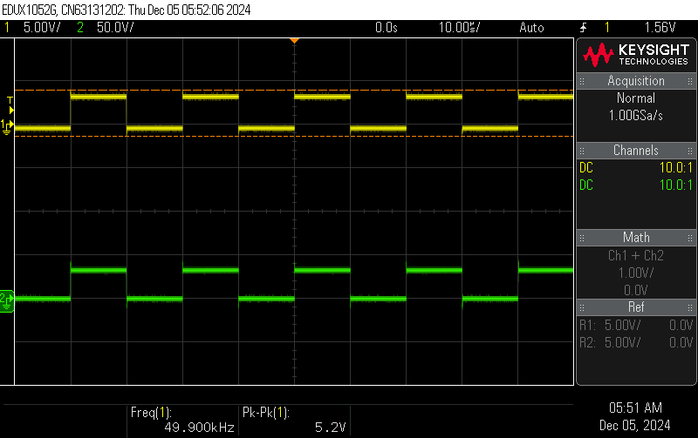

*Figure 38: PWM Generation EPWM7A & EPWM7B (GPIO 12 & GPIO13)*

The figure below shows two PWM waveforms being generated by the “epwm_ex13_up_aq” example code. These waveforms are being generated on the created PCB.

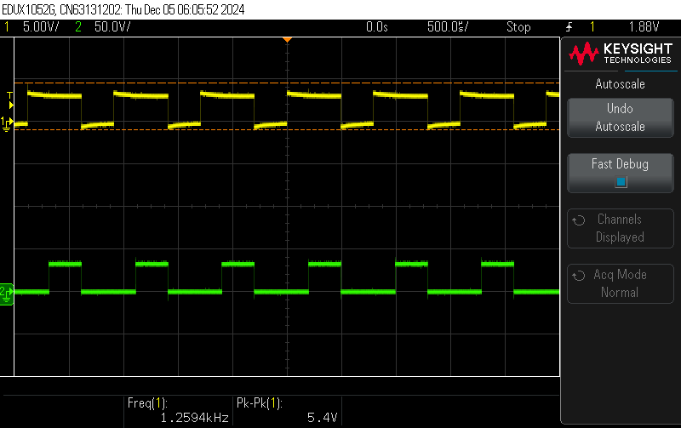

*Figure 39: PWM High/Low Generation*

The two previous figures demonstrate that the PCB is capable of generating the required PWM waveforms. The MCU/Processing subsystem will be able to send these PWM signals to the motor driver. The subsystem is ready for integration to the motor driver subsystem. After integration, the exact waveform requirement to rotate a BLDC motor is pending confirmation from the motor driving subsystem and is the next step to spin a motor.

#### 3.2.4.4. Communication with ESP-32

Communication between the ESP-32 and C2000 MCU was successful. The wireless connectivity subsystem will use an ESP-32 to interface with the mobile application. To test connectivity between the ESP-32 and C2000, an ESP-32 was purchased by the MCU/Processing subsystem and development began.

A program was written to toggle GPIO1 to high for 1 second and low for 1 second on the ESP-32. This program ran infinitely to constantly generate a high and low signal. The goal was for the C2000 to recognize this change of input from the ESP-32 and toggle an LED based on if the input is high or low to show that communication between these two devices was successful. To do so, GPIO1 from the ESP32 was connected to GPIO2 on the C2000 MCU. The software developed within CCS used the GPIO_ReadPin function to detect if the input state of GPIO2 was high or low. Based on this, the C2000 would use the GPIO_WritePin function to toggle the GPIOs connected to three LEDs (GPIO4, GPIO5, GPIO6) seen in the figure below.

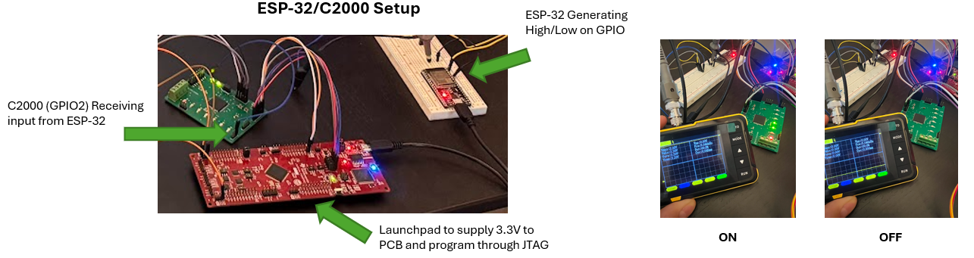

*Figure 40: ESP-32/C2000 Setup*

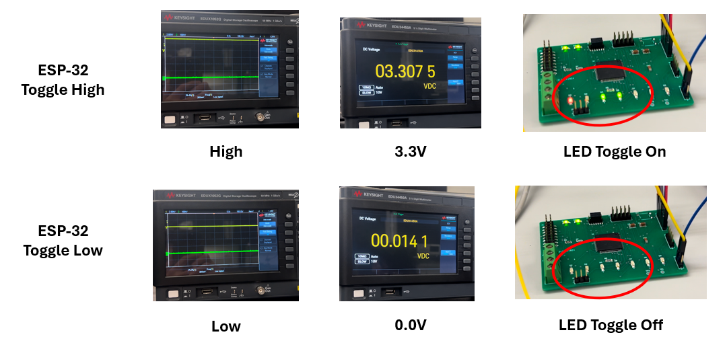

*Figure 41: ESP-32 to C2000 Communication (LED Toggle)*

The figure above demonstrates that communication between the ESP-32 and the C2000 was successful by using high/low signal generation on the GPIOs. A similar concept shall be used to integrate with the wireless subsystem next semester. When the user selects movement on the mobile application, (up, down, left, right, open, close) the ESP-32 will toggle a specific pin to high, the C2000 will then detect the input and through a series of if statements, output the desired PWM waveform to send to the motor driver to achieve the desired movement.

### 3.3. Subsystem Validation

The requirements of the MCU/Processing subsystem were validated in accordance with the validation and execution plan. The initial design of the PCB schematic was reviewed thoroughly before export to manufacturing, the development on the C2000 evaluation board built a foundation of programming knowledge, and the testing and validation of the PCB was accomplished to show the required deliverables of the MCU/Processing subsystem. The main objectives such as supplying power to board, programming through JTAG, generating PWM waveforms, and receiving signals from the ESP-32 were achieved.

The previous documentation provided in section 3.2.4. “PCB Testing and Results” documents in detail the steps taken to produce the required deliverables of the subsystem. Images to support the validation of the subsystem are included in section 3.2.4. The table below lists the required validation tasks for the subsystem, if and how they were achieved, and the supporting figure to ensure successful completion of validation.

| **Deliverable** | **Achieved (Yes/No)** | **How** | **Supporting Figure** |
| --- | --- | --- | --- |
| 3.3V power to PCB | Yes | Terminal block input with 3.3v at 500mA minimum to ensure no voltage drop off. | Figure 30 |
| JTAG Programming | Yes | JTAG programming through onboard XDS-110 debugger on the launchpad. | Figure 31, 32, 33 |
| PWM Waveform Generation | Yes | Software written using ePWM modules to generate waveforms on GPIO pins . | Figure 37, 38, 39 |
| ESP-32/C2000 Communication | Yes | Software written to receive input from ESP-32 through GPIO pins on C2000. Toggle instructions through high/low input. | Figure 40, 41 |

*Table 8: MCU/Processing Validated Deliverables*

### 3.4. Subsystem Conclusion

To conclude, the MCU/Processing subsystem was validated to achieve the milestones listed in the validation plan. The execution plan had milestones achieved, with it nearing completion as soon as subsystems are integrated in the coming semester.

The subsystem performs as expected and is capable of generating and receiving the required signals from the different subsystems. This includes receiving input from the wireless subsystems ESP-32, receiving 3.3v from the power subsystem, and generating the required PWM signals for the motor driver subsystem. The validation and execution plan aided in keeping the MCU/Processing subsystem deliverables on time and aligned with the team members. Furthermore, constant communication between team members ensured compatibility between systems to allow integration following the conclusion of the semester.

Although the subsystem performed as expected, work will be done during winter break to allow a smooth transition into next semester. The goals for winter break include developing a new PCB board, writing new firmware for the MCU, and strategizing with team members over physical design of the cobot. The new PCB board shall include a larger quantity of headers, allowing access to the necessary pins from the MCU. The firmware development will refine the PWM signal generation and communication with the ESP-32. Additionally, the approach to develop a physical cobot will be researched, with team support growing for a crane like structure.

The subsystem is now ready for integration with the motor driver, power, and wireless subsystems. Collaboration between the MCU and motor driver subsystems will continue to ensure proper development of firmware and signal generation, supporting BLDC motor motion. This momentum will carry into the next semester as the team transitions to a more team-oriented approach to accomplish the goal of delivering a fully functional collaborative robot (cobot).

# Power & Battery Management Subsystem - Emily Hamsa

## 4.1. Subsystem Introduction

The power and battery management subsystem is responsible for providing power to the cobot and its associated components. The subsystem uses a PCB to convert the input voltage to five different output voltages, with an additional output voltage that is connected directly to the input. To ensure seamless integration with the other subsystems, this PCB has been designed according to a load list that was developed as a part of planning for this subsystem, which breaks down each component requiring power and records the voltage and current specified by their data sheets. As the cobot is wireless, the input will be a 48V, 20Ah battery, which was selected also based on the load list and for a runtime of 30 minutes. Validation of this subsystem was completed based upon the validation plan to further ensure completeness and success during integration stages.

## 4.2. Subsystem Details

***4.2.1. Planning and Selection***

Initial planning for this subsystem included the development of a load list, which was used to select a battery size and to determine the necessary output voltages, as well as assist the PCB design stage to ensure trace widths would be able to withstand higher current demands of some components. Below is the completed load list.

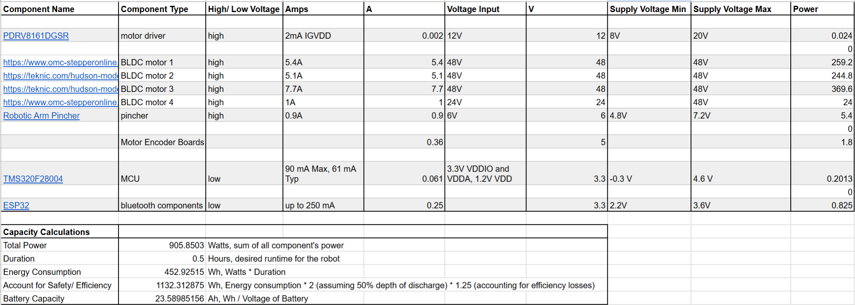

*Table 9: Cobot Load List*

Also included in the load list are calculations for the necessary battery size based on power demands of the system. Assuming a runtime of 30 minutes and a voltage size of 48 volts, a 48 volt 20 amp-hour battery was selected.

Grouping components with the same output voltage together to determine the total current demanded by the voltage rail, TI WeBench was then used to select TI-branded buck converters that had appropriate voltage output capabilities and current ratings. The output voltage rails, their current ratings and the selected converters are as followed:

* LM5163DDAR: 3.3V, 0.5V
* LMR36510FADDAR: 5V, 1A
* LM5012DDAR: 6V, 2.5A
* LMR36510FADDAR: 12V, 1A
* LM5164DDAR: 24V, 1A

***4.2.2. Schematic and PCB Design***

### 4.2.2.1. Schematic Design

Using TI WeBench and the load list described above, individual circuits were generated based on input voltage, desired output voltage, and the current rating needed for the circuit. After compiling the five selected circuits, Altium was used to design the individual schematics for each output voltage rail and connect them together through the power and ground nets to be used on one PCB. During the schematic design stage, terminal blocks were also selected, ensuring each component needing power would have access to a power and ground connection on the PCB.

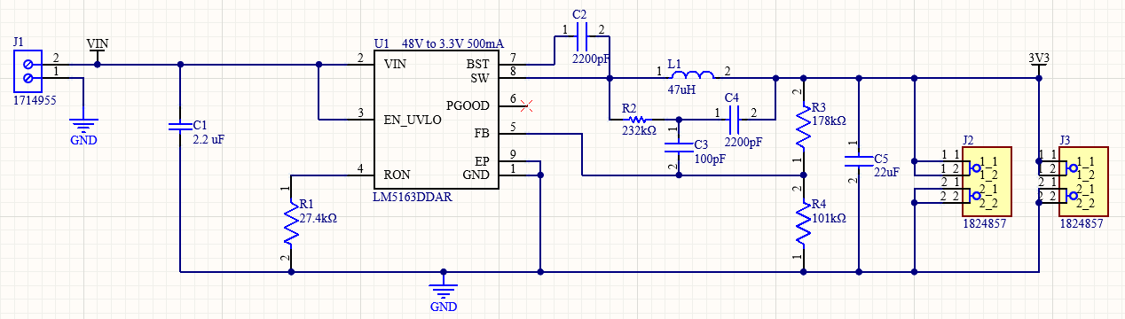

*Figure 42: 3.3V, 0.5A Step-down Circuit Schematic*

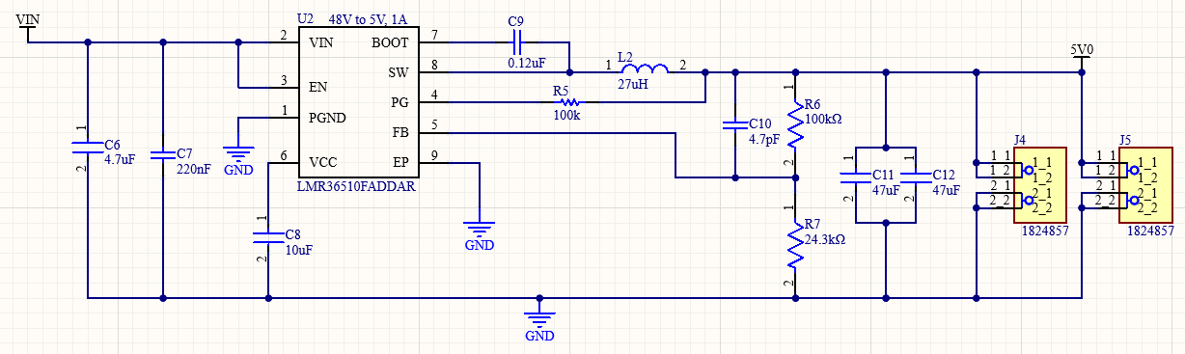

*Figure 43: 5V, 1A Step-down Circuit Schematic*

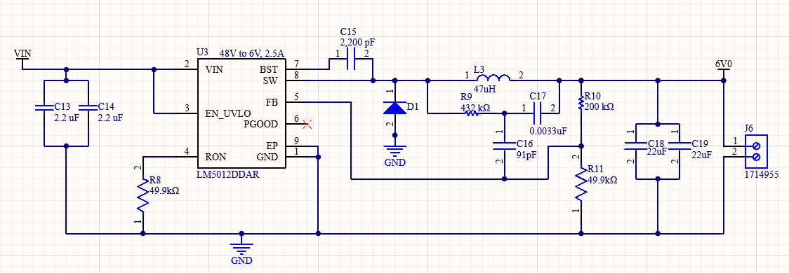

*Figure 44: 6V, 2.5A Step-down Circuit Schematic*

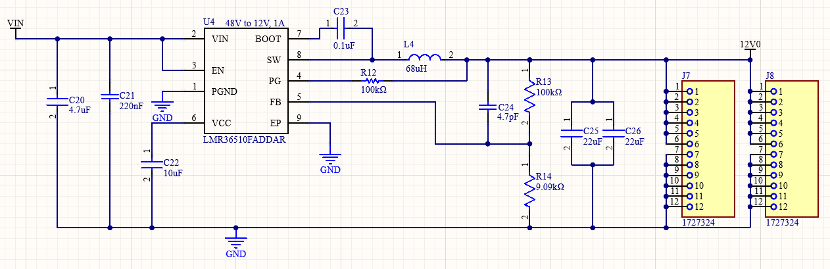

*Figure 45: 12V, 1A Step-down Circuit Schematic*

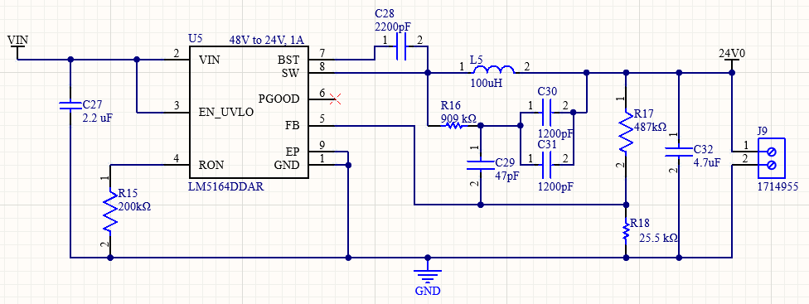

*Figure 46: 24V, 1A Step-down Circuit Schematic*

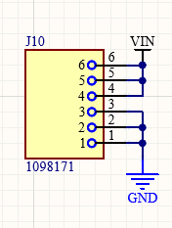

*Figure 47: Connection from Vin Directly to Output Schematic*

### 4.2.2.2. PCB Design and Fabrication

Layout and routing of the PCB was based on the schematics and the load list. Each step-down circuit was laid out isolated from the others and close to the terminal block providing the output from the converter. Routing and trace widths were determined based on the load list, ensuring that each trace was wide enough to sustain any large amounts of current expected for the load and preparing for integration.

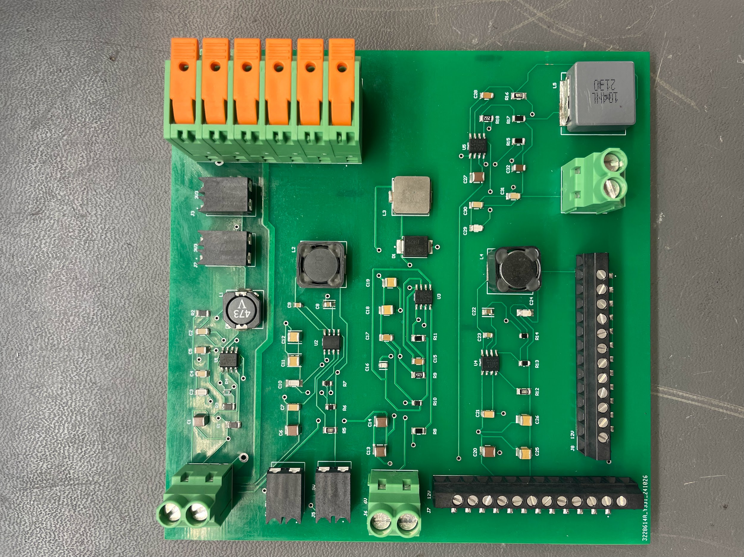

*Figure 48: Power Supply PCB*

***4.3. Subsystem Validation***

Validation for this subsystem was done based on the validation plan developed at the beginning of the semester. Within the validation plan there are tests to ensure that the output voltage is reading the correct voltage, and the output voltage is steady and not noisy.

## 4.3.1. Output Voltage Verification

To verify that the output voltage is reading correctly, a digital multimeter was used. The first output voltage to be tested was the 3.3V terminal. When testing this under 25V input and intermediate values leading up to 25V, the output was successful.

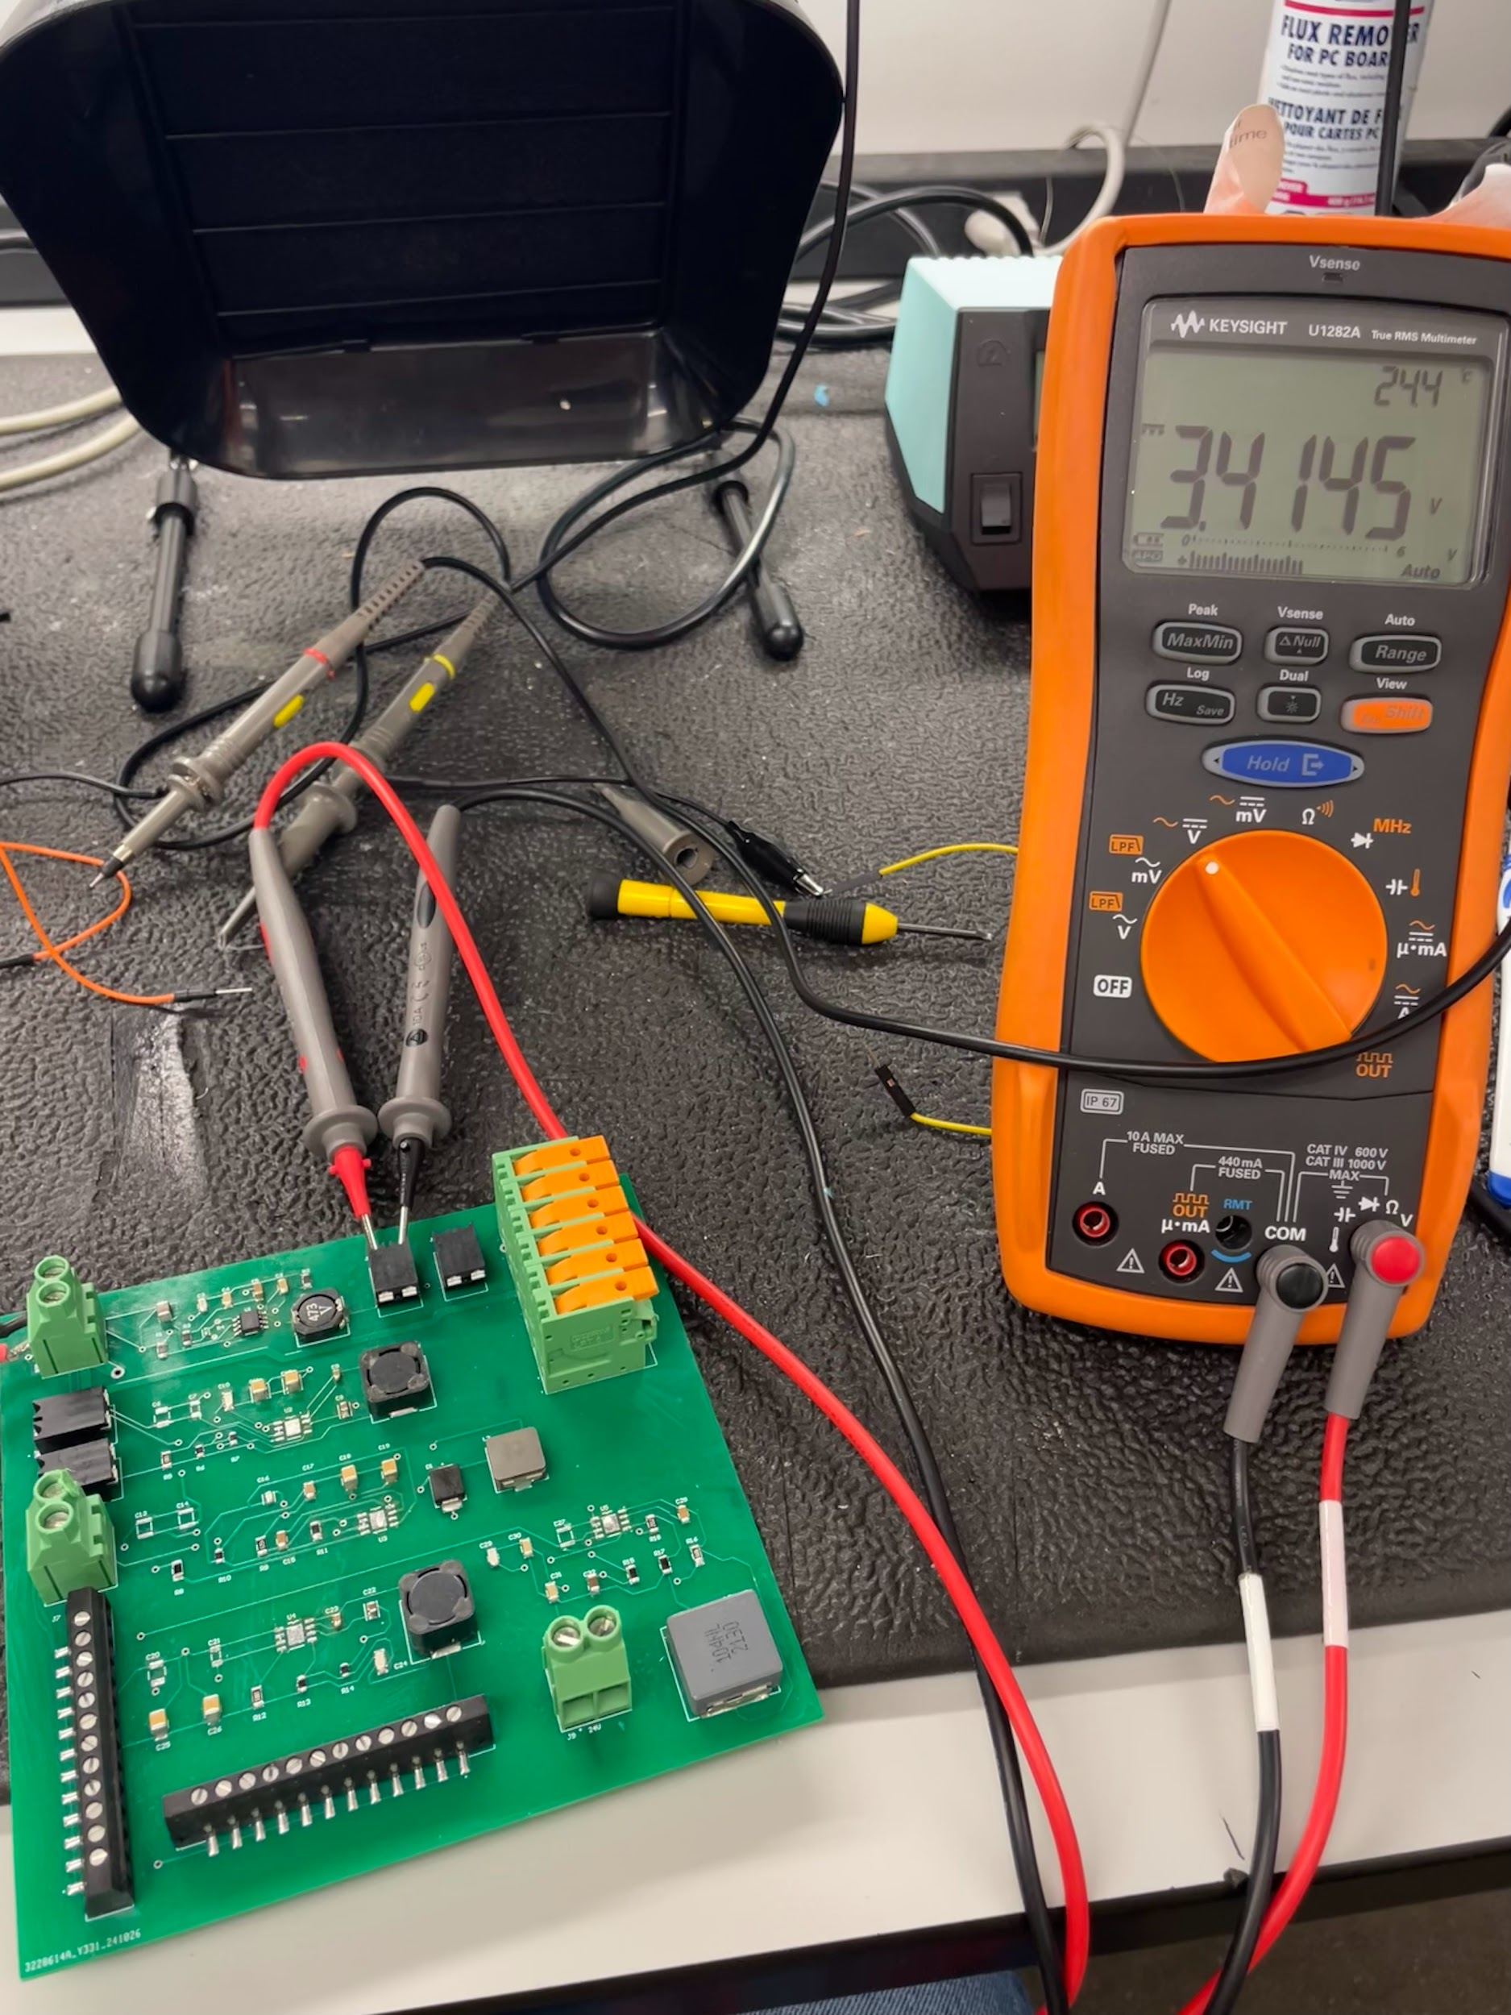

*Figure 49: 3.3V Output When Tested with 25V Input*

Testing the 6V, 12V, 24V, and terminal connected directly to the input were also successful when tested with intermediate voltages up to and including 30V.

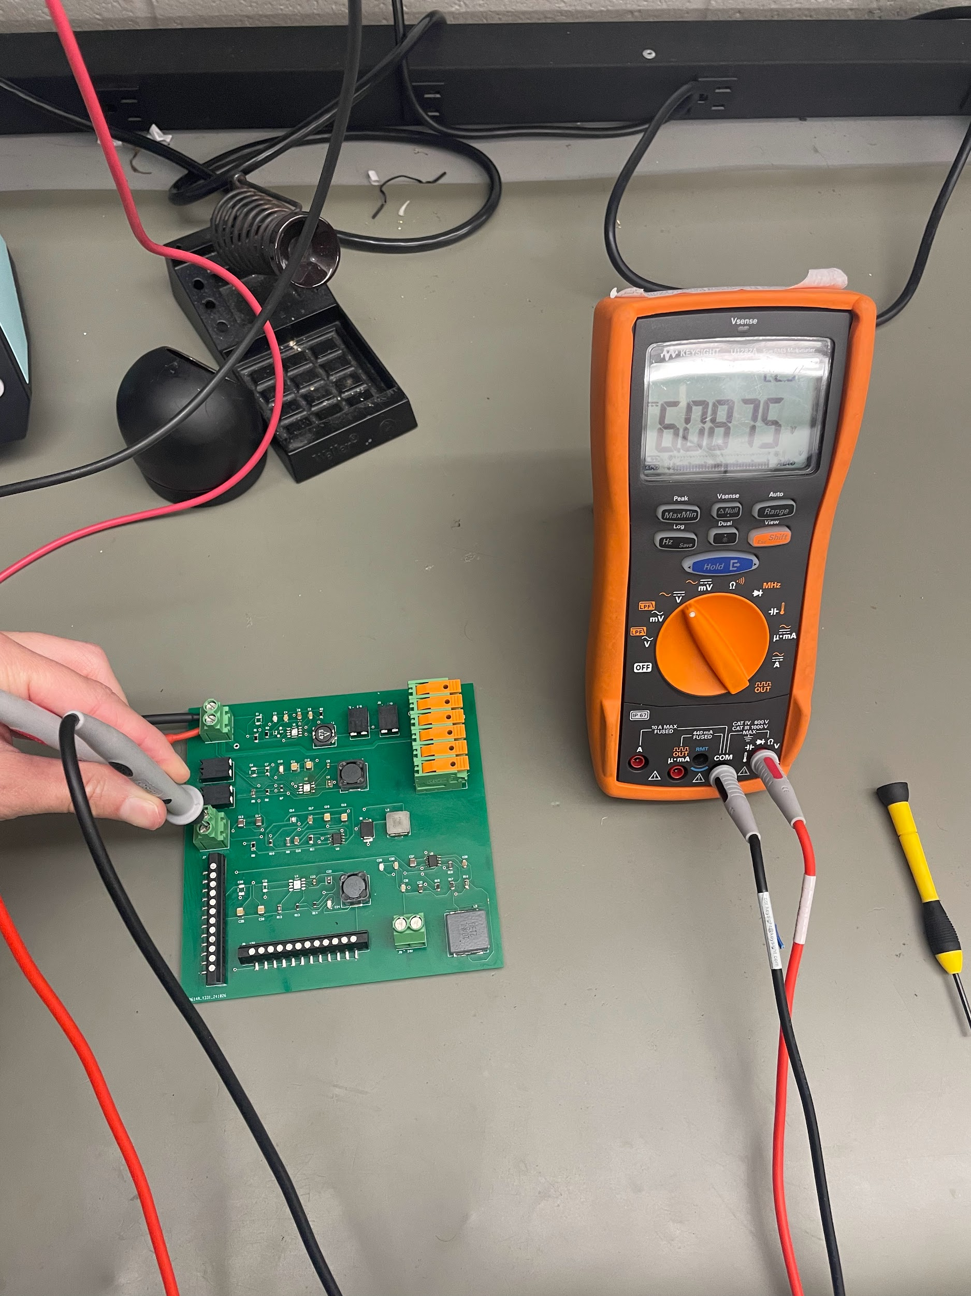 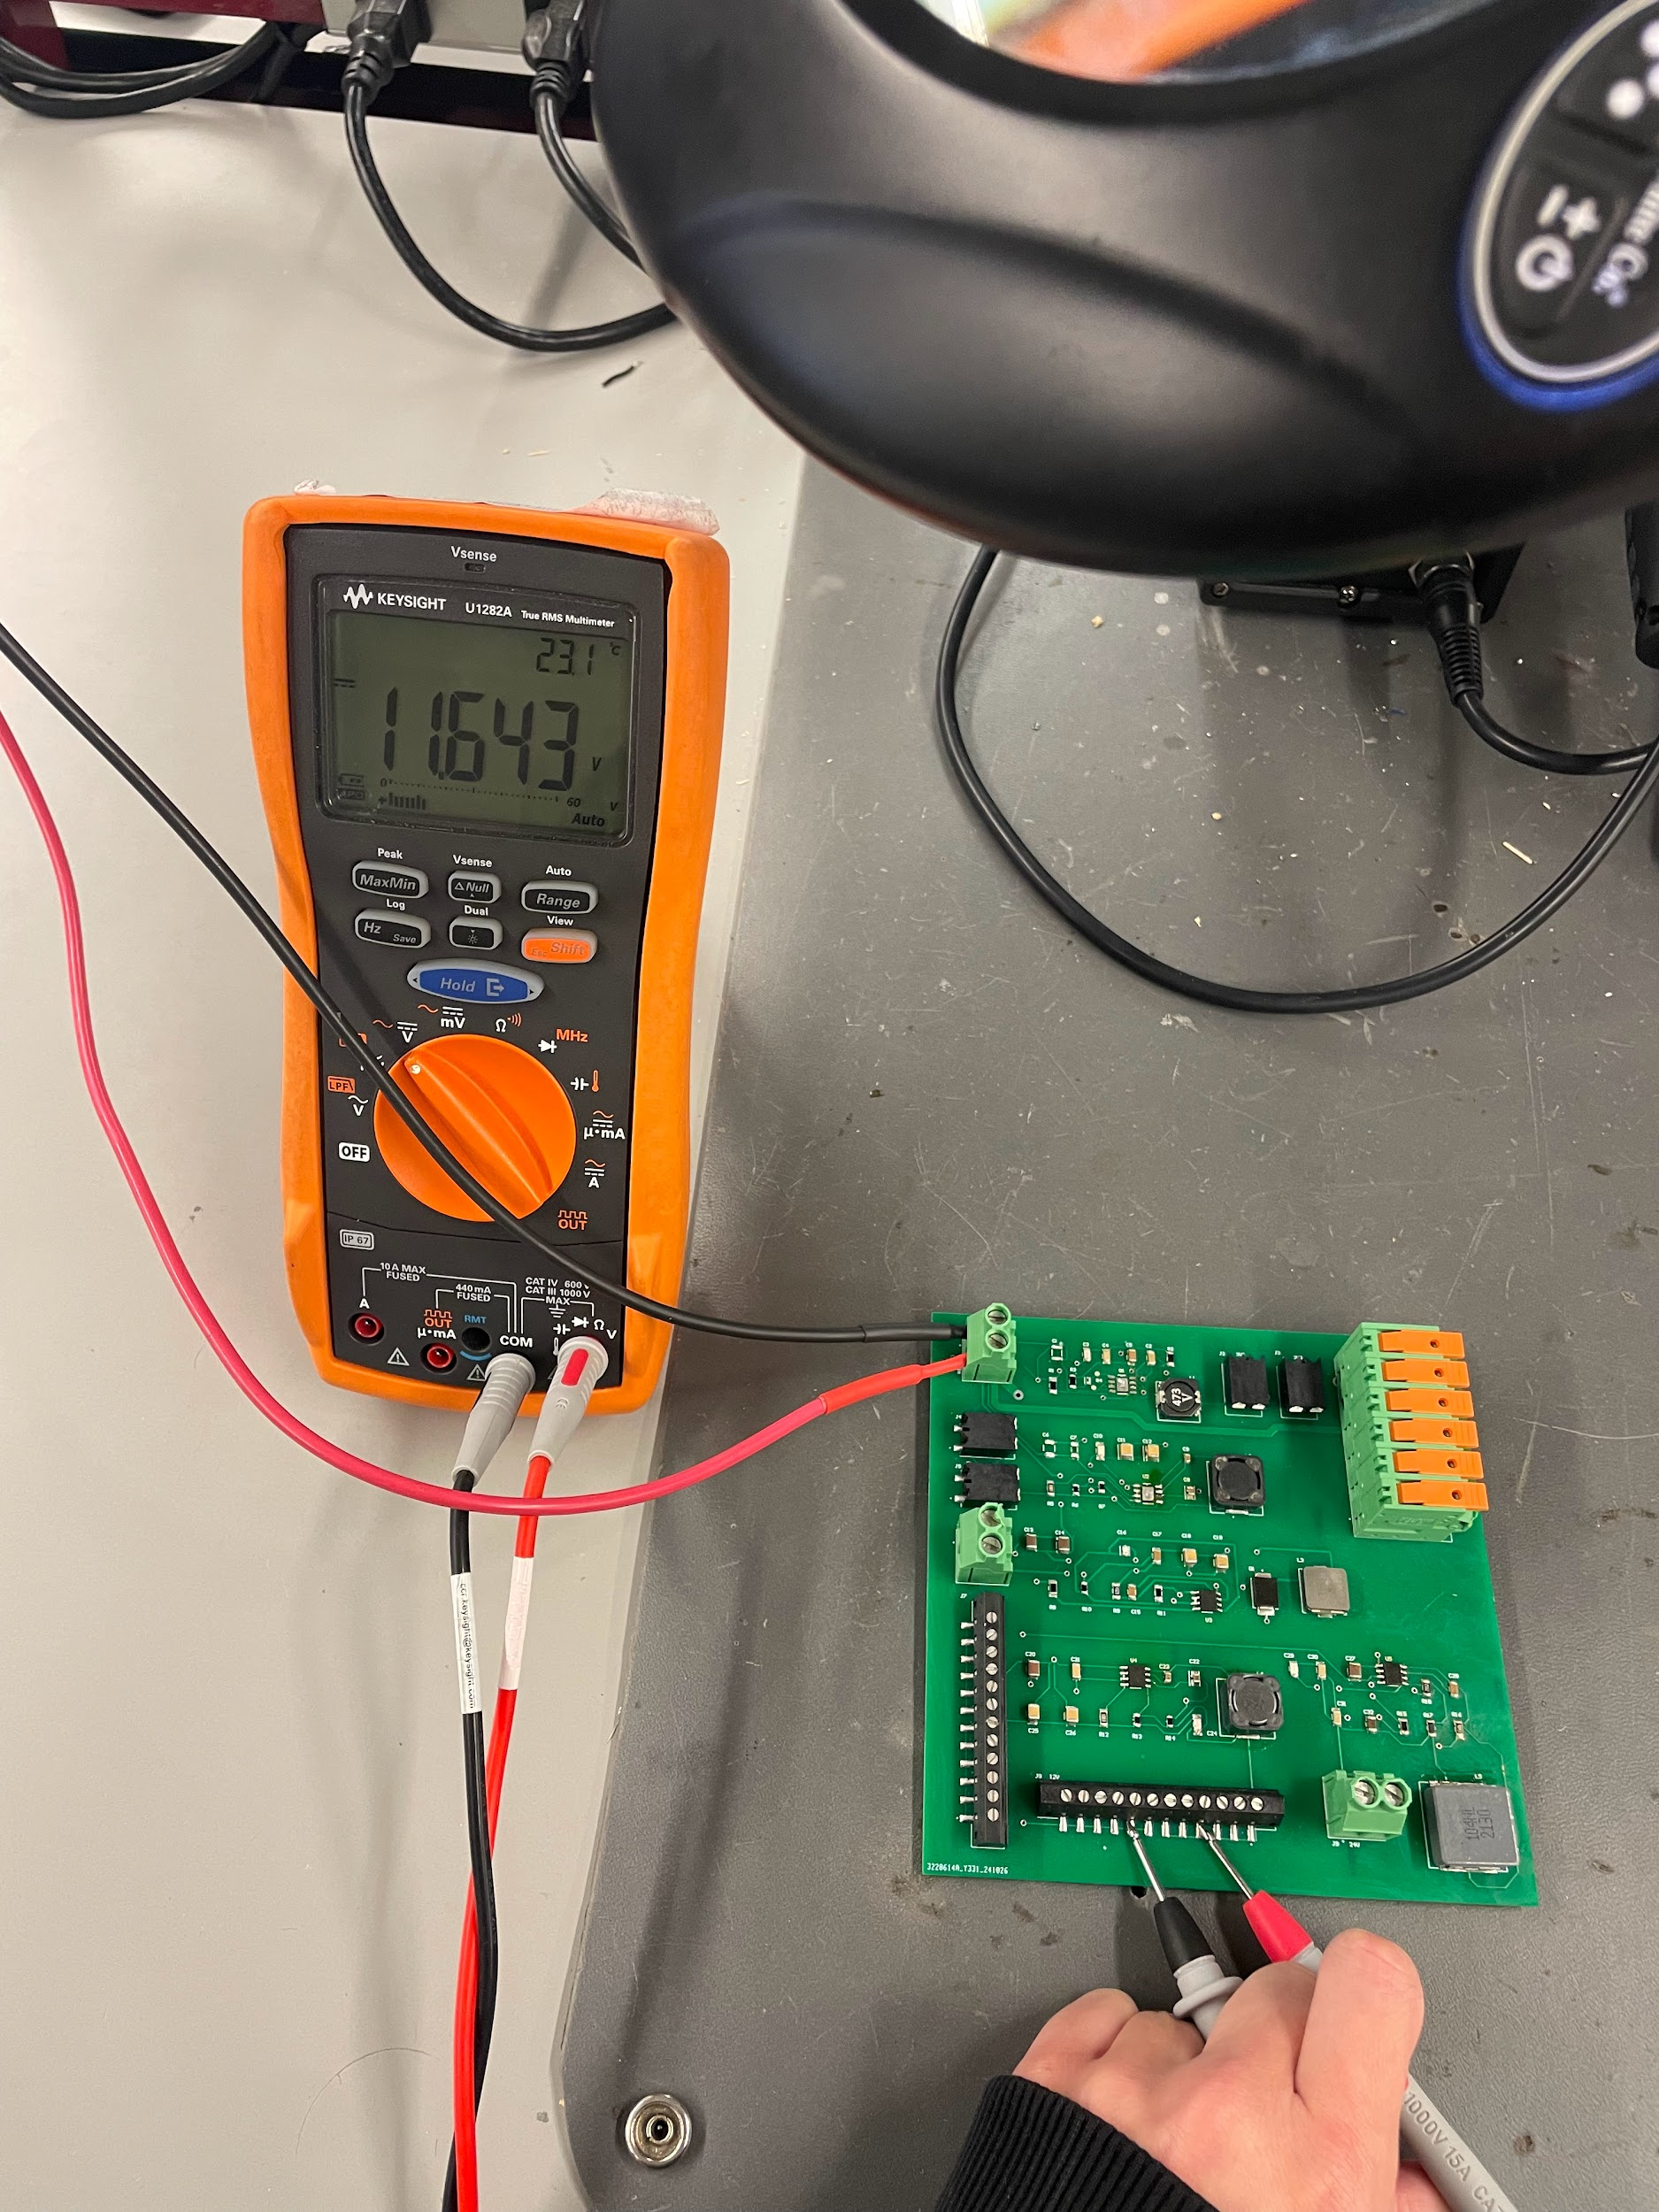

*Figure 50: 6V Output When Tested with Figure 51: 12V Output When Tested with*

*30V Input 30V Input*

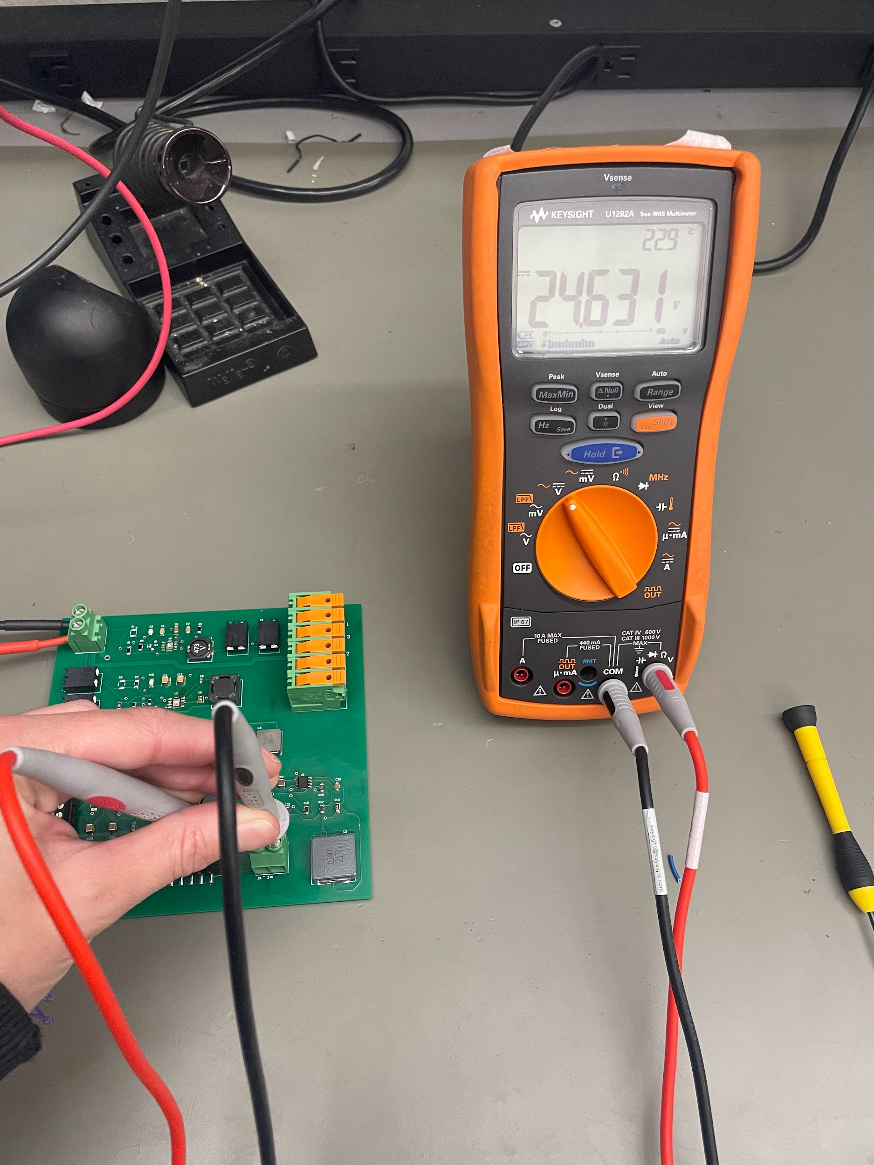

*Figure 52: 24V Output When Tested with 30V Input*

There were some complications during this testing. When connecting the components to activate the 24V step-down circuit, the converter used in the 3.3V converter circuit shorted between power and ground. Additionally, on the power subsystem PCB, the output of the 5V step-down circuit outputs less than one volt. Debugging for both of these issues included testing for continuity throughout the circuit, changing the converters, verifying the designs against TI WeBench, and verifying the components on the board are correct. None of these attempts fixed these issues, and so it is suspected that this is caused by a PCB board layout and routing issue. Further evidence for this is found in the motor and motor driver subsystems’s PCB, as the 3.3V and 5V step down schematics developed and designed in this subsystem were both as is on the PCB, and are operating as expected, with the only change being the physical layout and routing on the PCB.

While these voltage outputs have not been verified for the full expected input of 48V, once the entirety of the PCB is completed and verified at an intermediate voltage of 30V, there is little concern or doubt that continuing to raise the input voltage to 48V will cause the board to fail a multimeter test.

## 4.3.2. Input and Output Voltage Noise Verification

To ensure that the input and output terminals have limited noise and are truly delivering DC voltage, an oscilloscope was used. When testing the 3.3V and 6V are connected to a 25V input, there is little to no noise in the output or input terminals.

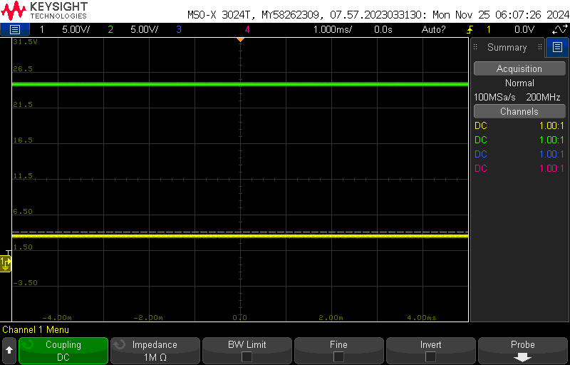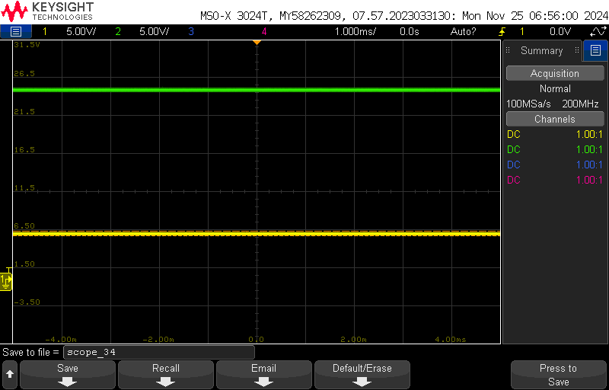

*Figure 53: 3.3V Noise Output When Figure 54: 6V Noise Output When*

*Tested with 25V Input Tested with 25V Input*

When testing the 24V output with a 30V input, there is also very little noise in the system.

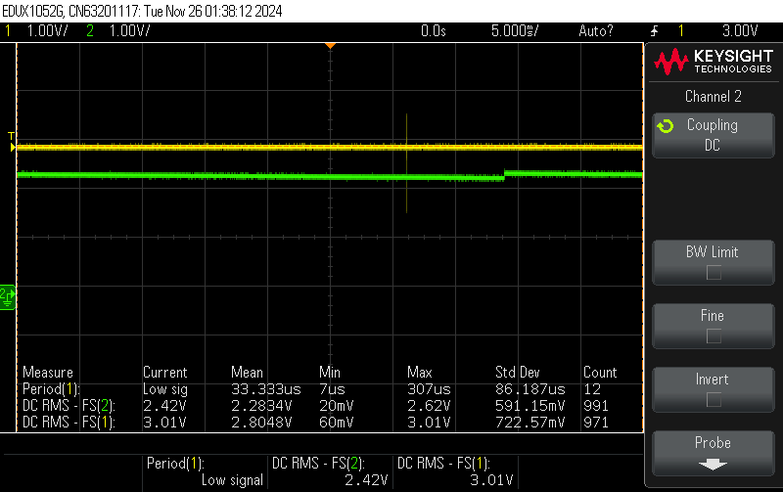

*Figure 55: 24V Noise Output When Tested with 30V Input*

Once adding the 12V output converter circuit and testing with a 25V input, noise in the system increased.

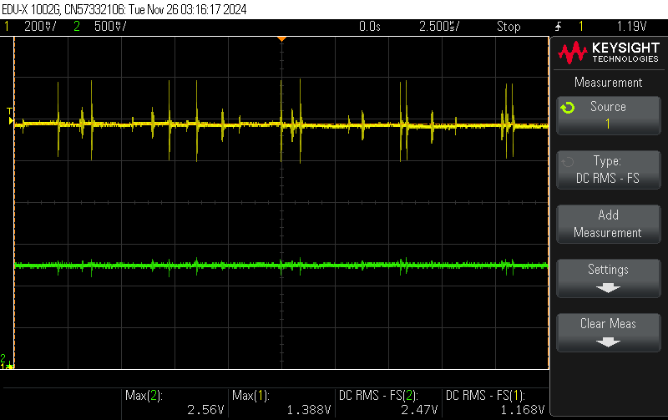

*Figure 56: 12V Noise Output When Tested with 30V Input*

This is suspected to be from an inductor or capacitor that is a part of the 12V step-down converter circuit. Debugging to resolve this was attempted by replacing the inductor in the circuit to ensure the component was not damaged, and this did not resolve the excess noise. Further debugging to resolve this issue will include research into the capacitors and inductors and verification of their ratings.

| **Deliverable** | **Achieved (Yes/No)** | **Criteria** | **Supporting Figure** |
| --- | --- | --- | --- |
| 3.3V DC Output | Yes | When testing with a multimeter, the voltage is 3.3V, and the oscilloscope shows minimal noise. | Figure 49, Figure 53 |
| 5V DC Output | No | When testing with a multimeter, the voltage is 5V, and the oscilloscope shows minimal noise. | N/A |
| 6V DC Output | Yes | When testing with a multimeter, the voltage is 6V, and the oscilloscope shows minimal noise. | Figure 50, Figure 54 |
| 12V DC Output | No | When testing with a multimeter, the voltage is 12V, and the oscilloscope shows minimal noise. | Figure 51, Figure 56 |
| 24V DC Output | Yes | When testing with a multimeter, the voltage is 24V, and the oscilloscope shows minimal noise. | Figure 52, Figure 55 |

*Table 10: Validated Deliverables: Power Supply PCB*

***4.4. Subsystem Conclusion***

Looking forward to integration, once a few tasks are completed, there should be no major roadblocks. Beginning with the 3.3V and 5V step-down converter circuits, a comparison between the layout and routing in the motor and motor driver subsystem’s PCB and this subsystem’s PCB will be completed, and a new board will be developed and fabricated to address any discrepancies between the layout and routing of the two. To fix the excess noise throughout the system, research into each component used in the 12V step-down circuit will be completed to determine which capacitor or inductor is causing noise, and selection of a new component which will be better suited for the application in this PCB.

After verification of the entire board is completed at an intermediate value of 30V, including a test with the digital multimeter to ensure voltages are as expected and with the oscilloscope to ensure the noise is no longer in excess, tests at the full expected input of 48V will be completed. In addition to these tests, testing with an E-load will be completed to verify that under the expected current demand from the cobot, the PCB is still able to deliver reliable DC voltage and withstand the load.

These updates and testing will be completed over winter break, prior to the start of the spring semester and integration with the rest of the subsystems. After the verification is complete, integration and movement towards the collective goal of cobot operation will be mostly straightforward for this subsystem.

# 5. User Interface & Wireless Connectivity - Jaishil Shah

## 5.1. Subsystem Introduction

The User Interface & Wireless Connectivity Subsystem allows seamless communication between an iOS mobile device using a Flutterflow-developed application and a C2000 MCU via an ESP-32 Bluetooth module. This subsystem is split into two major components, the User Interface (UI), and the Wireless Communication. The UI is responsible for being the interface between the user and the device, allowing signals to be sent back and forth. The wireless communication aspect is where the ESP-32 comes into play and is responsible for bidirectional data flow. The ESP-32 is capable of receiving data from the mobile device and from there sending it over to the MCU via high/low GPIO pins to perform cobot movement. Since the goal of the cobot is to create a safe and seamless procedure where the user does not have to physically interact with the robotic device, wireless communication & a virtual interface are crucial in fulfilling that goal.

## 5.2. Subsystem Details

This section will break down the details and design of the subsystem and how they play a pivotal part in ensuring proper connection/communication.  
  
**5.2.1. Subsystem Block Diagram**The figure below depicts a generalized flow of how and where signals will be sent via wireless communication. The heart of the subsystem lies within the ESP-32, as it functions as the middleman between the mobile application and the MCU.   
(The ESP-32 is displayed in turquoise)  
  
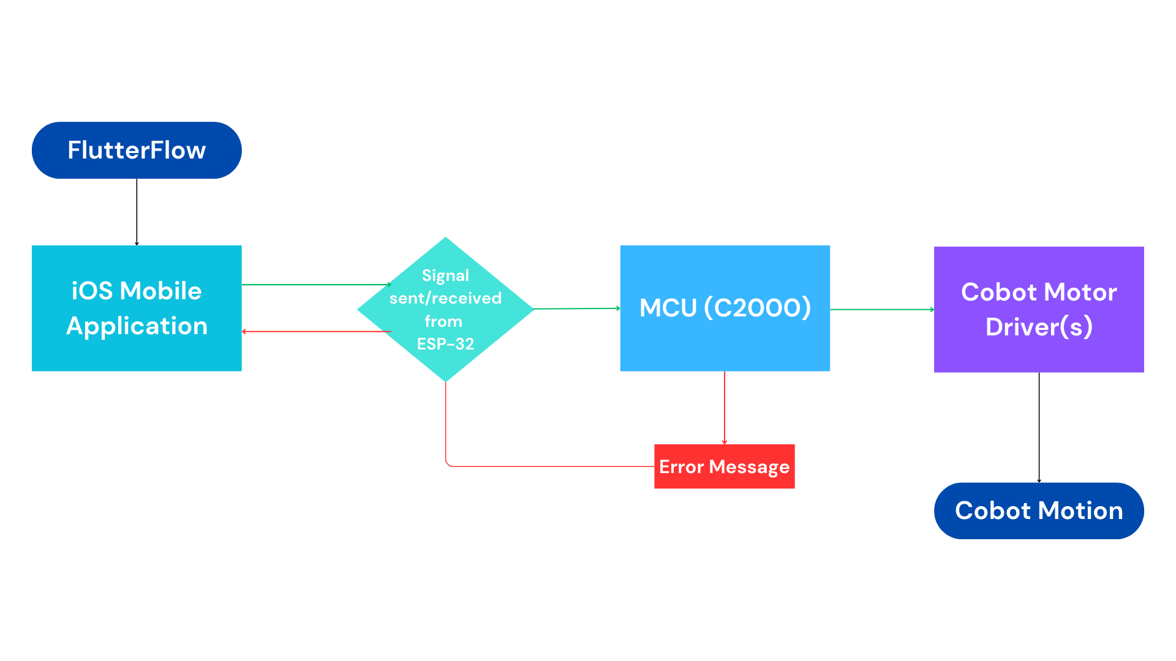Figure 57: UI & Wireless Connectivity Subsystem Block Diagram

**5.2.2.1. Mobile Application (Flutterflow)**The Mobile Application that was developed on Flutterflow had 4 main objectives: An interface that the user can easily understand and interact with, the ability to go back and forth between pages, a proper Bluetooth connection, and the ability to send data to the ESP-32. The first one was the least time-consuming, as it consisted of creating the app layout using Flutterflow’s design tools. In total, there are 6 pages to the app, where going back and forth between pages is no concern.  
  
  
  
  
  
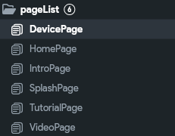

Figure 58: Application Page List

The next three criteria of the app were completed by splitting the tasks into their respective pages. The Intro Page is the first page the user will see when the application is opened, as it is where navigation to all other necessary pages is possible. The Tutorial and Video Pages are where users will be able to access all important information on how to use the cobot and the application (will be completed in 404 after Cobot Assembly). The Home Page is where the Bluetooth connection will be established. The User will enable Bluetooth, search devices, and connect all on this page. Finally is the Device Page, where the User Interface for the Cobot is located. Data can be sent from this page in either button input or string format.   
  
  
  
  
  
  
  
  
  
  
  
  
  
  
  
  
  
  
  
  
  
   
 Figures 59,60,61: Intro Page, Home Page, and Device Page (respectively)  
  
Additionally, the Bluetooth aspect required numerous steps to ensure the ability to enable Bluetooth, search for devices, connect to a device, and send data. This was done by creating 8 separate functions within Flutterflow that each tackles a different component of stable and secure Bluetooth connectivity. Figure 62 shows what the Flutterflow functions look like, and in this case, the connectDevices function. Figure 63 shows how some of the actions interact with each other to get the result that is intended. Table 11 lists the functions and a summary of what each of them accomplishes.   
  
  
  
  
  
  
  
  
  
  
  
  
  
  
  
  
  
  
  
  
 Figures 62, 63: Bluetooth Function UI, Block Diagram of Function Overlap 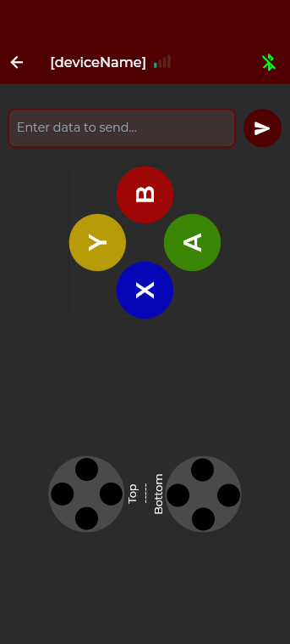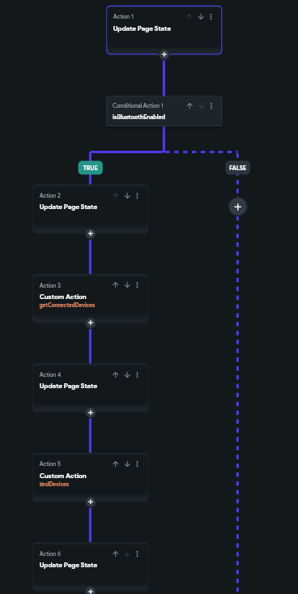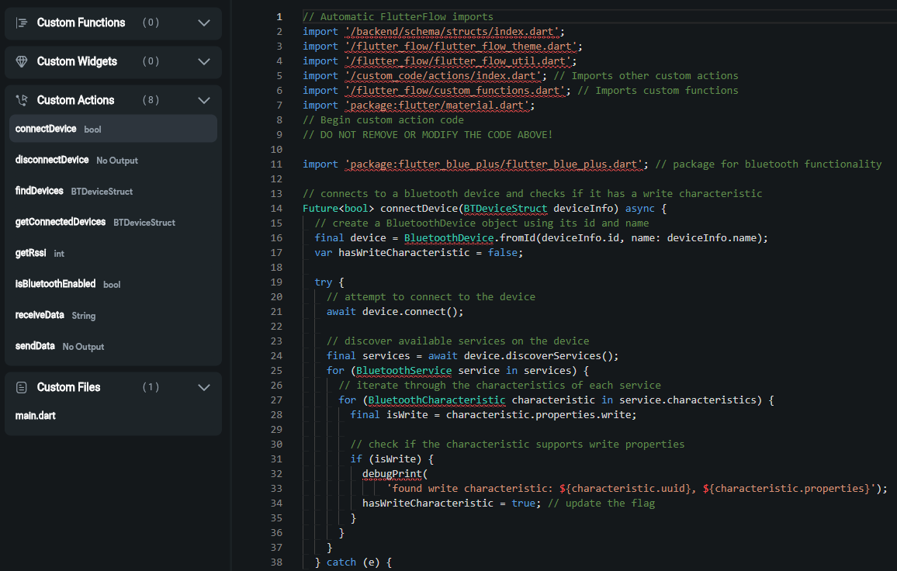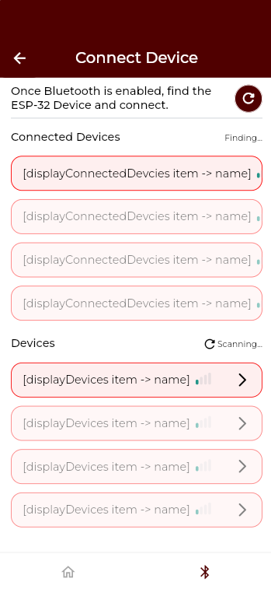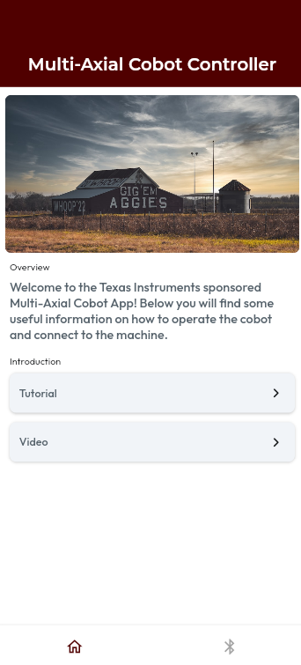

| **Function** | **Description** |
| --- | --- |
| connectDevice | Establishes a connection with a Bluetooth device |
| disconnectDevice | Disconnects the currently connected device |
| findDevices | Scans for nearby Bluetooth devices |
| getConnectedDevices | Creates a list of currently connected devices |
| getRssi | Returns the signal strength of the Bluetooth connection |
| isBluetoothEnabled | Check if Bluetooth is enabled on the device |
| receiveData | Receives data from the device |
| sendData | Sends data to the device |

Table 11: Bluetooth Functions & their Functionality

**5.2.2.2. Mobile Application (App Store / Mobile Application Deployment)**

Once the application was developed and full functionality was ensured, getting the application onto the mobile device was the next step. This was accomplished by creating an Apple Developer Account and registering to be affiliated with Apple’s App Store policies. Once that was completed, the application was sent into Beta deployment through Apple’s “Test-Flight” program, which allows the App to be distributed and downloaded on mobile devices linked to anyone who has access to the application. Below is the deployment of the application through the web interface, as well as directly on the mobile device. Additionally, Figure 65 shows how the application was successfully installed on two different devices through the TestFlight program: an iPad Air 4th Gen & an iPhone 16 Pro running iOS 18.0.1.

Figure 64: Mobile Application Deployment via TestFlight  
  
  
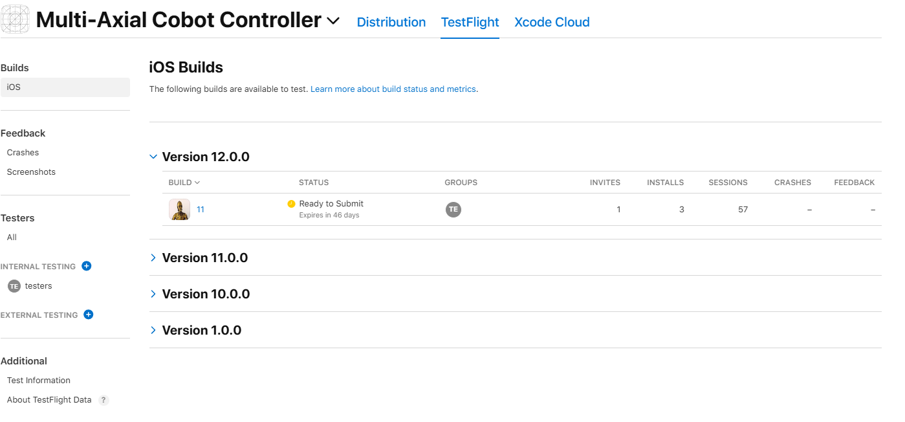

Figure 65: Mobile Application Deployment to iPad and iPhone  
  
  
  
  
  
  
  
  
  
  
  
  
  
  
  
  
Figure 66: Mobile Application on iPhone  
  
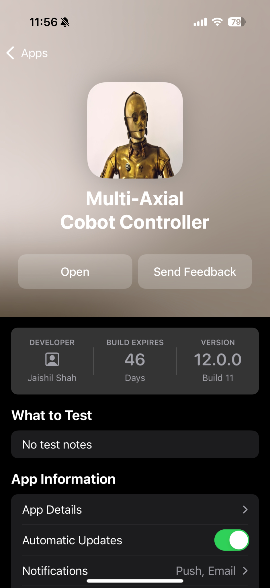

**5.2.3. PCB Layout Breakdown**

This section is the first of many that detail the second half of this subsystem. The previous sections explained the User interface, while the following sections will go over the Wireless Connection itself.

**5.2.3.1. ESP-32 Chip**

The largest and most important component in the PCB schematic is the ESP-32 chip. Bluetooth communication resides within the chip and is essential in making the PCB function as intended. This module contains pull-up and current-limiting resistors, capacitors in charge of power stabilization, and interfaces that enable FTDI communication. Some additional functionalities that this module houses include USB data transfer, GPIO operations, serial communication, and debugging/programming communication that is in charge of setting up the ESP-32. 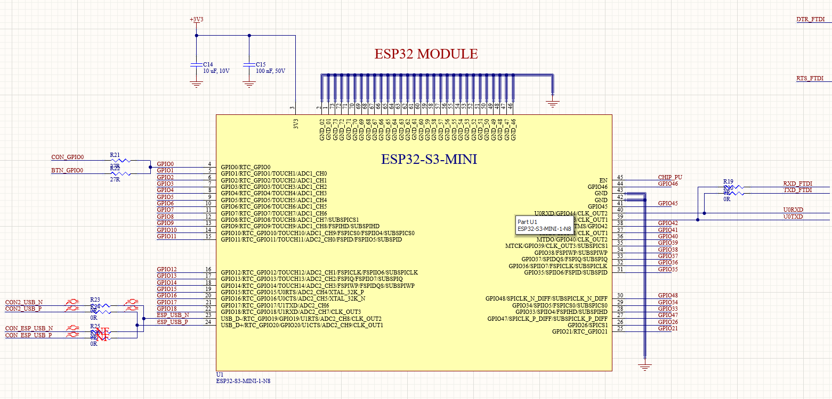

Figure 67: ESP-32-S3-MINI Module Schematic

**5.2.3.2. GPIO Headers**

This set of headers provides access to the GPIO pins and thus is connected to the ESP-32 module. Each header contains access the the pins, power lines (+3.3V and +5V), and essential ground connections. Additionally, decoupling capacitors of 100nF have been added to ensure power stability and minimize the signal noise along the power supply lines. These headers allow for the interfacing of external components, making this design both adaptable and versatile as it can work with other devices.   
  
  
  
  
  
  
  
  
  
  
  
  
 Figure 68: GPIO PIN Headers Schematic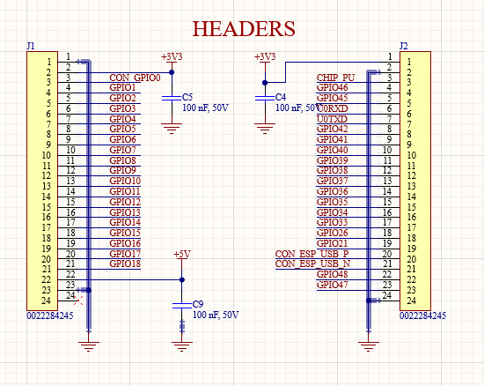

**5.2.3.3. Power Selection & Voltage Regulation**

This schematic details the circuitry responsible for power and voltage regulation. There is a 5V jumper connection that can select between two 5V sources. A 5V to 3.3V regulator based on the TLV1117-33 device is responsible for converting a 5V input to 3.3 V, with their respective decoupling capacitors. This allows stability and noise reduction. Additionally, there is a 3.3V power selection that allows the selection of a 3.3V output for more downstream components. This part of the schematic is essential for proper voltage levels and flexibility based on the operation of the ESP-32.   
  
  
  
  
  
  
  
  
  
  
  
  
  
  
  
 Figure 69: Power Selection & Voltage Regulation Schematic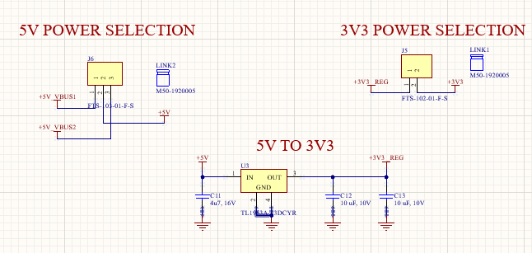

**5.2.3.4. Boot/User & Reset Buttons**

The boot/user button allows new firmware to update the board, and the reset button allows power to temporarily be cut off from the board. This allows the board to be reset during debugging and to program the board efficiently.   
  
  
  
  
  
  
  
  
  
  
 Figure 70: Boot/User & Reset Button Schematics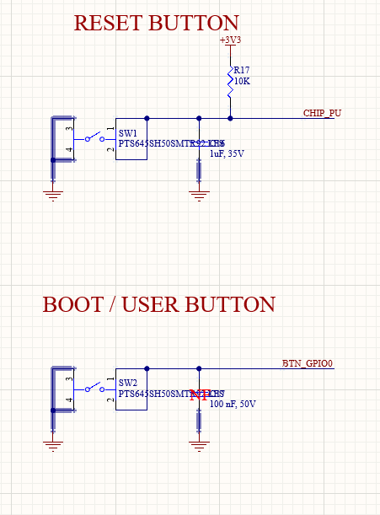

**5.2.3.5. USB Connectors**

This schematic displays the USB-C connectivity as well as the USB-UART conversion circuit for this PCB design. Two USB-C connectors handle power and data signals with their respective decoupling capacitors. The USB TO UART module is based on the FT2312X chip and facilitates the communication between USB and microcontroller via UART. It contains power regulation and level shifting, as well as VBUS sensing if it is ever needed. The bottom USB connector is what allows a device to connect directly to the ESP-32 Chip for debugging and programming. It also can function as a power connection for the board. Both of these connectors allow flexible communication and allow connection to and from external devices.  
  
  
  
  
  
  
  
  
  
  
  
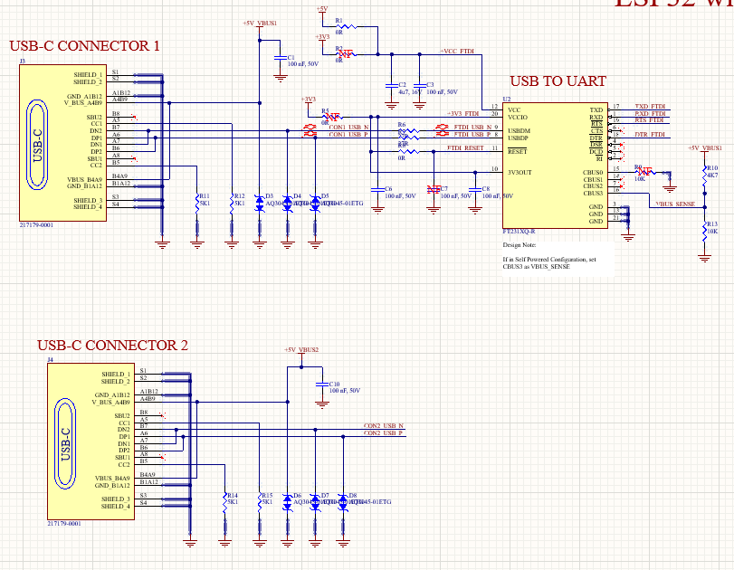

Figure 71: USB Connector Schematics

**5.2.3.6. Miscellaneous Components**

The left schematic shows the two LEDs that can display a proper connection as well as changes that are made or a successful Bluetooth pairing. The schematic on the right is in charge of differential pair routing, impedance matching, and controlled trace length. To summarize, this schematic will ensure signal integrity and avoid issues regarding noise or signal loss.

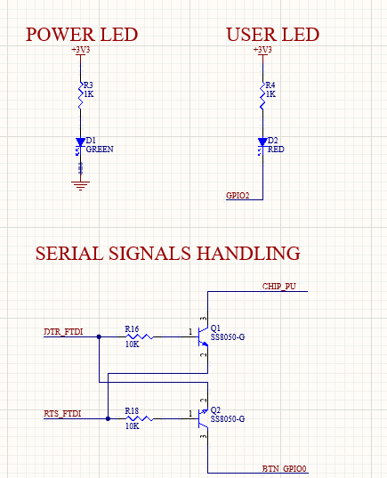

Figure 72: Miscellaneous Schematics

**5.2.4. GPIO Pin Layout**  
The table below shows the total number of pins (73) and what each one corresponds to. Notable pins include 39 and 40, which are the TX and RX pins respectively. These are the pins I used to communicate between two ESP-32 devices and what will eventually be used for communication to the C2000. There is compatibility with numerous different devices, such as screens, external LEDs, and many more. For this project, a majority of these pins will not be used, but are great additions because it allows for ideas to be expanded on and is adaptive to any changes that may be present in the future.  
  
  
  
  
  
  
  
  
  
  
  
  
  
  
  
  
  
  
  
  
  
  
  
  
  
  
  
  
  
  
  
  
  
  
  
 Figure 73: GPIO Pin-Out Sheet  
  
  
  
  
**5.2.5. Arduino IDE**Writing the Arduino code was done before the PCB board had been shipped and produced as tinkering with a prebuilt ESP-32 was done in the meantime. Arduino IDE allowed connection to the ESP-32, programming the device, and keep the connection secure through USB. The program that was written allows a user to connect their mobile device to the ESP-32 and send signals from the virtual controller screen. The ESP-32 was able to receive these inputs as shown in the serial monitor located in Arduino IDE. Additionally, a screen was connected to the ESP-32 and was able to show what inputs were sent and received in real-time.   
  
  
  
  
  
  
  
  
  
  
  
  
  
  
  
  
  
  
  
  
 Figure 74: Arduino IDE interfaceFigure 75: Mobile Input → ESP-32 → OLED screen  
  
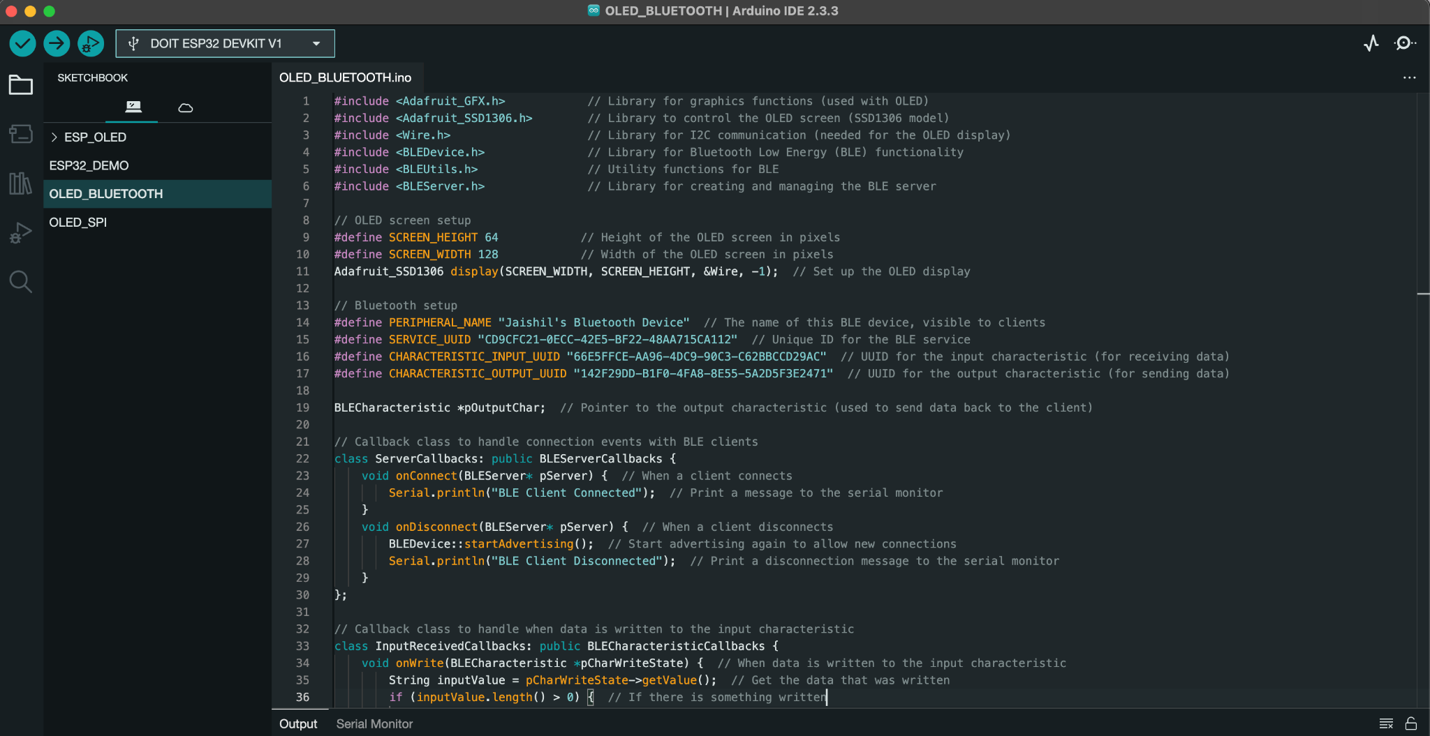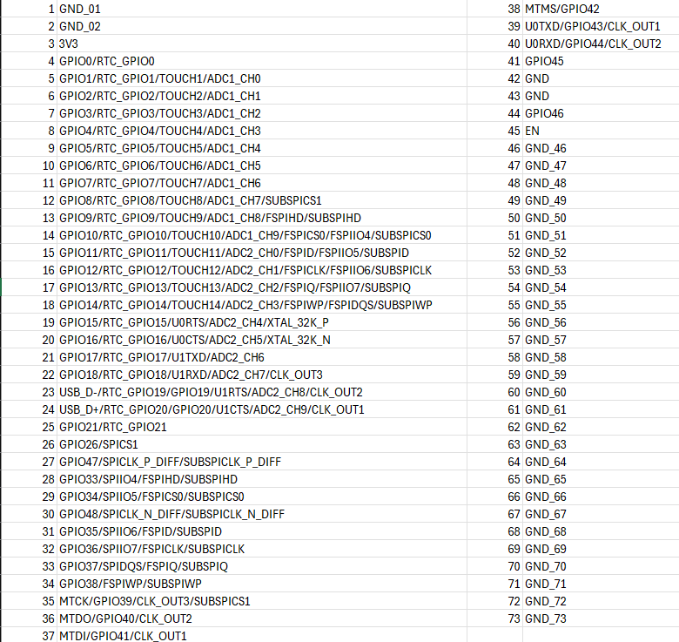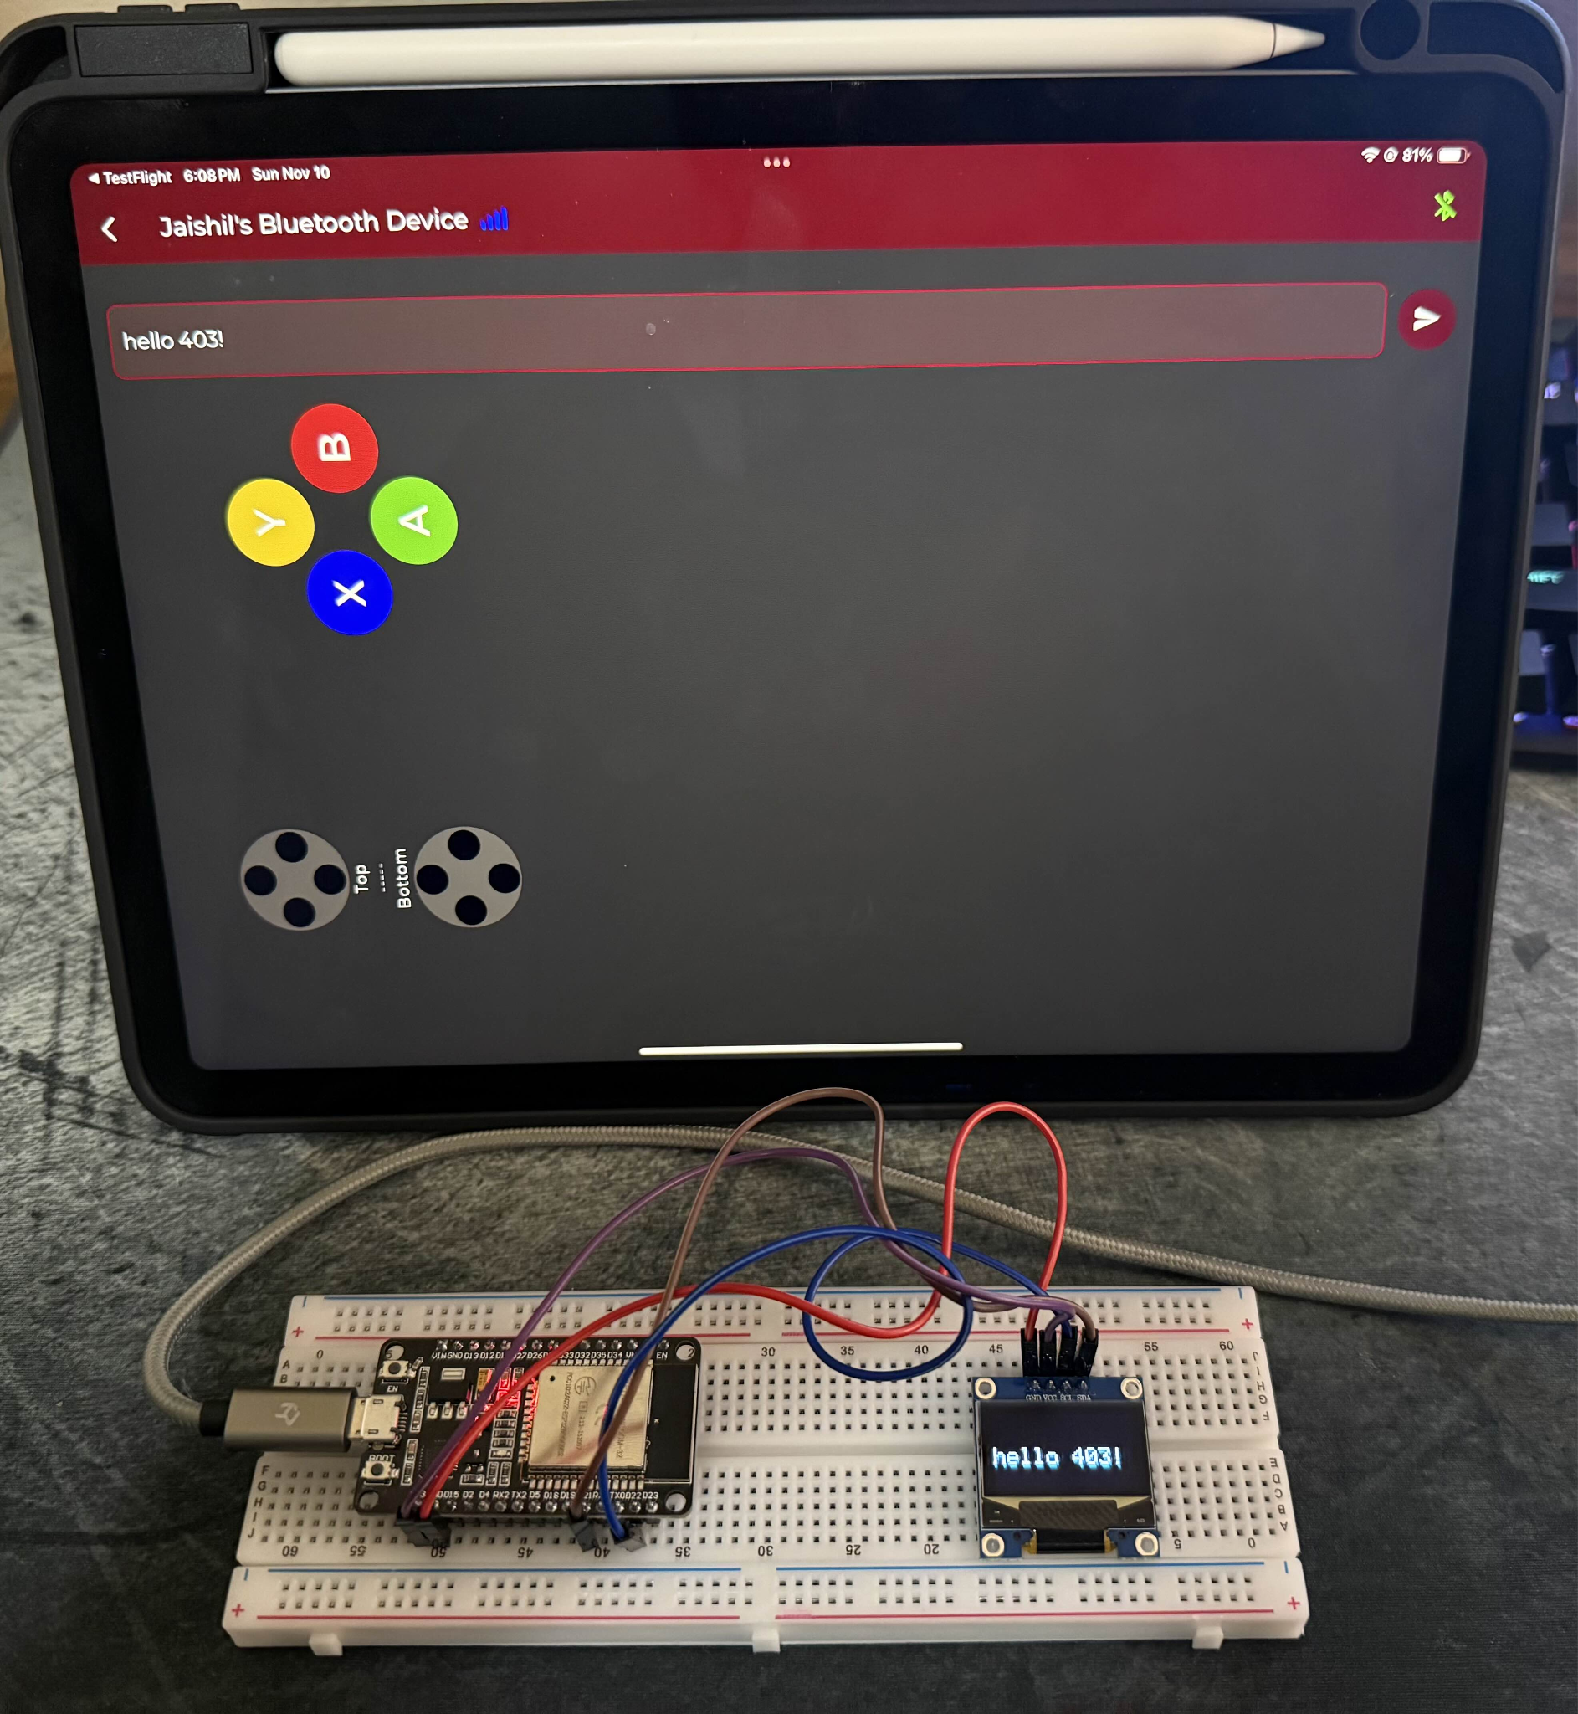

**5.2.6. Communicating via high/low GPIO Pins & Physical Board Validation**With all the previous sections within this subsystem in mind, it is time to put them together and create a system where all these parts are able to work together.   
  
Below is a four-part system that is able to take an input, communicate via two separate devices, and display the input on a screen. Here is a step-by-step process on how this works and how this implementation will work in ECEN 404. First is the mobile input. Once the Bluetooth device is connected on the mobile application, it is then connected to the student-developed PCB (green board on the image below). That PCB is connected to the black PCB (amazon-ordered) via TX/RX pins which can be depicted by the yellow and green jumper cables. Both PCBs are connected to separate computers, both running and communicating through Arduino IDE. Once the black ESP-32 has received the data from the mobile device, it takes that and transmits a signal to the OLED screen.

This mimics the intended result for cobot design, as instead of the black PCB, there will be a C2000 MCU. Since TX/RX is utilized here, the goal is to use the same process for the MCU. UART was unfortunately not functioning as intended, and thus on this green PCB, that connector is not even soldered on. In 404, tinkering will take place to see if UART is still a feasible solution, but for now, TX/RX pins are confirmed to work.

In order to simplify the process when combining the subsystems, the inputs will be simplified into 6-10 specific inputs that can be read, and be assigned their own GPIO pin. Since this PCB was designed with adaptability in mind, these extra GPIO pins will come in handy.   
  
Additionally, the breadboard and OLED screen were temporary and only there for this semester to display what a MCU will receive when the cobot is designed and created. The screen will be replaced with the motor & motor drivers so that in 404, the process goes: Mobile Device → ESP-32 → MCU → Motor Drivers. 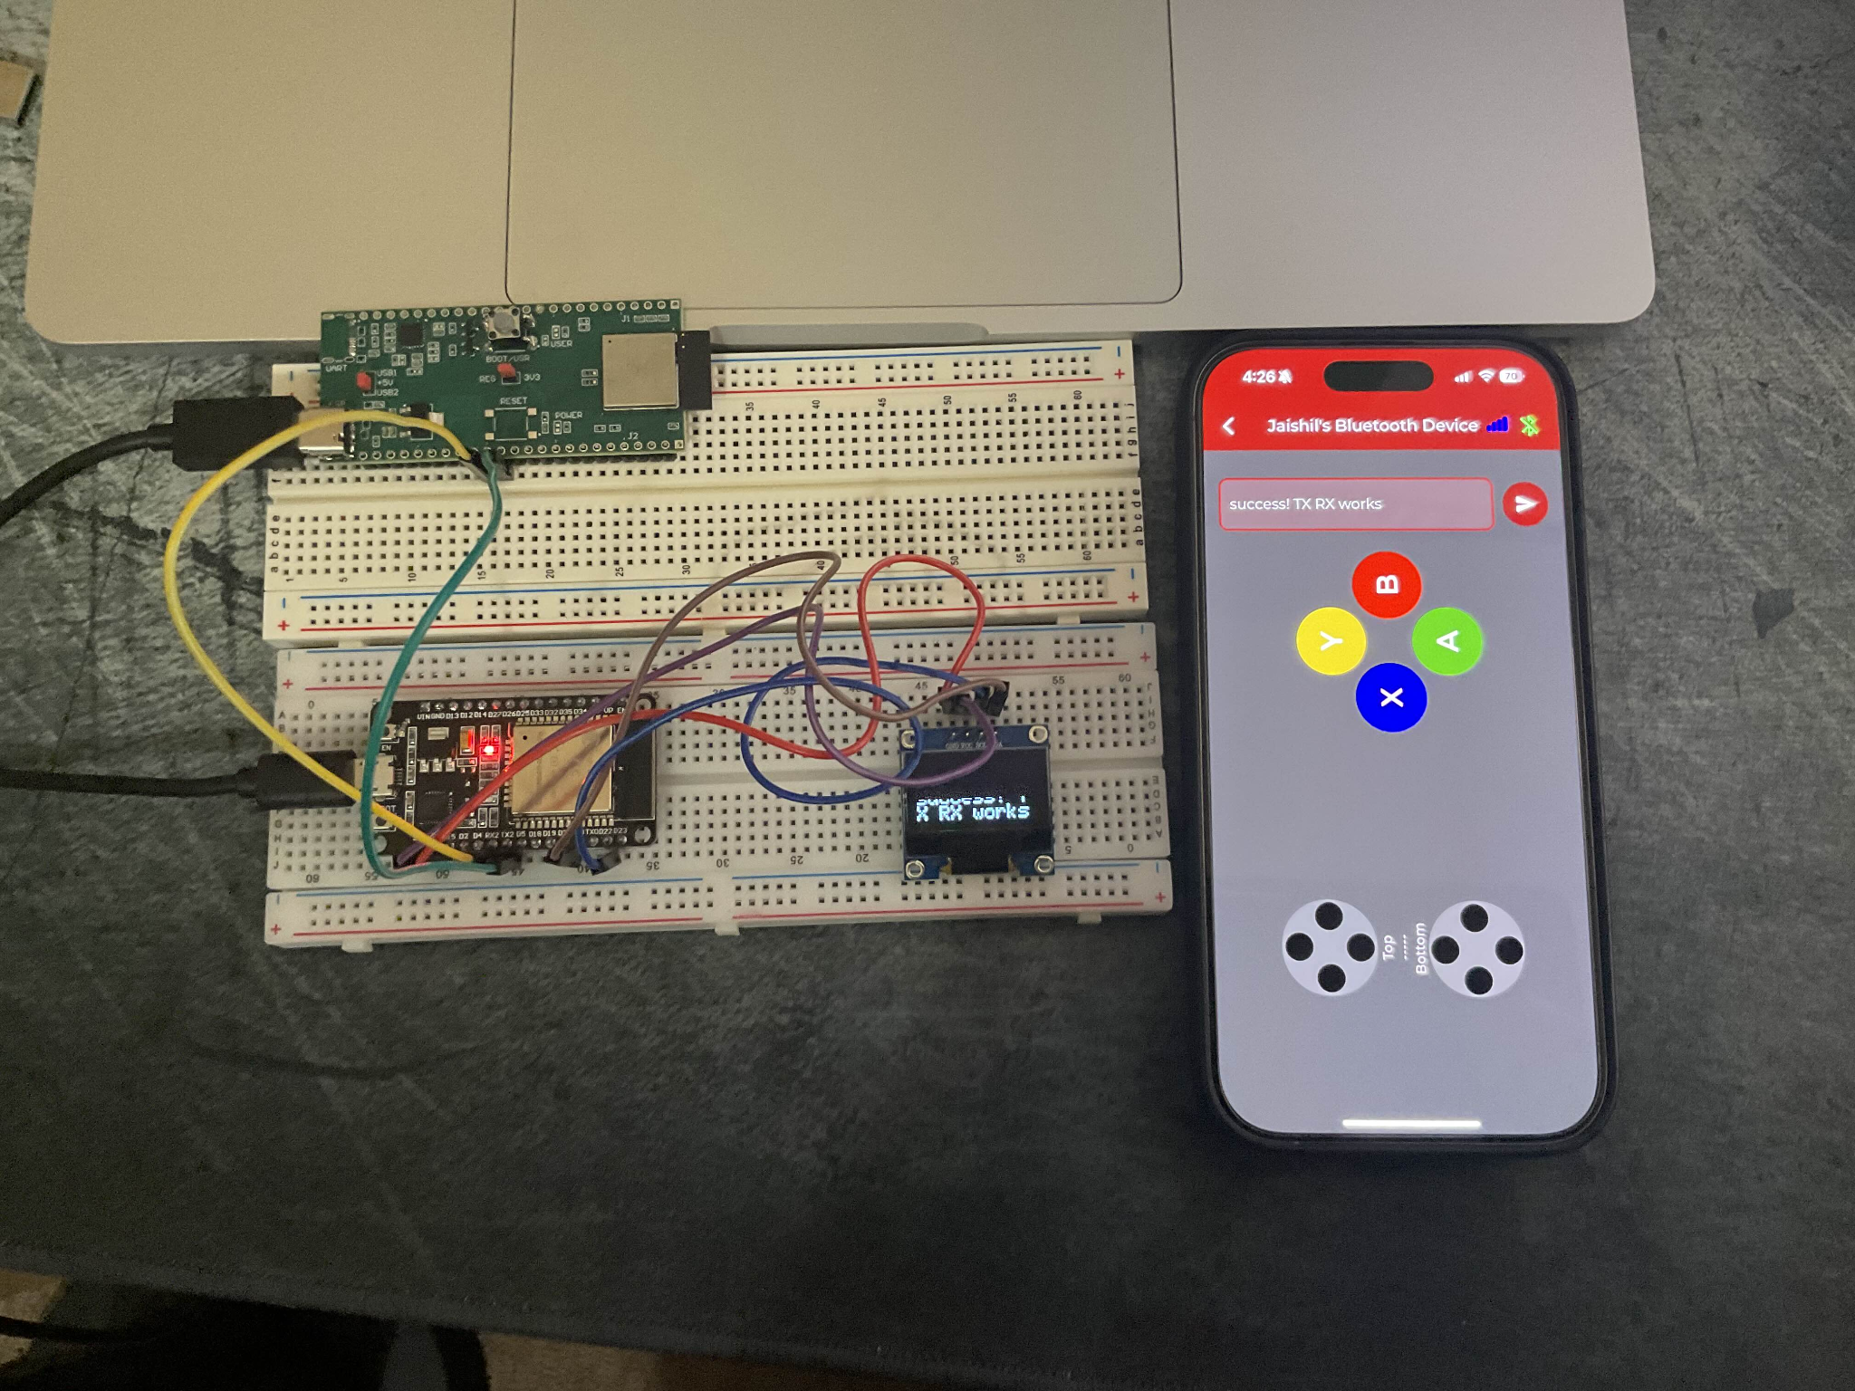

Figure 76: Full Subsystem Functionality Test

Below is the 3D render of the PCB, as well as the necessary components solder onto the physical board. The Reset Button was not soldered on as it was not needed for this semester’s functionality, and the UART connector was not installed as it did not work on another board that was previously soldered. (This board below is the third of five boards sent over from JLCPCB. The first was damaged as a trace ripped out, and the second had too much solder that touched where it should not have. The second was the one in which UART was attempted, and it did not function properly. Thus, it was ignored for this rendition of the PCB).

Figure 77: 3D render of ESP-32 PCBFigure 78: ESP-32 PCB used in four-part systemFigure 79: Arduino Serial Monitor displaying Signals Received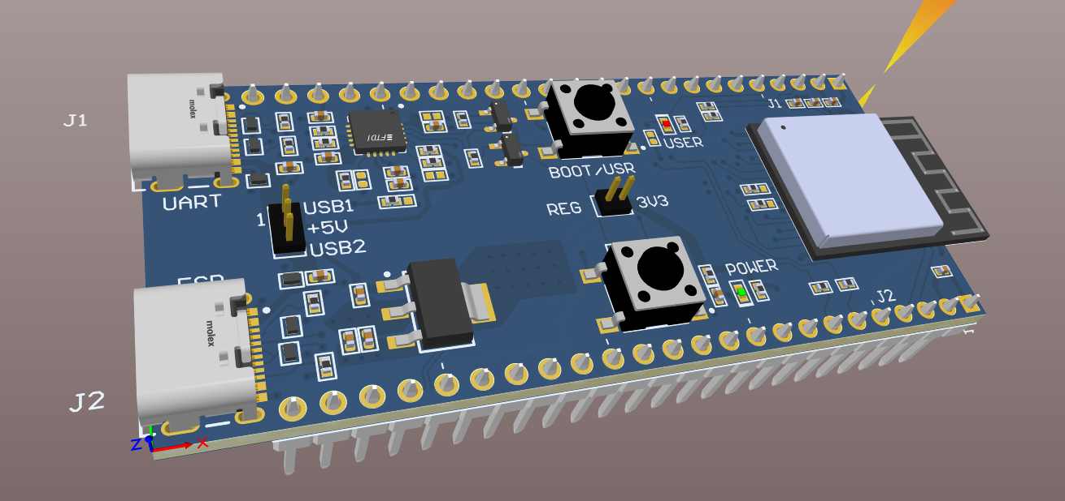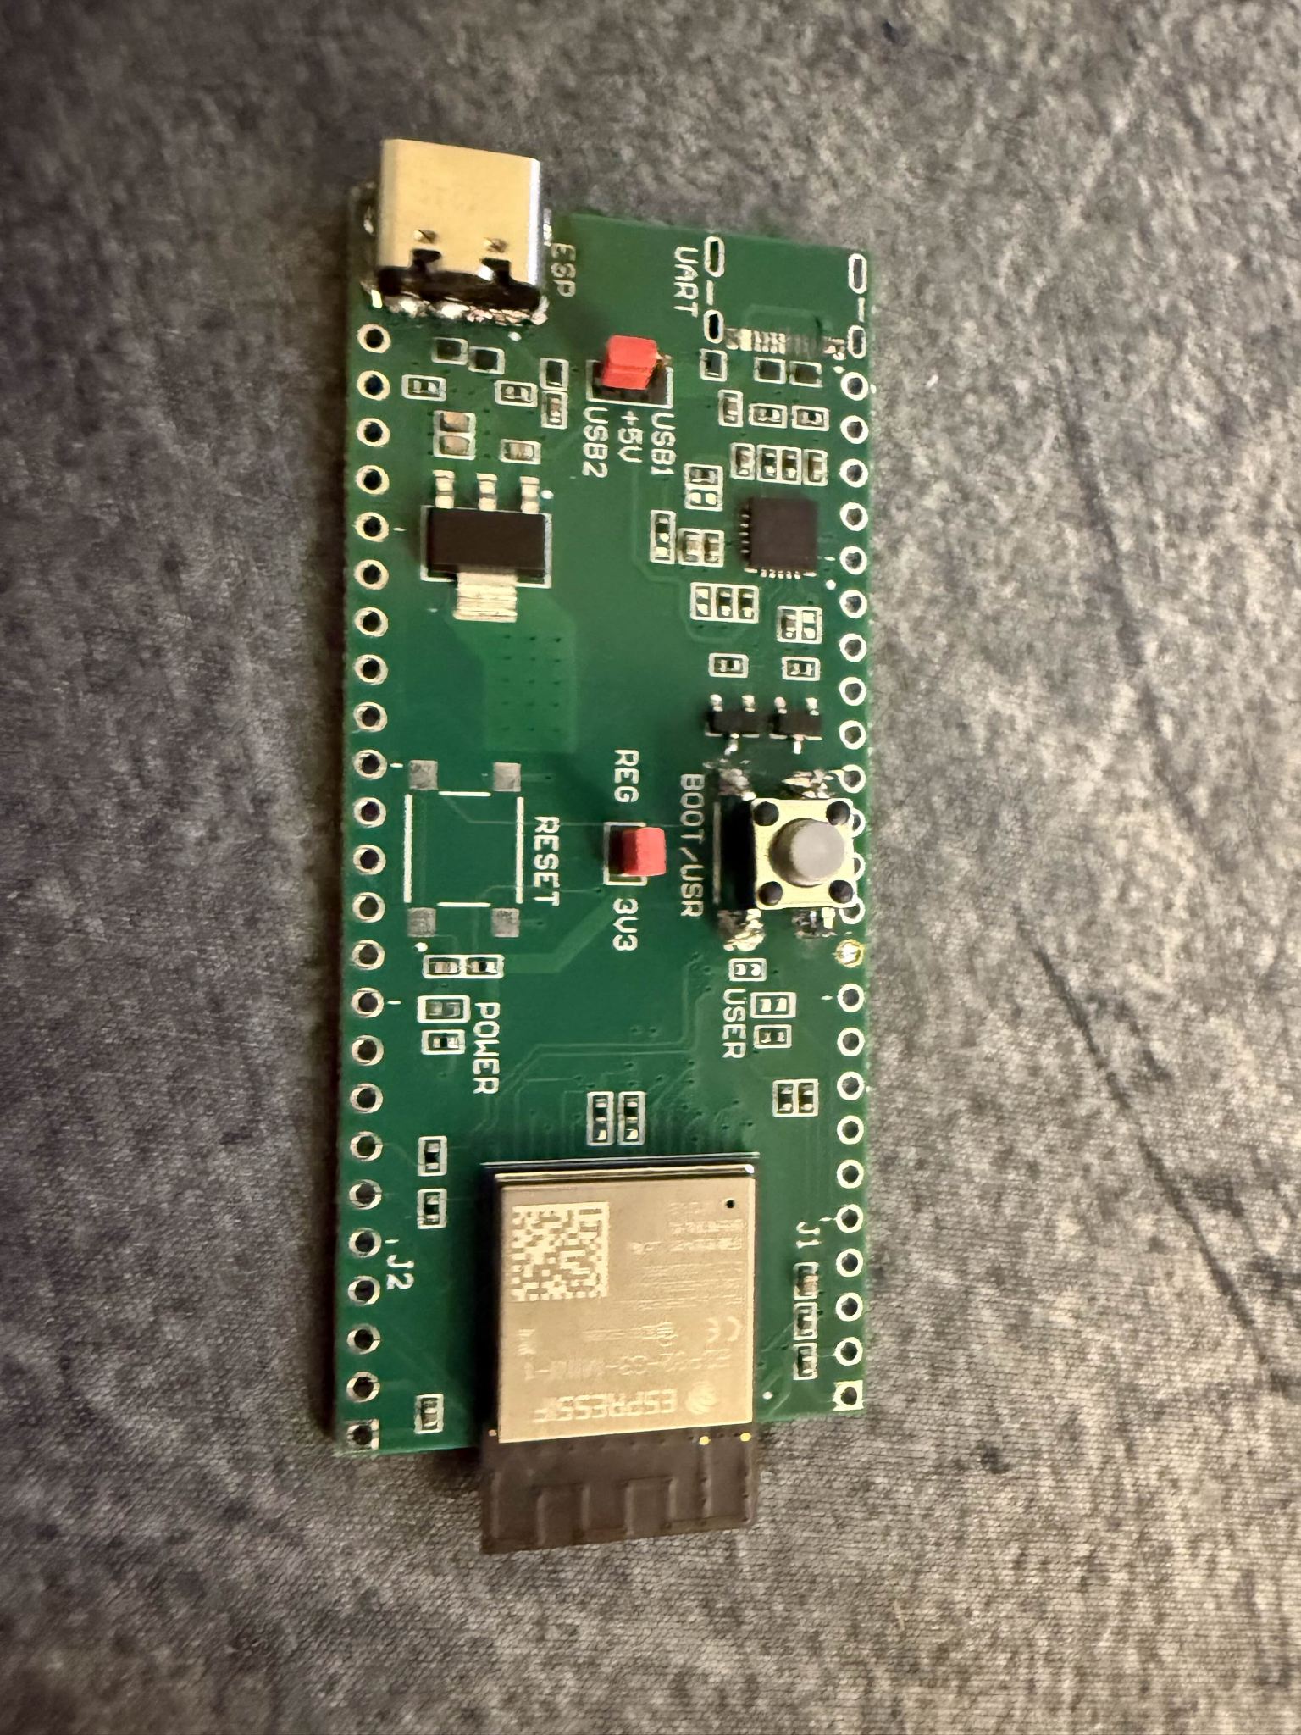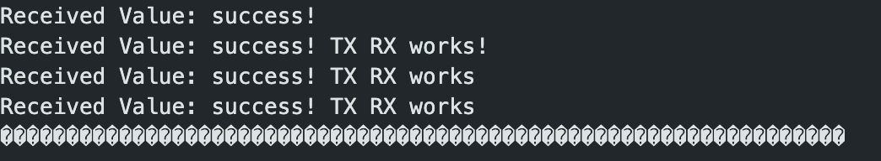

**5.3. Subsystem Validation**

| **Test Name** | **Successful** | **Criteria** | **Proof of Functionality** |
| --- | --- | --- | --- |
| Wireless Connectivity | Yes | Mobile app. stays connected for a minimum of 5 minutes and connects seamlessly. | Figure 75,79 |
| GUI Operational | Yes | Connection is stable, input lag is minimal, and outputs are properly received. | Figure 76,79 |
| FunctionalityMessages | Yes | Functionality messages can be sent from the ESP-32 via GPIO Pins | Figure 79 |
| Button Functionality | Yes | All User inputs and interactions work as intended without fault. | Figure 76 |
| Application Device Deployment | Yes | The application is deployed onto the device and is easily accessible to multiple users. Is also multi-device compatible | Figure 65,75 |

Table 12: Subsystem Validation - Jaishil Shah

***5.4. Subsystem Conclusion***Although a proper connection to the ESP-32 PCB that was designed was not established during the final demo, successful connection was established afterward and all criteria in the validation are met. In conclusion, this subsystem can successfully perform all required tasks and ensure that proper communication with other hardware and software will be successful during next semester’s assembly. All validation tests passed and all deliverables included in the execution plan were completed on time, excluding the PCB design not functioning properly. Once all components are fixed and started working as intended, this subsystem can be deemed ready for ECEN 404 integration and seamless cooperation with the other three subsystems within the project. The next steps include communicating to the MCU C2000 and from there communicating to the motors & their drivers, as well as making sure the 3V3 & 5V power can enable the ESP-32’s operations. In terms of direct work that needs to be accomplished next semester, a proper fabrication of the enclosures and cobot design needs to be completed, as well as complexity and finishing touches to the mobile application.